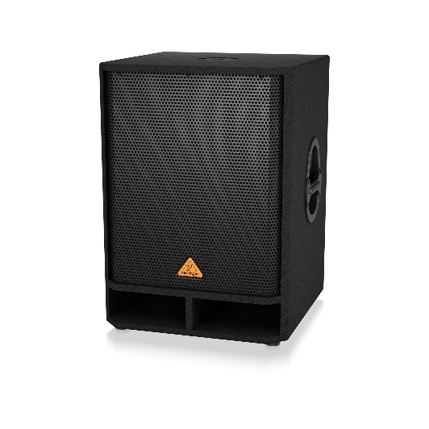
Item: Speaker to cover bass frequency
Cost: $529

- The speaker would provide a deeper bass sound without sacrificing clarity.
- The item would be placed in the organ speaker room above the stage.
- Speaker is powered and ready to connect to our equipment. Easy install

Item would be purchased online from Sweetwater.
https://www.sweetwater.com/store/detail/VQ1800D--behringer-eurolive-vq1800d-500w-18-inch-powered-subwoofer

