Texts
Bible (a phone app works great, but I LOVE to see young people with a book)
Strength Finders 2.0 (ISBN: 159562015X)

Pre-Class
- Take this DISC personality assessment –
https://www.truity.com/test/disc-personality-test
(Agree or disagree?)
Ex: My results are IDSC (INFLUENCE is biggest, then DRIVE, then SUPPORT, then CLARITY)
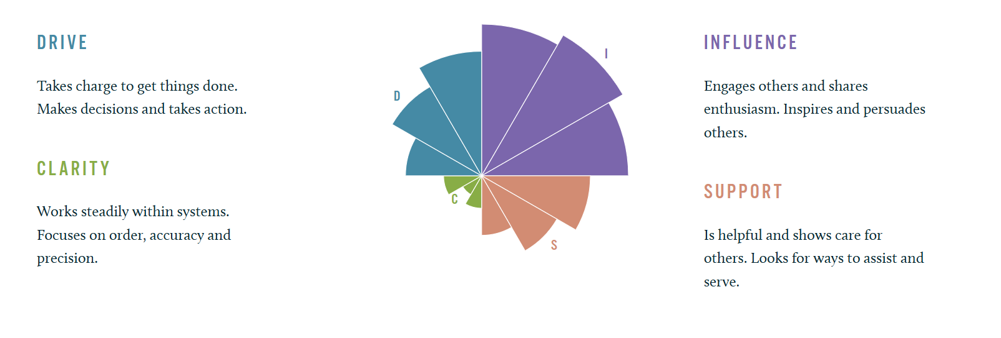

- Take the Strength Finders 2.0 Assessment. The code is at the back of the book.
Record your TOP 5 STRENGTH results and come ready to talk about them. (Agree or disagree?)

Week 1
What does God’s Word say about your Career and Calling?
- Be prepared to talk about your personality & strength assessments

