Team (Date for background check with Cleta)
Lupita Cortez
Abby Nguyen
Savannah Nolan
Courtney Nolan
Sophia Silva
Vicky Skinner
Michelle O???
PA???

Resources
Group Children's Ministry
-Hands on activities
-Toddlers-6 grade
Dig in (I think this is the most useful but $130 per quarter)

Bibles
NRSV Children's Bible 5 of each=$117.45

The Beginner's Bible 3 of each=$38.78

Total=$165.26

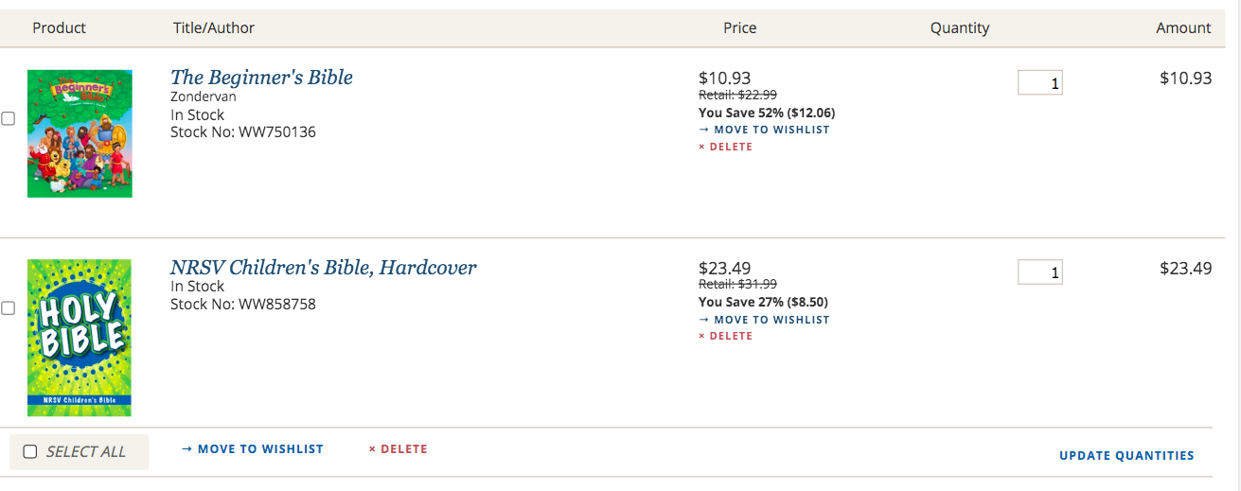

Office Supplies

Printer
Copy paper
Construction Paper
Craft Kit
Sharpener
Scissors
Cutter
Markers

