I tried to work on more precise references but was never able to figure it out. On the bottom of the Evangelical Dictionary it shows a Bibliography but does not footnote these bibliographies into the article.
There is also a FIND IT LINK…
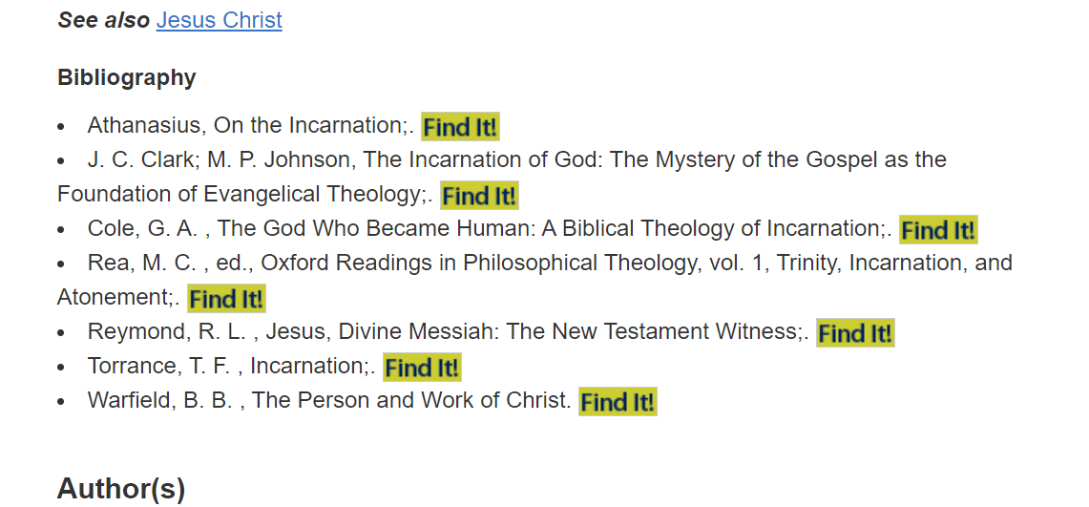
…but it just takes me to this page to show if it is available in thee PTS Library.
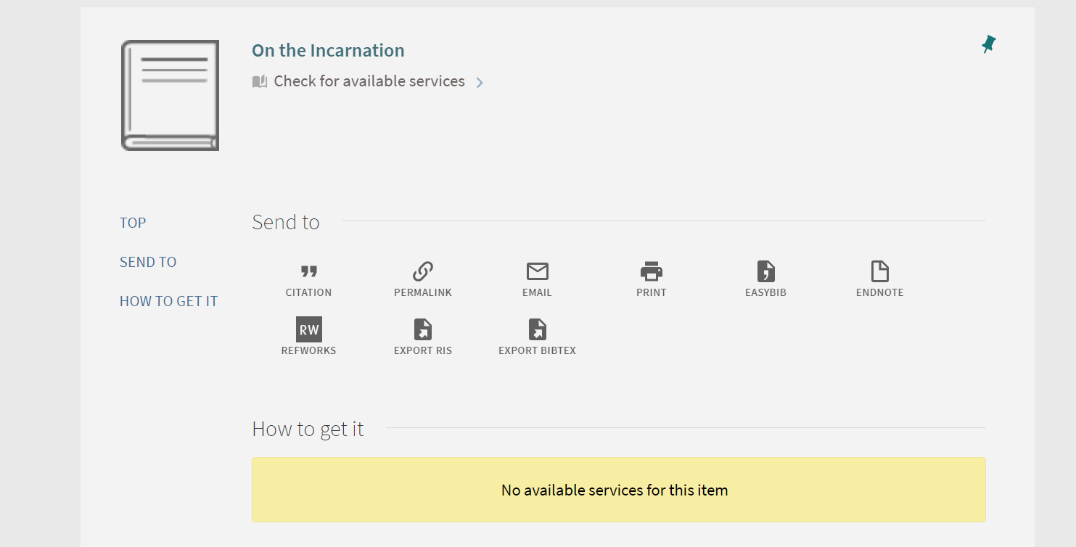
What am I missing?
Chris Fluitt
Week 4 Terms - extended definition - Incarnation
Theology in Ministry

