(Separate Slides for the following quotes)
"We must learn to live together as brothers or perish together as fools." - Martin Luther King Jr.
"Coming together is a beginning, staying together is progress, and working together is success." - Henry Forde
"Alone we can do so little; together we can do so much." - Helen Keller
“Why can't we all just get along?” - Rodney King
Welcome to Redemption Church of Plano Tx…
Raise your hand if you think unity is important.
Now, raise your hand if you think unity is difficult. (Me too!)
Think about people who don’t get along…
The Hatfields and the McCoys.
The Montagues and the Capulets
Democrats & Republicans.
Yankees and Red Sox fans.
Apple and Android phone users.
Coke & Pepsi.
…Christians.
In a world that often seems fractured and divided, the Church of Jesus is called to be a beacon of unity, but are we?
Scriptural text
Our scripture for today comes from 1 Corinthians 12:12-27, where Paul speaks to the Corinthians about the body of Christ and the unity that should characterize it.
"For just as the body is one and has many members, and all the members of the body, though many, are one body, so it is with Christ. For in one Spirit we were all baptized into one body—Jews or Greeks, slaves or free—and all were made to drink of one Spirit. For the body does not consist of one member but of many. If the foot should say, 'Because I am not a hand, I do not belong to the body,' that would not make it any less a part of the body. And if the ear should say, 'Because I am not an eye, I do not belong to the body,' that would not make it any less a part of the body. If the whole body were an eye, where would be the sense of hearing? If the whole body were an ear, where would be the sense of smell? But as it is, God arranged the members in the body, each one of them, as he chose. If all were a single member, where would the body be? As it is, there are many parts, yet one body. The eye cannot say to the hand, 'I have no need of you,' nor again the head to the feet, 'I have no need of you.' On the contrary, the parts of the body that seem to be weaker are indispensable, and on those parts of the body that we think less honorable we bestow the greater honor, and our unpresentable parts are treated with greater modesty, which our more presentable parts do not require. But God has so composed the body, giving greater honor to the part that lacked it, that there may be no division in the body, but that the members may have the same care for one another. If one member suffers, all suffer together; if one member is honored, all rejoice together. Now you are the body of Christ and individually members of it." (1 Corinthians 12:12-27, ESV)
11 times Paul uses the word “ONE” to describe the body of Christ.
Recent statistics cite 47,000 Christian denominations. (OMSC) How can we be one?
Contemporary Issue
In today's context, the Church faces numerous challenges to unity. Racial tensions, political divisions, and socio-economic disparities often creep into our congregations. The rise of social media has also amplified voices that can lead to division, as people find themselves in echo chambers that reinforce their views and vilify others. As we near an election this becomes more visible.
Consider the current debates within many churches about social justice issues. These debates can create significant rifts, with different factions accusing each other of either ignoring biblical mandates or misapplying them. Imagine all the good we could accomplish if we could just get along.
Scripture’s message is profoundly relevant here: our unity in Christ transcends these differences. We are called to listen, to empathize, and to work together for the common good, recognizing that each perspective can contribute to a fuller understanding of the Gospel and its implications for our world.
Thesis
In our Scripture reading, Paul uses the metaphor of the human body to illustrate the essential unity and diversity within the body of Christ. Our thesis today is that true Christian unity is not about uniformity but about embracing our God-given diversity within the framework of love and mutual care. This unity is essential for the Church's mission and witness in the world.
This has everything to do with us gathered here today.
-We at times struggle to unify in our Church body.
-We often struggle to unite with the Christians in our own family home.
-We fall short of Christian unity in our City, State, and World.
-We must unify within our Church body, homes, and community.
Exposition of the Text
Paul addresses the church in Corinth, a community that was struggling with divisions and conflicts. Members were comparing spiritual gifts and creating hierarchies, leading to disunity. In response, Paul emphasizes that just as a human body has many different parts that function together as one unit, so does the body of Christ.
Paul’s teaching to the Church in Corinth transposes to our to our context today.
1. Unity in Diversity (v 12-14)
Paul begins by stating that just as a body is one entity made up of many parts, so is Christ’s body. We are all baptized by one Spirit into one body, regardless of our backgrounds. This emphasizes that our unity is rooted in our shared identity in Christ, transcending all social and ethnic divisions.
Application
Do we have such an emphasis in the shared identity of Christ?
Are we divided by social divisions? Traditional background, Politics, Socio-economics?
Are we divided by ethnics and race? As a majority white congregation, can we own that we may be divided in this area?
Christian unity is not about erasing our differences but about embracing them within the unity of the Spirit. As Paul teaches us, we are all parts of the one body of Christ, each with a unique and indispensable role. Our unity in diversity is a testament to God’s wisdom and design.
2. Interdependence (v. 15-21)
Paul highlights the interdependence of the body parts. No part can dismiss another as unnecessary. Each part, whether seen as prominent or not, has a crucial role. This teaches us that in the church, every member is important and has a unique contribution to make. No one should feel inferior or superior.
Application
Are you independent or interdependent?
When did you last ask for help?
When did you last offer help?
Do you view yourself as superior to others?
What does that look like?
-I shouldn’t have to take time to help them… I have an important position.
-I give so much already; I think someone else should serve this need…. Not me.
Do you feel inferior to others?
What does that look like?
-I can’t pray, serve, minister to others… I’m just little ole me.
-I can’t make much of a difference. I lack the skill, ability, and wealth of others.
If your feelings of inferiority and superiority are keeping you from interdependence, then you are missing out on the power of unity. What if you are missing out on purpose, fulfillment, or even miracles that come from serving in the ONE Body of Christ?
Would consider making a change?
3. Mutual Care (v. 22-27)
The parts of the body that seem weaker are indispensable, and those we consider less honorable, we treat with special honor. This principle of mutual care ensures that there is no division in the body. When one part suffers, every part suffers with it; when one part is honored, every part rejoices with it. This mutual empathy and support are fundamental to maintaining unity in the church.
Application
When was the last time you suffered because someone else in the body suffered?
-A Natural disaster/famine in another part of the world causes you to say “NO” to your Starbucks, entertainment, and shopping addiction and instead you are touched with their suffering – sending tearful prayers and offerings.
-You take time to suffer with those who have lost a loved one. You serve them in their sorrow.
-Have you joyfully honored others news like it was your own good news?
When was the last time you received care from the body?
-Do you have a struggle that you haven’t even told others about? You are missing out on the mutual care of the body.
IF WE DON’T KNOW YOU ARE SICK how can we help you? Don’t make us play doctor and follow the clues to come the conclusion that you need help.
The same could be said for lost jobs, broken situations, and physical, emotional, and spiritual distress.
You are a part of the Body.
We are not going to judge you – we love you.
We are not going to cut you off – we are going to protect you.
We are not going to dishonor you – we are going to honor you.
Personal testimony – Our life has been a whirl wind.
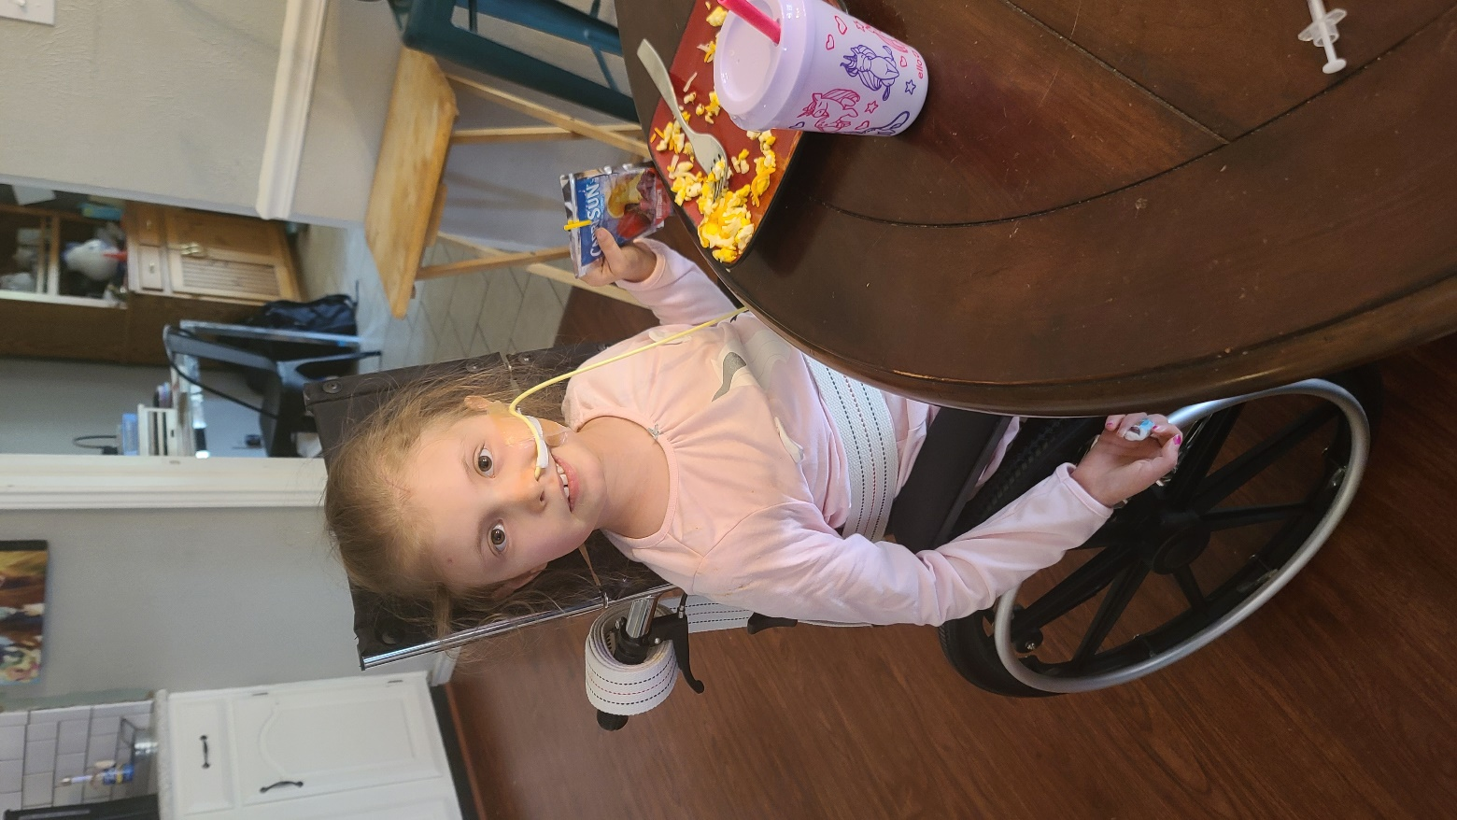
(Picture of Aria)
My 10 year old foster daughter Aria passed away on June 4th after a long hard fight with a brain tumor. We hurt every day from this loss.

(Elliot Picture)
The same month, on June 27th we were blessed to bring Elliot Hayes Fluitt into the world. We are blessed every day by this gift.
I am so thankful for the mutual care of the body of Jesus.
You suffered with us as we surrendered Aria back to the Father.
-You cried with us in prayer and at the funeral.
-You brought us meals and cared for our kids in their pain.
-You mowed my lawn, you ran my errands… you let me not be ok and not have to act like a have my act together pastor.
And at the same time you also rejoiced with us.
-You held a birthday parties for our 2 sons Josh and Hudson that we did not have the bandwidth to plan.
-You helped us experience the joy of new birth. Handwritten notes, texts, and gifts.
This is the strangest season of my life. I don’t know what I would do without the mutual care of the Church. Thank you for being 1 Corinthians 12:12-27 for me.
You have exampled:
#1 Unity in Diversity
#2 Interdependence
#3 Mutual care

Missional Application (Call to Action)
1. Embrace Your UNIQUE Role in the Body
Reflect on your unique gifts. You are gifted by God and have so much to contribute.
Do not compare yourself with others, but rather seek to serve where God has placed you.
REPENT of feelings of superiority and inferiority.
Pray to better understand your gifting.
Sign up for our “NEXT STEPS CLASS” to learn how to be a part of what God is doing in the Body here at Redemption.
Pray about looking beyond our local Church body to join with others in the good work of the Kingdom.
2. Promote Interdependence
Foster relationships within the church that cross typical boundaries. Engage with those who have different backgrounds and perspectives. This could mean joining a small group in the Church. It could mean to look for friendships with people that are not you… diverse in age, ethnicity, or socio-economic status. Seek to understand and appreciate the contributions of others.
Let our unity within the church be a testimony to the world. Advocate for peace and reconciliation in your community. Participate in interchurch or interfaith initiatives that promote understanding and cooperation. The unity we demonstrate can serve as a powerful witness to the transforming power of the Gospel.
3. Practice Mutual Care
Would you like to see a miracle today? I think it would be a miracle if in these closing moments today two things would occur…
#1 It would be a miracle for you to pray with someone in their need. Take on that role of minister amid someone’s suffering.
#2 It would be a miracle for you to, in your need, receive prayer from others. Open up, trust the body, and not be independent for a change.
#3… do both. Pray for others and be prayed for.
As our worship team begins to lead us in worship, I invite you to come and take part in a miracle… take part in the mutual care of the Church…

**Works Cited**

- The Holy Bible, English Standard Version. Wheaton: Crossway, 2001.
- Colossians 1:18, ESV.
- Ephesians 3:10, ESV.
- John 17:21, ESV.
https://omsc.ptsem.edu/the-annual-statistical-table/

