1. Mission, Vision, and Core Values
Mission Statement - Helping people find and follow Jesus Christ.
Mission is WHAT we are called to do.

Vision Statement - Love God, Grow Faith, Serve Others, Go Change the World.)
Vision is HOW we will accomplish our mission.
More Vision Info
The way we best fulfill the LOVE GOD portion of our vision is through our Sunday Worship Service. We want to create services that cause others to Love God more.
The major way we GROW FAITH is through our Connect Group. (small group ministry) We have a simple small group discussion around a scripture a member in the group shares that has intrigued them. We read this passage together and ask prompt questions (What did you like about this passage, what did you not like about the passage, what questions do you have, what have you learned, and an accountability question - in light of this passage how will you live differently this week?) Our goal is to gather in community, become familiar with our bible, and apply the scripture to our life. This is discipleship.
We SERVE OTHERS through joining the DREAM TEAM and serving in and out of the Church. We believe that God has a plan and purpose for everyone (Ephesians 2:10). We desire to see people use their giftings, abilities, and calling to serve others. We believe people should surrender their Time, Talent, and Treasure back to God. We serve others in and out of Church services. We love to serve in our community.
We GO CHANGE THE WORLD by sending people out to be leaders in God’s Kingdom and by giving to worldwide missions. We support Jesus Centered works in Russia, Belarus, Cuba, Nepal, Thailand, Ghana, Lebanon, and home missions in the United States. It is our desire to plant Churches. We also know God has called us to build up leaders that make a difference in the World.
Core Values:
- Jesus Changes Lives (We push for Transformation. We offer more than Biblical “information” and Religious “conformation”; but we challenge everyone to embrace “TRANSFORMATION” through the message of Jesus Christ. Every person can be changed by the Gospel. Every person can become a disciple. Every person can disciple others. We LIVE for REAL STORIES of lives changed by Jesus. We aim to REJOICE louder than the angels when transformation happens!)

- Celebration Party People (We celebrate our victories and the people who work hard to bring it about. Nothing is more fun and rewarding than serving God with people you love and making a difference. We smile and laugh a lot! There are no thankless tasks. We say THANK YOU. )
- Other’s Focused (We exist for others to know Jesus and grow in His purpose. The Church does not exist for our preferences. We are contributors and not consumers. The church does not exist for us. We are the church, and we exist for the world. We give our Time, Talent, & Treasure to God, for others. )
We know that Core Values must be our behavior at Redemption Church.

2. Denominational Affiliation and Theological Distinctives
Redemption Church of Plano, Tx is a Non-denominational Church. We know that denominations often divide. Our membership comes from many Christian backgrounds and we are willing to do missions work with other groups.
We are a Spirit Filled book of Acts Church. We are Pentecostal in experience.
We want to see people receive the Gospel by faith… repent, be baptized in Jesus name, and have n experience with the Holy Spirit. We woud like that experience with the Spirit to be powerful like it was in Acts 2. We do believe in speaking in tongues and recognize that the disciples saw it as an evidence. WE DO NOT CONDEMN PEOPLE if they have not experienced these steps. Instead we encourage people to take their next step in God.
We baptize in Jesus name for the remission of sins. Acts 2:38.
We do not use the word “Trinity” to describe the Godhead. We use more biblical language that some would consider modalistic/oneness language. We believe strongly that Jesus is the same God who created the world in Genesis 1. Jesus is Almighty God incarnate. We avoid saying “God the Son” or “Persons.” We do see distinction between the father and son yet one God.
Theological emphasis: We want to be like Jesus and the Book of Acts Church. We use a pool metaphor as a church – we want a shallow end for unchurched people to experience God, and we want a deep end for people to continue to grow in their faith and become used by God in ministry, service, evangelism, discipleship.
We believe the Bible is the Word of God. It is reliable and relevant.
View on key doctrines:
We are not Calvinist. We believe in free will. We don’t believe ONCE SAVED ALWAYS SAVED. People need to continue in the Lord.
We believe in Heaven and Hell. We let Gpd be the final judge of people’s eternity.
We allow open communion but offer it in a contemporary setting where people may serve themselves communion during worship gatherings.
We believe in Spiritual gifts.
We believe Jesus is coming back.
We do not lead people in a sinner’s prayer or ask them to come forward to join the church.
We do push for transformation in every service and invite people to come to an altar to receive prayer and pray for one another. Instead of a sinner’s prayer we do lead people in a prayer of repentance when the opportunity arises.
Our Musical style is Rock and Roll contemporary with high energy.

3. Target Audience
We have developed an avatar as our target named Plano Paul.
Male, 33 years old, currently married (like their 2nd marriage, they have 2 children.
They work in middle management or work with their hands in a craft (electrician example).
Tired of social media (but perhaps still addicted to scrolling)

Worries of target audience:
Relationship - Marriage, step kids, ex-wife
money worries, saving for house
aging parents
Career stalling
Life Balance - Worried about what is next
Future – Kids and how they will make it in society
Secret addiction - drugs, gambling, porn,
Lacks close positive relationships
Likes video games, sports, food
Drives an SUV
We are developing a secondary avatar named Military Mike.
60 year old military veteran of desert storm.
DIVORCED, SINGLE, PTSD, LONELY, FEELS UNAPPRECIATED
Strong discipline, duty, and devotion.
Additionally, we greatly value reaching young families, singles, and skeptics

Cultural context – City, fast paced life style, pressure and stress, rarely enough time for family

Spiritual maturity level: New believers and seekers.

4. Communication Style
Andy Stanley is our communication style. We appreciate his logical, practical, conversational style of connecting. We also use Andy’s form of ME, WE, GOD, YOU, US.
We insist on reaching the heart (emotions) and mind (logic) of our audience.
We deliver relevant messages that address real life problems with the teaching of Jesus.

Preaching Style: Topical , story-driven, practical application with 3 clear call to actions. Call to action 1 & 2 are lifestyle driven for the upcoming week. Call to action 3 is to seek transformation RIGHT NOW THROUGH PRAYER AND WORSHIP.
Preferred language: Are there buzzwords or phrases the church uses often? Love God, Grow Faith, Serve Others, Go change the world.
We exist to help people Find and Follow Jesus Christ.
We are not a mega church, but we are a mighty church.
Everyone is a 10 at something. Find and Unleash your superpower. Before God created you, He created the good work you are to do. (Eph 2:10)
Next Steps
Connect Groups

5. Ministry Focus Areas
Kids ministry – Treehouse Kids and Nursery

Missions: Nepal, Russia, Belarus, Cuba, Taiwan, Ghana, Lebanon
Benevolence ministries in the Plano area.

Discipleship/small groups – Connect Group using a simple small group outline.
Outline:
#1 Agreement prayer – state 3 things we can agree upon (ex: it was a pretty day, it is good to hang out, God is good) then pray over our time together
#2 Key Discipleship Question - Go around the room and ask what did you read in your Bible that intrigued you this week.
#3 Bible passage selection (Select the scripture that brought the most life and energy. Have everyone read it)
#4 Discovery Questions • What did you like about the passage? • What did you not like about this passage? • What did you not understand? • What new thing did you learn? • What is God asking you to do as a result of this passage? o What are you going to do about it? o (Everyone answers - write it down) (Accountability question next week and follow up during the week)
#5 Prayer circle
Worship – Contemporary rock styles. Passionate display of worship. Jesus centered.

6. Common Questions or Objections
Can I trust the Bible? Why do bad things happen to good people? How do I find my purpose?

How the church typically responds to these.

7. Content Preferences
Bible version used NIV

Famous quotes, authors, or resources regularly referenced – CS Lewis, Corrie Ten Boom.
John C. Maxwell, Purpose driven Church by Rick Warren

Integration of pop culture references, movie clips, song lyrics, etc.
We like to use anything that is current to drive home our points.

8. Event Calendar and Annual Rhythms
Major yearly series
We do message series monthly.
Easter and Christmas are major seasons.

Recurring outreach events or missions

Themes for particular seasons:
January – Leadership Restart Reboot ideas.
Summer – Fun Fruits of the Spirit
October – Something Spooky with a sin problem focus
December - Christmas

9. Leadership Team Info
Names, titles, strengths/personality styles (optional)
Chris Fluitt (me), Lead Pastor and Board member
DISC - I,D Worship, Exhortation
Strengths: Music, Creativity, Communication, Relational, Influence, Leadership
StrengthFinder 2.0 assessment: 1 W.O.O
2 Positivity
3 Ideation
4 Communication
5 Strategic
I am weakened by busy work.
Ron Muller, Board Member, Sound Tech
Lupita Cortez, Board Member, Treehouse teacher and coordinator
StrengthFinder 2.0 – 1 Relator
2 Belief
3 Connectedness
4 Learner
5 Deliberative
Cleta Alexander, Worship Leader, Secretary
Disc: C/I Gifting: 1) exhortation, mercy, music/worship 2) helps, shepherd, service
Strength: Singing, financial accounting
Rob Cortez, Worship Service Tech Leader
Analytical, Learner
StrengthFinder 2.0 – 1 Context
2 Restorative
3 Deliberative
4 Consistency
5 Intellection
Any leadership principles the church abides by
John Maxwell – Law of the Lid
Purpose driven church – Crowd, Congregation, and Core circles. The goal is to get people from the community into the crowd… to the congregation… to commitment… to core.
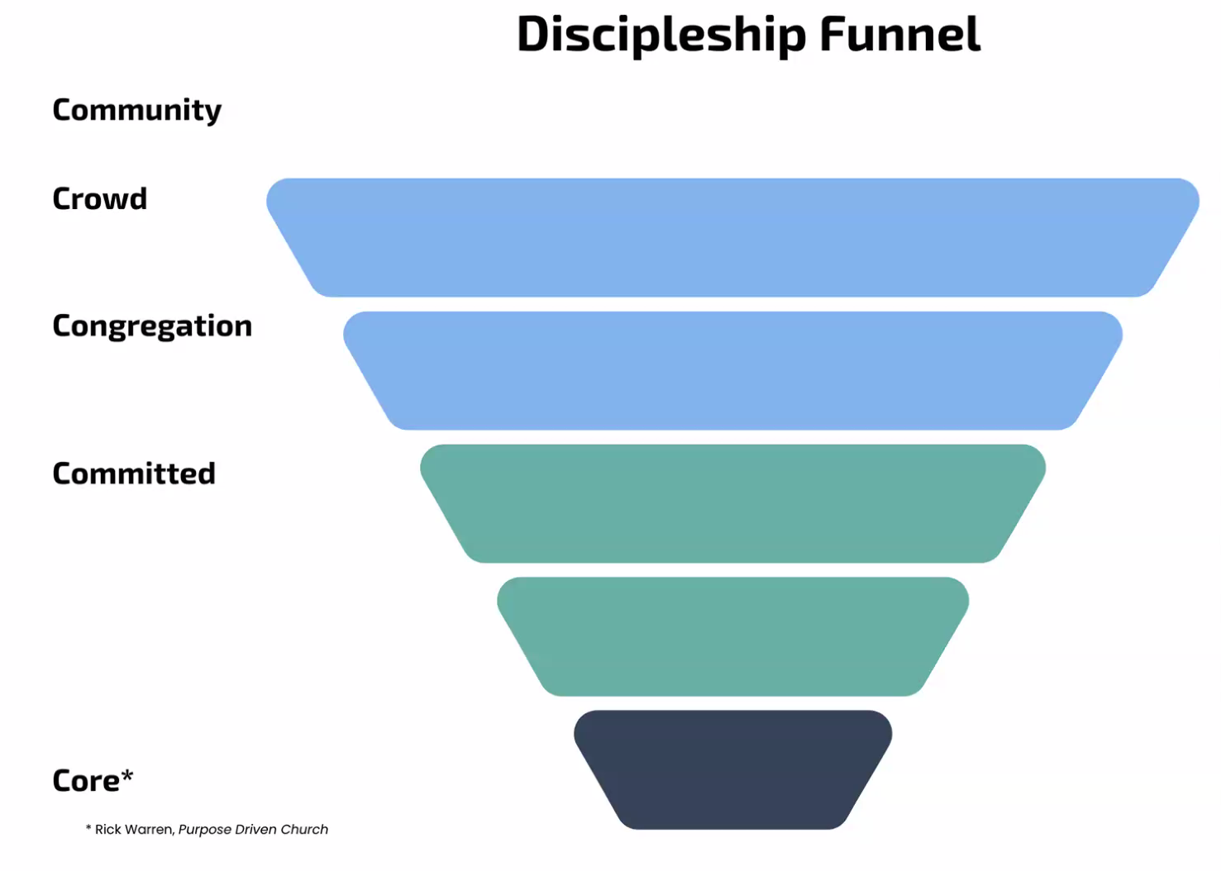

10. Organizational Language & Terminology
How you refer to things
Next Steps #1 is our membership class
Next Steps 2, 3, 4 is members investigate their strengths, see the need for their gift, and join the team.
We call our Sunday gathering our Worship Service
We call our small groups – Connect Groups.
We call our group of volunteers our Dream Team.
We have a monthly worship service geared for our Core Dream Team members. This Gathering takes place on the First Thursday of Every Month at 7pm. We call it First Thursday Worship
We call our children’s ministry – Treehouse Kids
We call our hospitality team – Host Team.
We have a coffee bar we call the Hospitality Café.
✅ Pro Tip:
You can also upload documents into your Custom GPT training—like sermon archives, mission/vision statements, staff bios, or policy handbooks—to help the AI “speak your language.”

