START HERE – WEEK 3
Why You Won’t Fail This Year - The Habit Fix
January 18, 2026
Key Scriptures: John 15:4-8; Matthew 26:40-41; Hebrews 10:24-25; Daniel 6
Big Idea: You do not change by trying harder. You change by realigning your life around Jesus.

SERMON INTRO
Every January we start with hope. New goals. New intentions. New promises. But somewhere between motivation and Monday morning, something breaks down. This message is about why that happens - and why it does not have to happen again. Today is not about willpower. It is about alignment.

ME
I have failed at change more times than I can count. Not because I did not care. Not because I did not love God. But because my life was not aligned to support the change I wanted.

WE
Only 9% of New Year’s resolutions last the whole year. Intentions account for only about 28% of our behavior. More than 70% of what we do is shaped by something other than willpower.

GOD
Jesus said, 'The spirit is willing, but the flesh is weak.' That is not condemnation. That is compassion. Jesus invites us into alignment with Him, not pressure to try harder.

ILLUSTRATION: DANIEL IN CRISIS
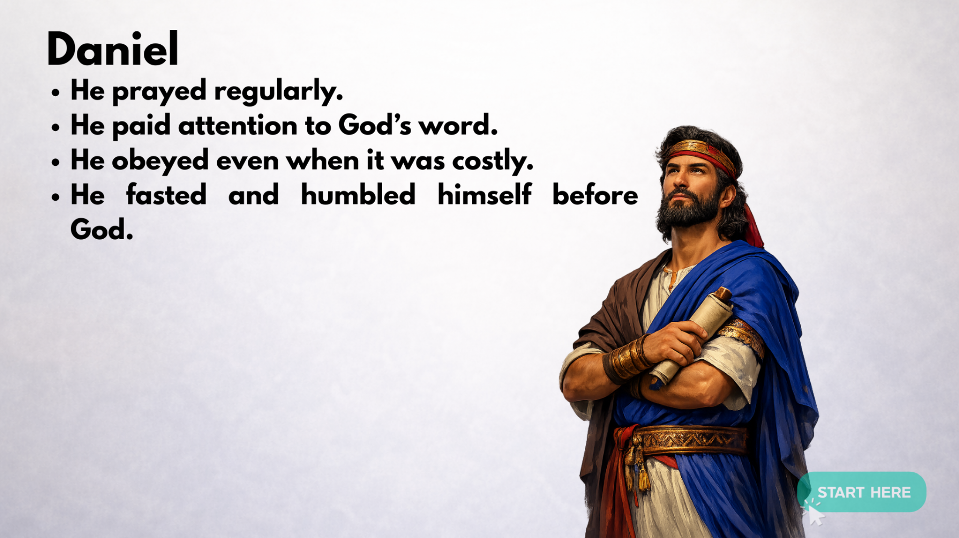

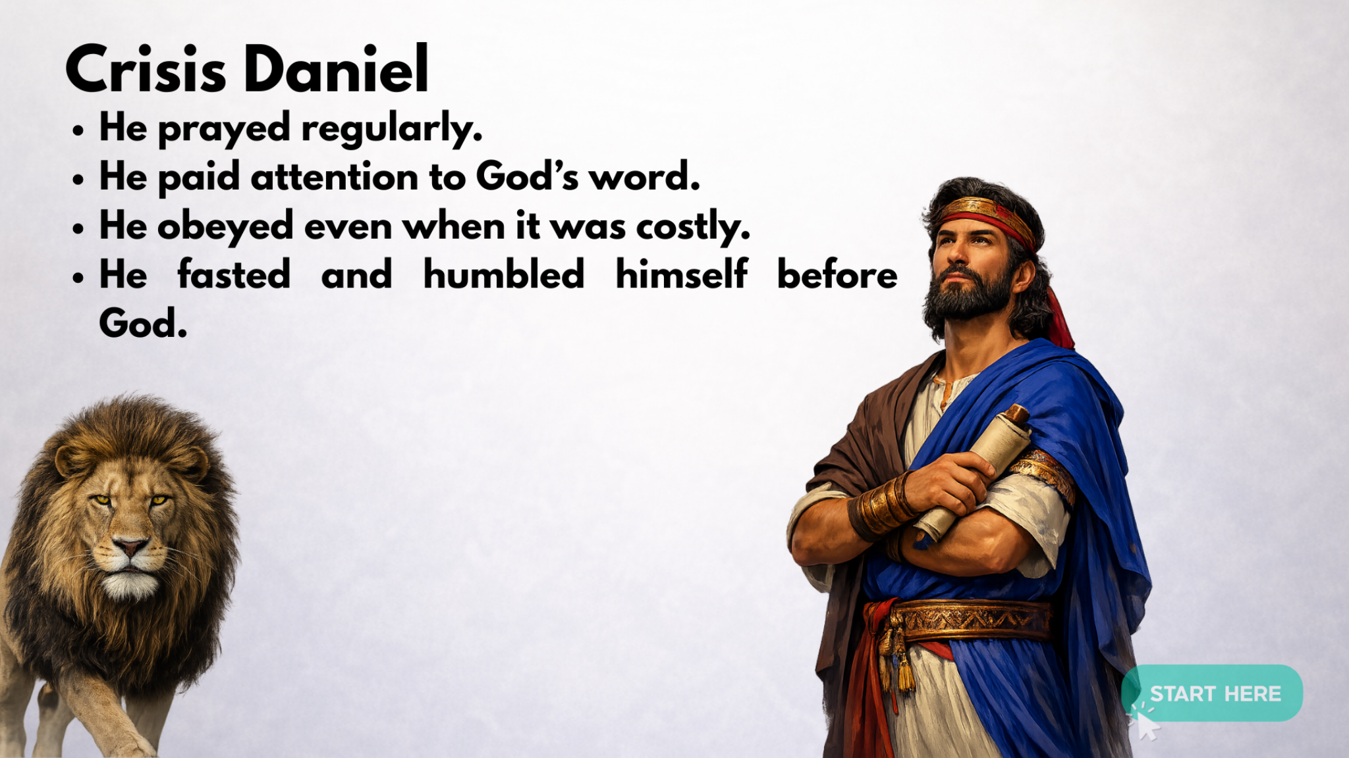

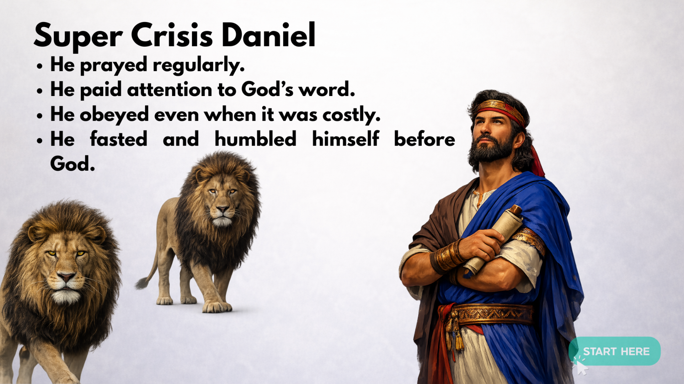

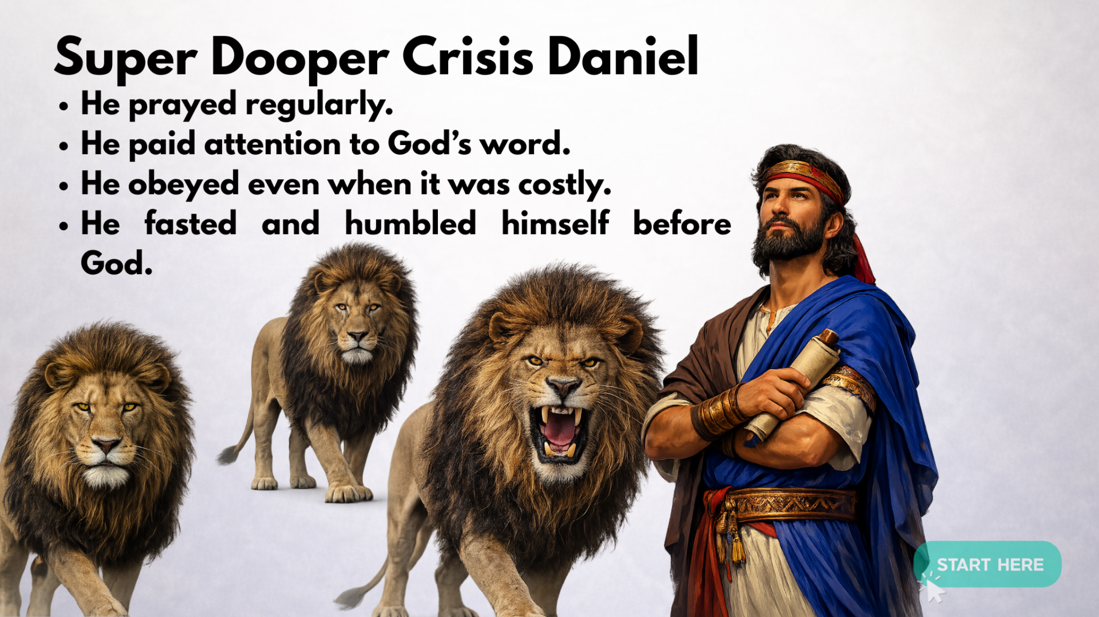

Daniel stayed faithful long before the lions showed up. The lions den did not create his faith. It revealed his alignment.

YOU
Change does not come from trying harder in the moment. It comes from arranging your life around what you love.

PRACTICAL HABIT FRAMEWORK
When I notice ________, I will choose ________, because I want ________. To make this easier, I will change my environment by ________.

US
Right now we choose a new cue, a new craving, a new response. Through prayer and worship, God realigns us.

