Phillips Theological Seminary

WK 3:__TEACHER TALK

Buddhism, Sikhism

3.1 SOME MAIN IDEAS

The Buddhism that has come to us in the West in modern times may not be the Buddhism you encounter in our study this week. We Westerners have adapted this ancient and complex religion to our own tastes and uses.

Besides, as with Hinduism, there isn't just one Buddhism.

The place to start, I think, is to see Buddhism as a reform movement. Like Mahavira, Sidartha Gatauma becomes dissatisfied with Hinduism. He introduces some changes into it.

He rejects the necessity of worshipping gods and goddesses. He rejects the necessity of studying the Vedas for correct understanding. He says you can do those things if you want to, they won't hurt you. It's just that don't really get to the heart of the problem. He redefines the essential human problem differently than Jains or Hindus, so his notion of the solution is different.

For Hindus, the basic problem that keeps us in samsara is ignorance of reality, so we must study the Vedas and do yoga or get help from the gods.

For the Jains, the basic problem is that we are caught in a physical existence that is evil and unspiritual, so we must practice asceticism to break out of this trap.

For the Buddha, the problem is that we have wishes and desires. All pain and suffering come from this, so the solution is to rid ourselves of all desire. Desire means attachment to this world. Any desire feeds this attachment.

A quote from Dhammapada captures this idea: “Let therefore, no man love himself.”

He came to this realization in his famous moment of enlightenment after he had tried all other ways to achieve moksha. This flash of enlightenment becomes the essential and defining mark of Buddhism through all the various changes it undergoes.

So Buddhism teaches a kind of meditation that has as its goal a sudden flash of enlightenment, what becomes known as satori. What is experienced in satori and how is it achieved? This is where different schools of Buddhism differ from one another. As you examine Buddhism, look out for some of these differences.

Because the focus in Buddhism is meditation, it is natural that some practices of yoga are adapted from Hinduism. The purpose of meditation is different, however: it is to set aside rational thought, to achieve a kind of emptiness within which intuition can allow for satori, the flash of enlightenment.

3.2 THE MAIN SACRED PATHS OF BUDDHISM

There appear to be two main branches of Buddhism.

Theravada Buddhism is the more conservative branch. It is also known as Hinayana Buddhism which literally means "small raft." This means that it is more exclusive in what is allowed. It claims to be the purist form of Buddhism, following more closely the teachings of the Buddha. This Buddhism is found in Sri Lanka and the Malaysian peninsula.

Mahayana Buddhism is the more liberal, inclusive branch: "large raft."
It has a broader interpretation of the Buddha's teachings which has allowed it to spread and adapt to other cultures. Consequently, most of the many various forms of Buddhism have developed out of Mahayana Buddhism in China, Mongolia, Korea, Japan, Tibet, and elsewhere. Pay special attention to these developments: the Bodhisattvas and the Buddha Essence.

Within Mahayana Buddhism, there appear to be an amazing variety of approaches, or "schools." Some schools develop definite ideas of a heaven, and along with this comes elements of religion, even though the emphasis is still on meditation and satori. Intuitive Buddhism in China is Ch'an, and this word becomes Zen when it reaches Japan.

Note: Buddhism develops within Hinduism. Many of the same ideas remain. In fact, it is often hard to tell them apart. This is complicated by the fact that once Buddhism got going, Hinduism simply adopted many of its teachings and practices. For many Hindus, the Buddha's model of meditation is the one they use, with some modifications.

Hinduism did the same with Jainism. Some Hindus practice extreme asceticism and ahimsa.

Note that there is another path, the Buddhism that developed in Tibet: Vajrayana, the "Diamond Way."

3.3 LATER BUDDHISM

Thanks to Asoka in the 3rd century BCE, Buddhism spread beyond India. Note the changes and new ideas that occurred in this process: There were "secret teachings" which only a few received. The Buddha was more than a man. There were other Buddhas, even a Buddha Essence. Bodhisavattvas could help others on the path.

These changes allowed Mahayana Buddhism to absorb other religions and philosophies as it moved into other cultures.

After the 3rd century CE, Buddhism became the third major religion in China, alongside Taoism and Confucianism. We face a difficulty of looking at Buddhism in China before we study what happened in China before Buddhism. Briefly, Buddhism shapes Chinese history and culture profoundly, and, Buddhism is shaped in return.

3.4 BUDDHISM IN CHINA

You will recall that Hinduism and Buddhism have a life-denying aspect: the purpose of life is to escape it. But the Chinese have a long history of affirming life. The purpose of life is to live long and be wise. Wisdom comes from studying the order of the universe as it shows up in nature or in the moral urge toward virtue, then emulating this order. For the Chinese, excellence and wisdom are attainable in this life.

Buddhism had to change in order to flourish in China, so it adopted some of the nature focus of the ancient Chinese. In turn, Buddhism influenced the Chinese toward a meditation-style culture. The interchanges between Buddhism and Chinese culture are many.

Look for a few things along the way…
Some Chinese heroes become Bodhisattvas.
Nature becomes a doorway to eternity.
Buddhism develops temples, priests, religious rituals.
Ideas of heaven emerge.
Monasteries of all kinds proliferate in China.

Another aspect of Chinese culture was its prolific animism, with belief in many spirits, both benevolent and harmful. Buddhism absorbed some of this folk religion as well, and took on ideas of spiritual forces that operate at many levels of existence, from below the earth to far above it. This is especially true of the Buddhism that reached Tibet where a strong animism was being practiced.

3.5 BUDDHISM IN TIBET & JAPAN

When Buddhism reaches Tibet, many changes occur.

There is an indigenous religion there call Bon. It has a strong mythology of male-female gods and demons, is animistic, and makes use of a lot of magic. The Buddhism that arrives here takes on many of these elements. One of the most visible is the magical practice of prayer wheels. Paper with prayers or scriptures are placed within the wheels, and as the wheels are turn, the prayers are released: they are prayed.

There is also a wide use of tantras. These are chants and litanies written in a particular script, and they must be spoken correctly by a trained practitioner. When performed correctly, the speech effects and outcome. This is magic.

When Buddhism reaches Japan, more changes are in stock…
Japan changes ... Buddhism changes.

Some things to look for…
Buddhist arts flourish: haiku, pottery, calligraphy, etc.
Buddhist martial arts flourish: samurai code
Buddhist temples adapt to Shinto shrines.
Buddhist rituals become a part of Japanese culture.
We will look at the culture of Japan and it's Shinto religion later.

3.6 SIKHISM

Nanak said “There is no Muslim and there is no Hindu.”

Sikhism is a much more recent religious development in India and Pakistan – an attempt to build a bridge between Hindus and Muslims. I hope you'll pay close attention to the teachings of the Sikhs and their struggle to practice a more tolerant form of faith.

The founders were moved by the conflicts between Islam and Hinduism, and were inspired to create ways for both to live and worship together. They combined elements of both religions in an effort to create peace.

Sikhs move away from the ascetic practices that grew up in Hinduism and Jainism. They affirmed this worldly existence as good, and took on practices of cleanliness as well as communal structures. Their main symbol is the Khanda

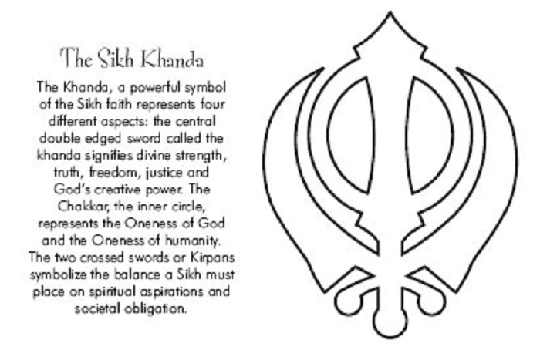

Look for how the Sikhs perceive this world, and what is the basic purpose
of living. Look for the symbols and rituals that represent Sikh teachings and
Perceptions and behavior: icons, clothing and appearance, meals, structures, place of women, relationships with others, place and meaning of culture and society,

The big new word to learn here: syncretism.

There some Sikh temples in the Rogers-Springdale area in Arkansas, and might be worth a visit.

