PURPOSE

This document is to provide a guide on what to check for Audio/Visual tasks.

# | STEP | SCREENSHOTS / OTHER NOTES
1 | Turn on the power strip under the table in the Tech Booth | Order to power up:  - Power strip in Tech Booth under the table  - Mac Mini (computer with ProPresenter)  - Projectors and Stage-facing TV  Applications to start up:  - LightKey – Stage Lights  - ProPresenter  - ATEM software
2 | Turn on the Mac Mini (and monitor if needed)  NOTE: Do NOT open up ProPresenter yet | The button is on the rear, right side of the Mac Mini
3 | Turn on the two projectors (Benq) and the TV that faces the stage
4 | Start LightKey  Double-click on the Redemption Church Project (far left)  Adjust the lights in LightKey by clicking on the top left corner and dragging the cursor to highlight all the lights. You will then be able to control all of them simultaneously with the up/down dimmer in the software.  Once LightKey is configured, turn off the wall lights (next to the door to the Tech Booth)  - Front  - Back  - Media
5 | Start Chrome and open the following tabs:  - Dropbox - Navigate to the following: THIS WEEK / IN SERVICE / (Current Sermon series) - To get to any files that are needed  - *.proBundle for the sermon and/or songs  - Any pictures or videos  - Facebook - Make sure that you have the white tree for the correct page to stream  - ATEM - To stream to Facebook  - Planning Center Online - To get the schedule | 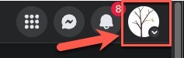
6 | ProPresenter - Build the schedule based on Planning Center Online (PCO) for the songs. You will have to add files such as photos or videos to the media bin (at the bottom of ProPresenter)  If the projector screen does not look right after opening ProPresenter, you may have to power-cycle the HDMI splitter. | 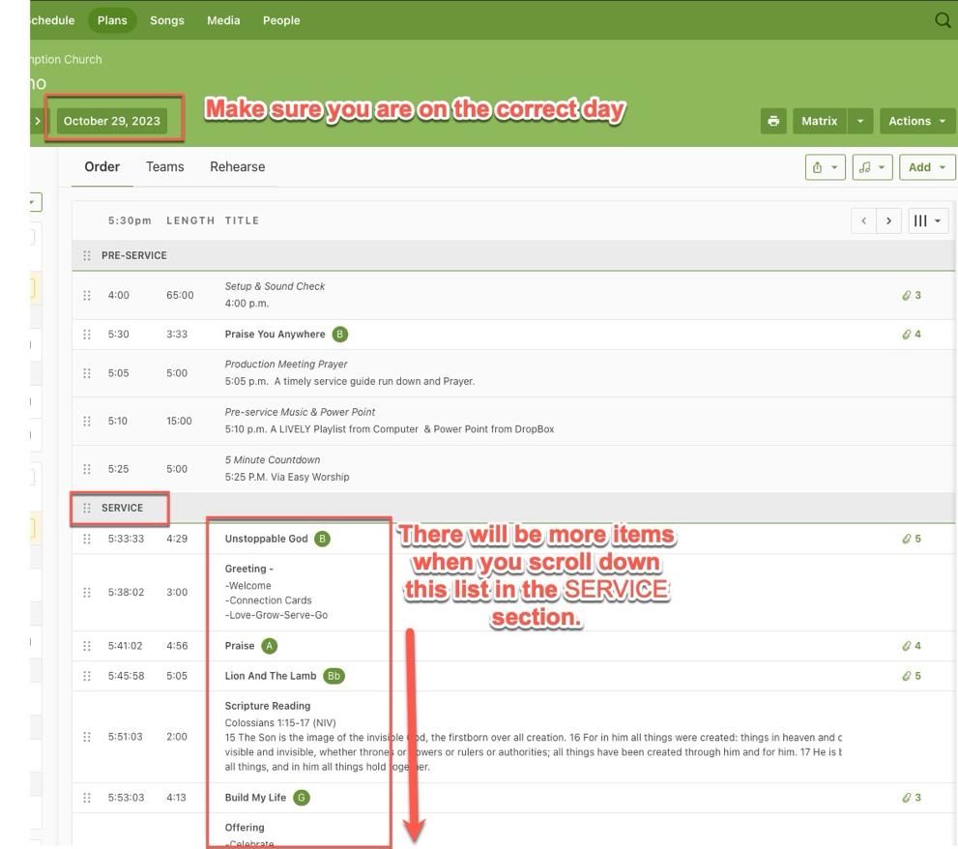  Issues with the display - Do the following:  - Close out ProPresenter  - Unplug the USB B cable (that goes to the Mac Mini) from the HDMI splitter and wait at least 5 to 10 seconds  - Plug in the USB B cable back into the HDMI splitter and wait for it to connect to all the external displays (projectors and stage monitor)  - Start ProPresenter
 | Make sure that the audio cable from the soundboard is plugged into the ATEM and the button is set to 'on'. | See the 'ATEM Setup.docx' for the MIC 1 input.
7 | Set up Facebook  - Create a Live Video by clicking on 'Live video'  - Click on 'Go live'  - Copy the stream key | 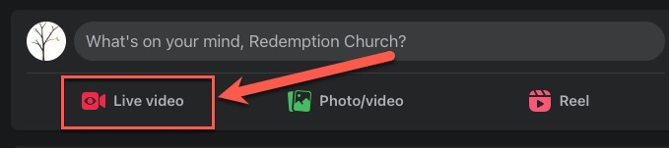  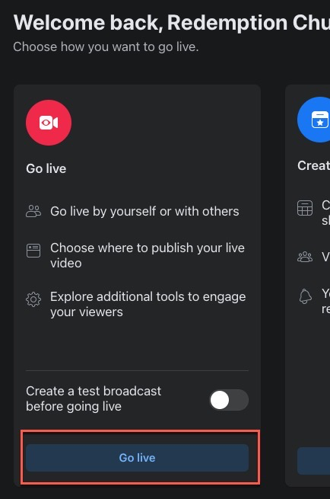  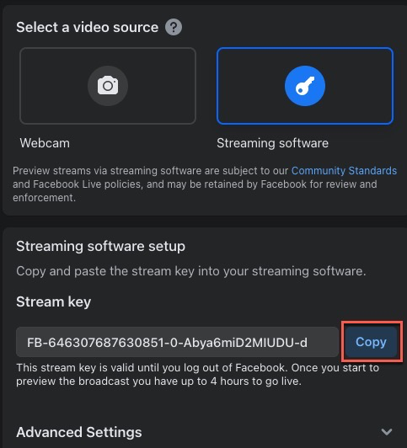
8 | Paste the key into the ATEM software interface  Click on the 'On Air' button  NOTE: For more on the ATEM setup, see the 'ATEM Setup.docx' document. | 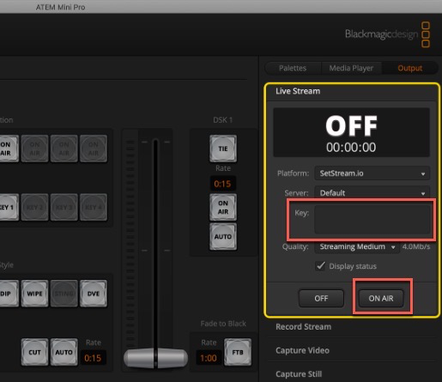
9 | You must add post details to start the stream.  You must enter a Title and Description.  TITLE: Sermon Series (i.e. DeepFake 2 - True Image)  DESCRIPTION: Something inspirational or informative (i.e. Thank you for joining us! Please leave a comment! OR Next Steps coming next week! Thank you for joining us on this Baptism Sunday!) Or you can combine them as long as it is appropriate.  Click 'Save' at the bottom once entering the Title and Description | 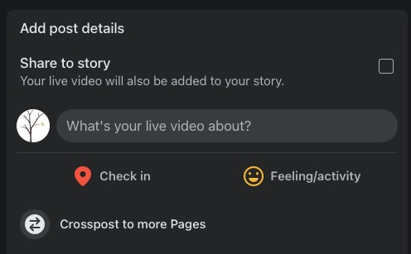  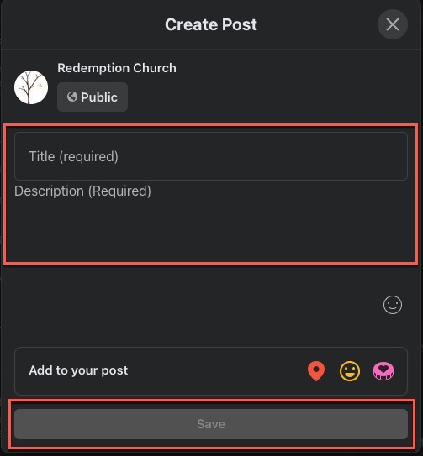
10 | IMPORTANT: You will be streaming to Facebook once you click the 'Go live' button.  At the bottom left corner of the Facebook page, the 'Go live' button will turn red and will be clickable.  Click on it to 'Go live'  You should be streaming to Facebook now.  Check the webpage for sound quality.  https://www.facebook.com/MyRedemption | 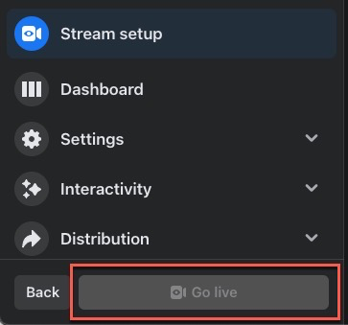
11 | If you are saving to a USB-C flash drive, make sure to click the 'REC' button on the ATEM  Typically you would do this during the Bumper video, before the pastor goes on stage or starts talking to deliver the sermon.  NOTE: the red light will turn green once after about 2 or 3 seconds after pressing the 'REC' button | 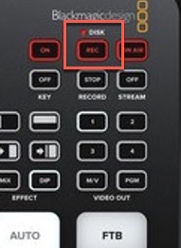
12 | … | …

