Purpose
This document explains how to use a Smartphone as a video camera for ProPresenter.

# | DESCRIPTION | SCREENSHOT
1 | Download EPOCCAM from this link.  Install the software.  This will allow connect your phone to ProPresenter. | 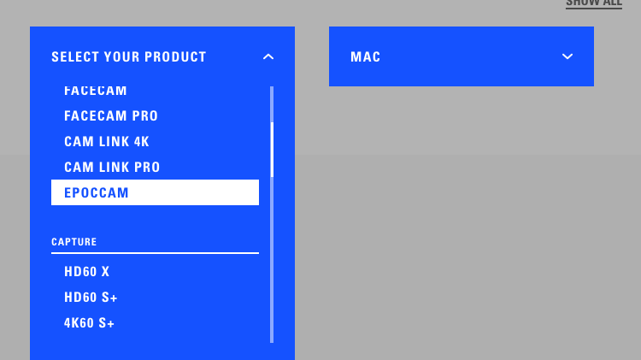
2 | On your Smartphone or Tablet, download EpocCam or EpocCam Pro from the iOS store or Android store | 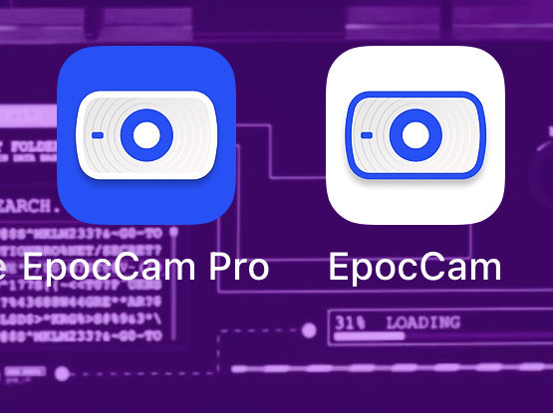
3 | You will need to be on the same WiFi or wired network to connect to ProPresenter
4 | ProPresenter  Go to Video Input > From Video Input > Video Input Configuration… | 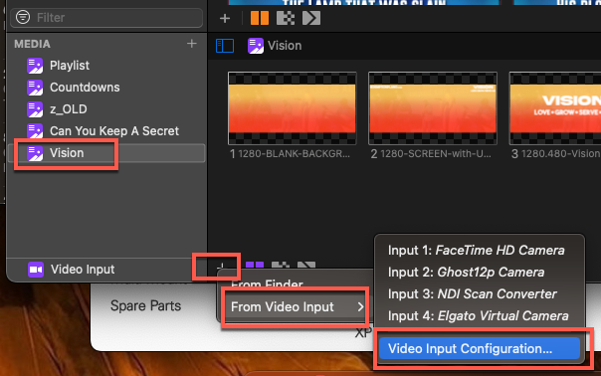
5 | Click the “+” sign next to ‘VIDEO’ to add another video input or use one of the existing video inputs. If this is a first time set up, you can use one of the default 3 video inputs. | 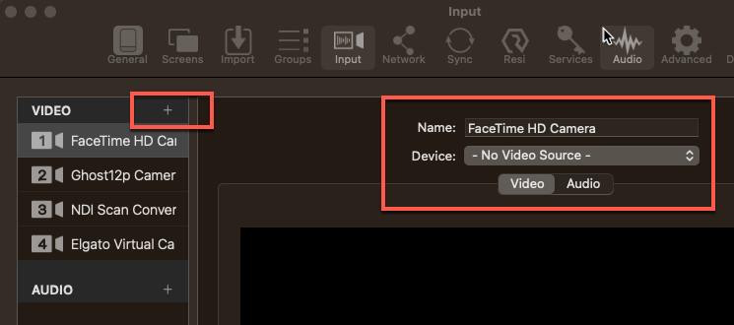
6 | Click on ‘Device’ and choose ‘Elgato Virtual Camera’. | 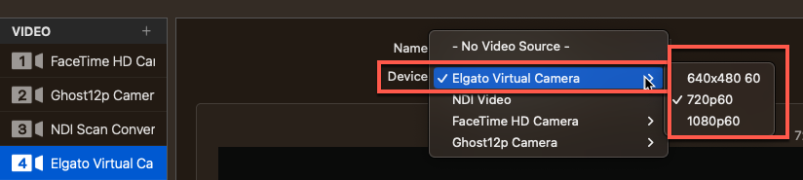
7 | Make sure that the EpocCam or EpocCam Pro app is running on the Smartphone and that it is on the same network as the PC/Mac running ProPresenter.
8 | Run Elgato Camera Hub.  If the app on the Smartphone is NOT on, you will see the message to the right. | 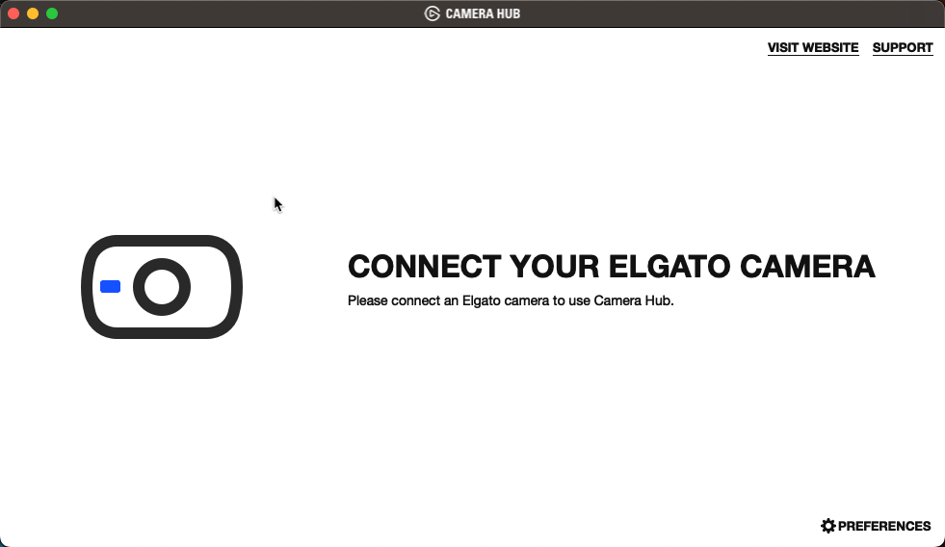
9 | Once you start the app on the smart device, you will see this screen with whatever the forward-facing camera is pointing to.  NOTE: If you are using the FREE version, you will have a watermark on the video and a some of the options will be greyed out. | 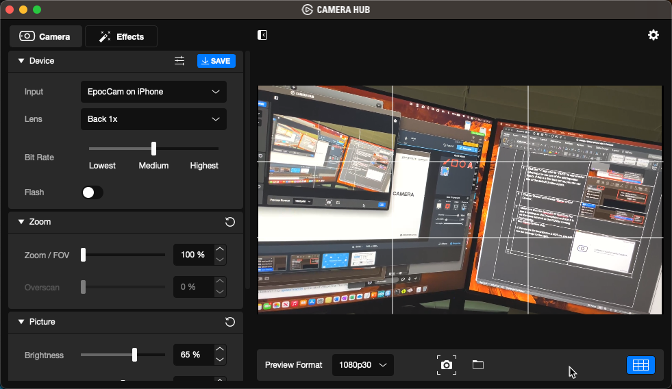
10 | You can now add this stream into a Presentation slide.  Check ‘Fill’  Select ‘Video Input’  Select the Input #  Resize the area for the video input | 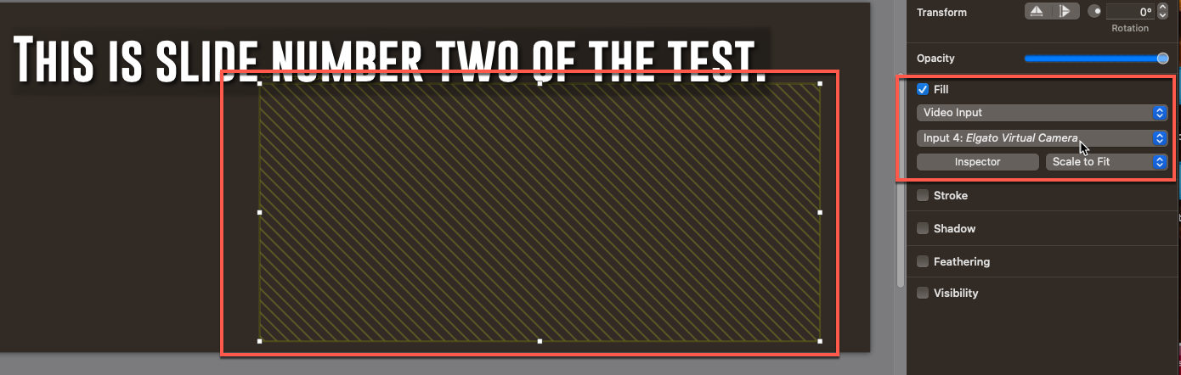
11 | You will see the video output when you go back to ‘Show’
 | RECASTING BACK INTO PROPRESENTER
12 | Make the following connections:  - Connect a 2nd PC/Mac into the ATEM as a camera.  - Connect the USB OUT from the ATEM to the ProPresenter Mac | 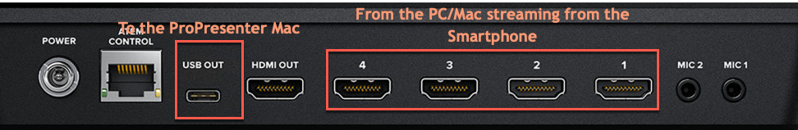  See Visio diagram for more information
13 | After setting up the ATEM, you can:  - Cast from the camera output, into a ProPresenter slide and have that go out as the feed into Facebook Live or other streaming service.  - Cast directly to Facebook, bypassing ProPresenter altogether. | See this link for the diagram.

