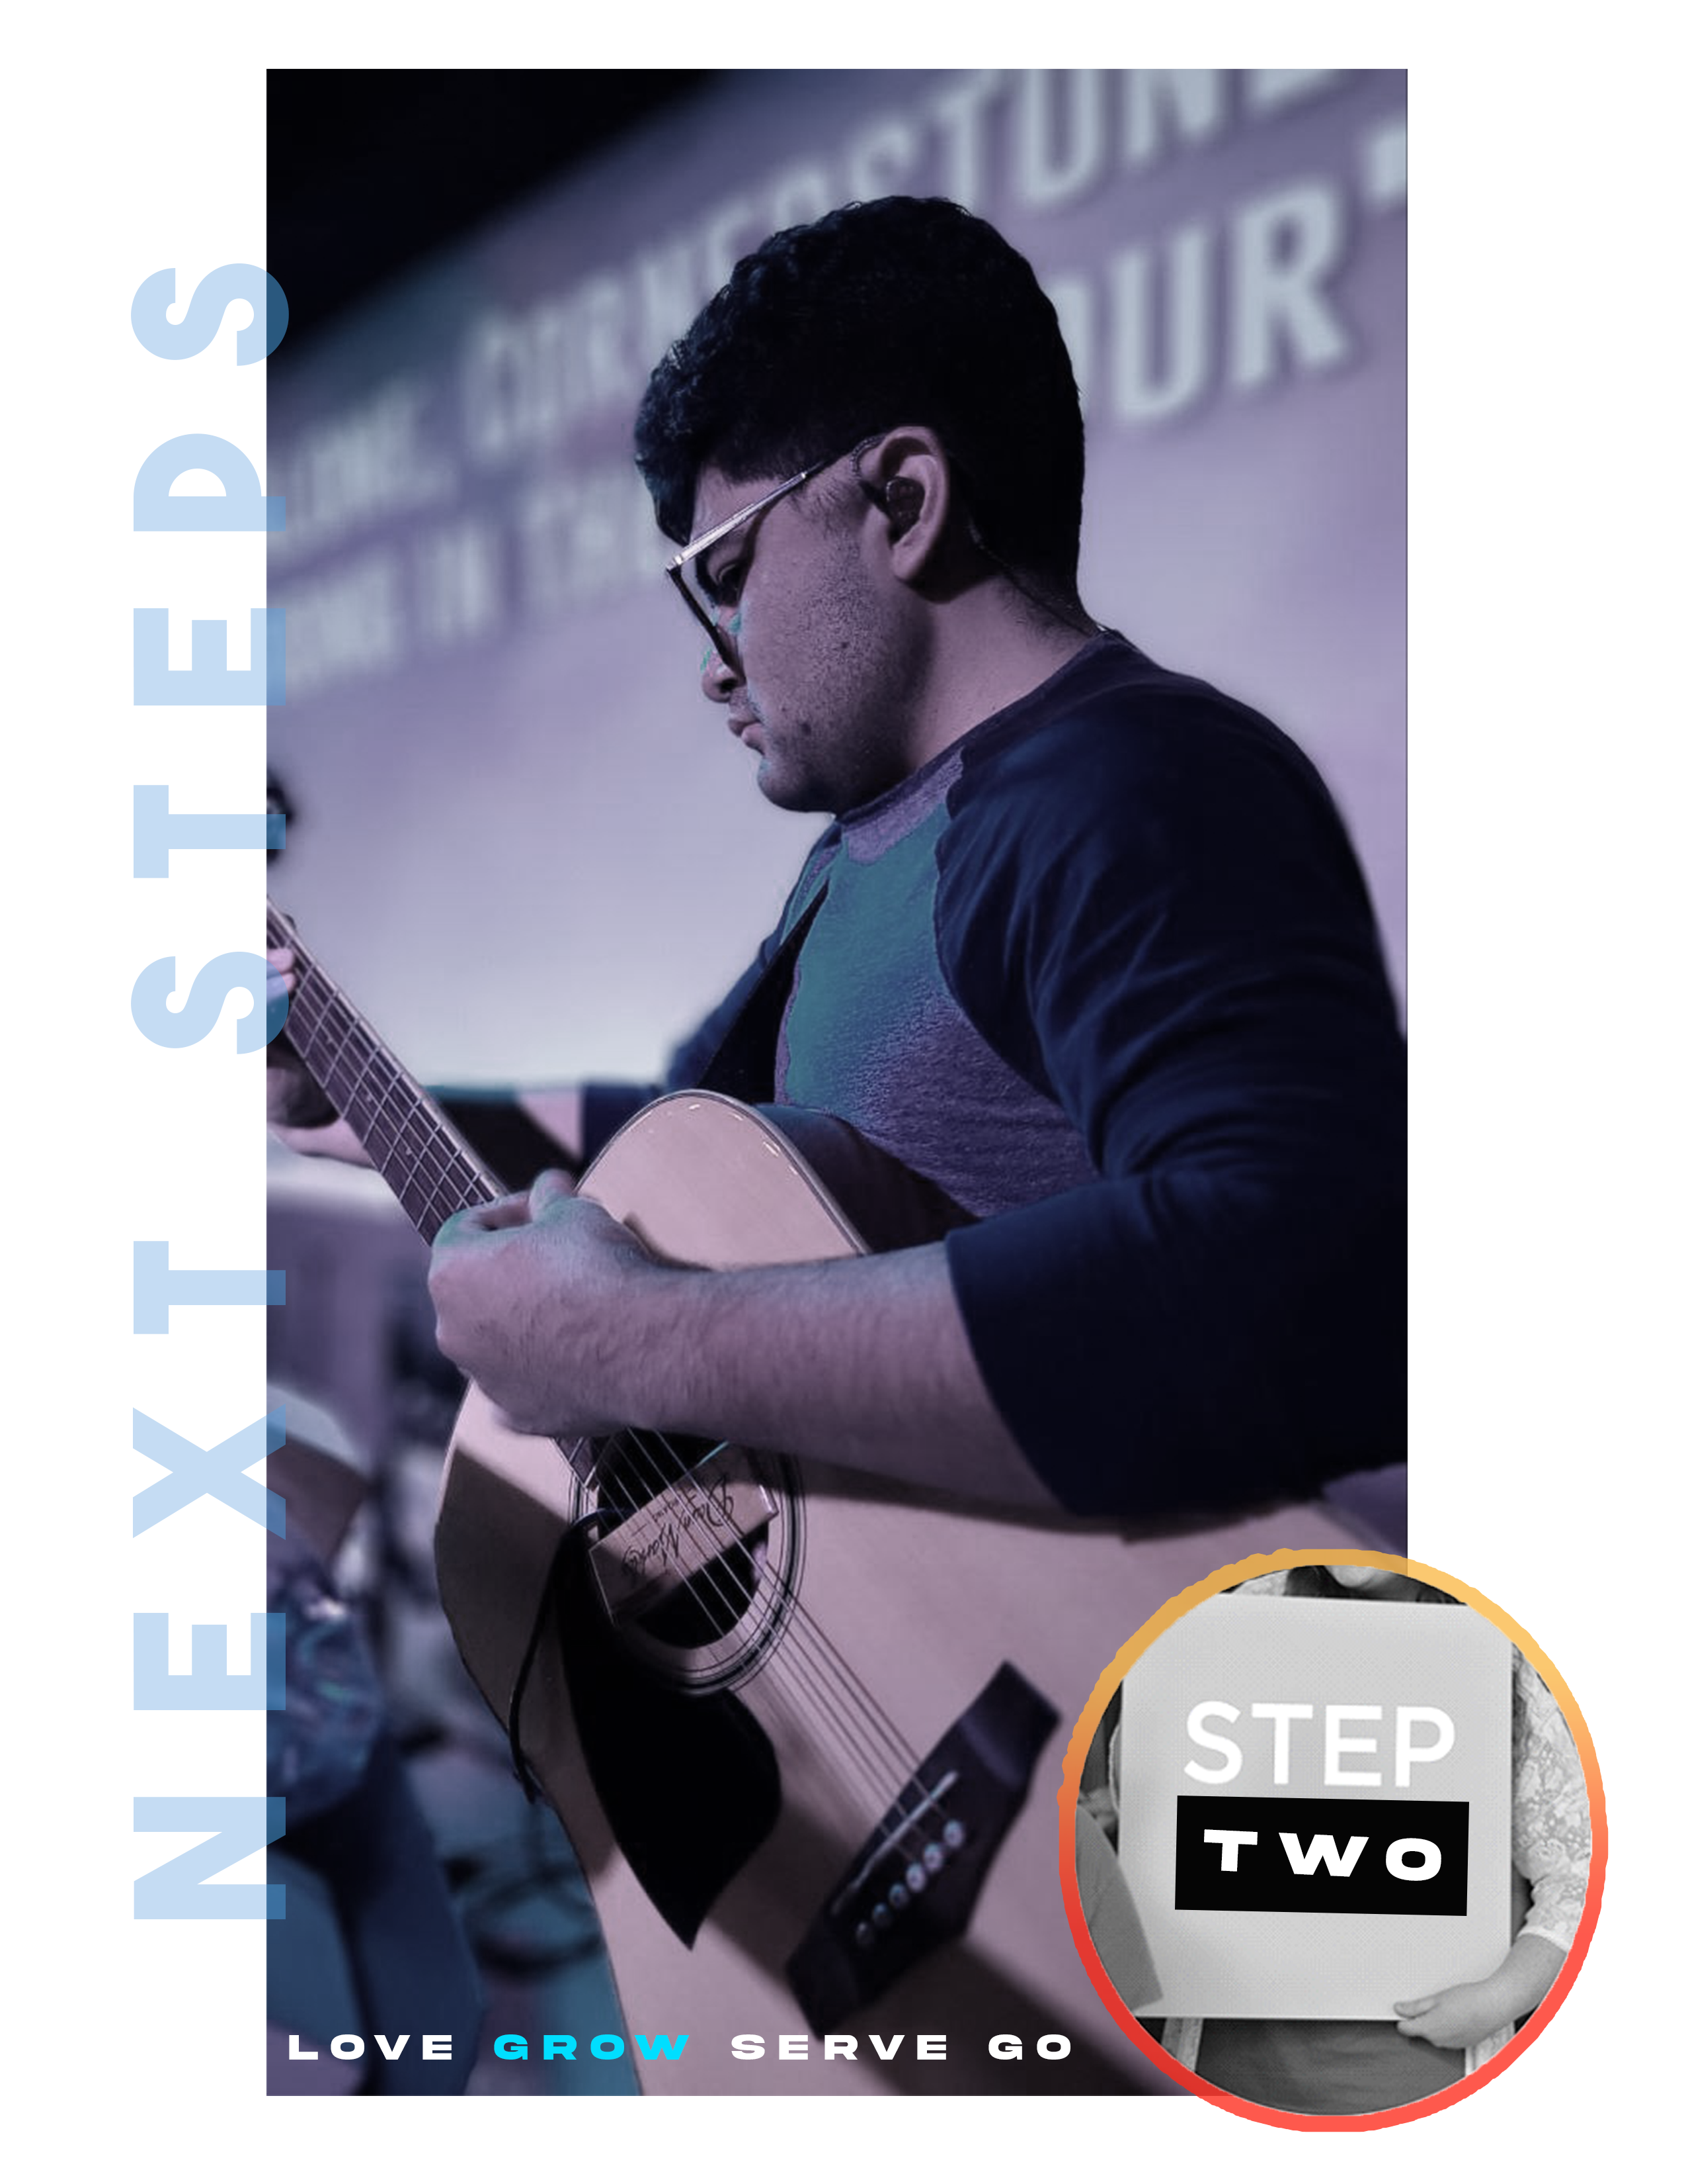

W H O Y O U A R E
stepTWO

OUr Hope for yoU

YOU ARE UNIQUE! Today at STEP TWO, our hope is that you understand how your uniquely designed personality, along with the spiritual gifts God has given you, help reveal the path to God’s plan for your life. Proverbs 25:2 says it is God’s privilege to conceal things and our privilege to discover them. Today, we want to discover what God wants to do through you to make a positive difference in the world.

“For we are His workmanship, created in Christ Jesus for good works, which God prepared beforehand that we should walk in them.” Ephesians 2:10

THE GOAL OF THIS CLASS:
The goal of this class is a two-part understanding of God’s purpose.
First, my goal is to discover how my God-given design helps to reveal my destiny.
Second, I want to discover the amazing potential of my life.

If you can do those two things today, you’ll walk out of here on a road to fulfillment in God’s Kingdom that you never thought possible. Because your design, your destiny, and your potential set you up to do what Jesus did, to love like Jesus loved, and to make a difference as Jesus made a difference.

“Most assuredly, I say to you, he who believes in Me, the works that I do he will do also; and greater works than these he will do, because I go to My Father.” John 14:12

Your gift is something you were designed to do and when you use it these 2 things happen.
First: It is easy for you, because it comes naturally.
Second: It’s fulfilling to you.

We need to know our gift!

WRITE THIS DOWN!
My purpose in life is to serve my God by using my gifts to serve others.

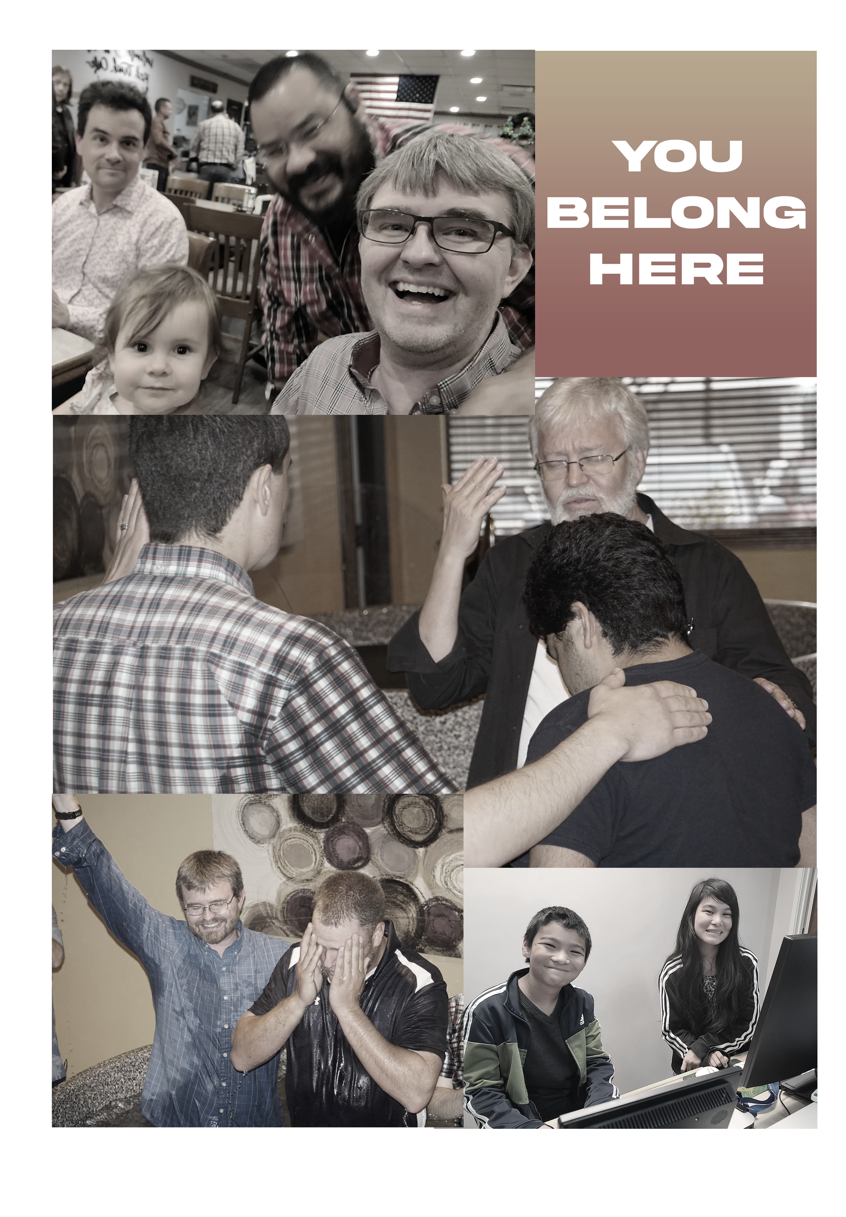

THE PERSONALITY ASSESSMENT

On the following pages, you’ll uncover the truth about the way God made you. Shy, outgoing, loud, quiet…it’s all part of God’s plan to use you to make a difference. As we go through the questions that follow, answer quickly and go with your first response. There is no right answer or wrong answer.

The way God created you unlocks the door to what God wants to do through you!

DISCOVERING YOUR PERSONALITY and leadership

1. Examining Four Personality Types
“D” dominant 3%
“I” influential 11%
“S” steady 69%
“C” compliant 17%

This helps you ascertain your type of personality and leadership style.

2. Elements that Help to Develop Your Personality
There are four things that contribute to the development of your personality.
- Family History – the way you were raised
- Training – the things you’ve been taught
- Mentors – the people who taught you
- Life Experiences – the life you’ve lived

simpleDISCovery My Personality / Leadership Style _____________________

Never Rarely Sometimes Often Always
1 2 3 4 5
1 2 3 4 5
1 2 3 4 5
1 2 3 4 5
1 2 3 4 5

1. Total
I am assertive, demanding, and decisive.
I enjoy doing multiple tasks at once.
I thrive in a challenge-based environment.
I think about tasks above others or myself.
I am motivated by accomplishment and authority.

Never Rarely Sometimes Often Always
1 2 3 4 5
1 2 3 4 5
1 2 3 4 5
1 2 3 4 5
1 2 3 4 5

2. Total
I enjoy influencing and inspiring people.
I am optimistic about others.
I tend to be the life of the party.
I think about motivating people.
I am motivated by recognition and approval.

Never Rarely Sometimes Often Always
1 2 3 4 5
1 2 3 4 5
1 2 3 4 5
1 2 3 4 5
1 2 3 4 5

3. Total
I thrive in consistent environments over changing ones.
I prefer specifics over generalizations.
I enjoy small groups of people.
I prefer being a member of a team over leading the team.
I am motivated by stability and support.

Never Rarely Sometimes Often Always
1 2 3 4 5
1 2 3 4 5
1 2 3 4 5
1 2 3 4 5
1 2 3 4 5

4. Total
I typically do not take big risks.
I love tasks, order and details.
I am right most of the time.
I comply with clearly defined rules.
I am motivated by quality and correctness.
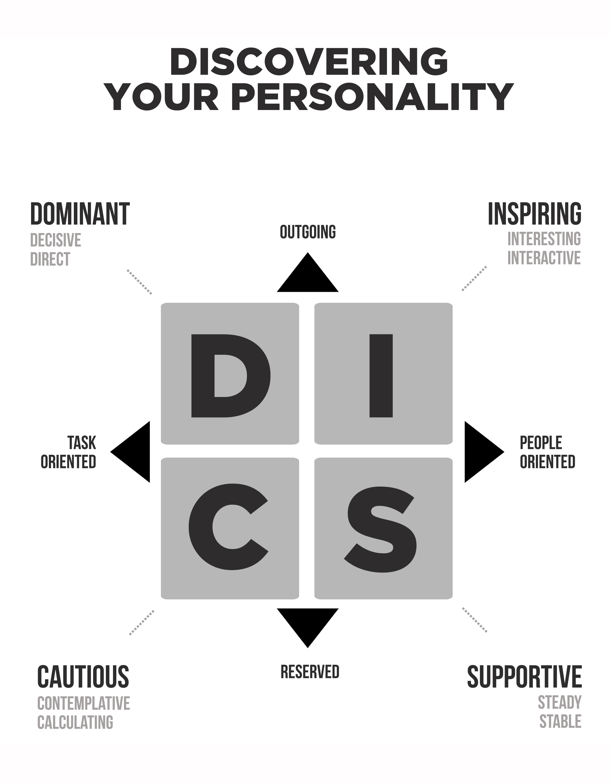

DISCOVERING YOUR PERSONALITY
D
“D”s are direct and decisive; they are risk takers and problem solvers. They are more concerned with completing tasks and winning than they are with gaining approval from people. Though the internal drive tends to make them insensitive to those around them, “D”s are not afraid to challenge the status quo, and they thrive when it comes to developing new things. They need discipline to excel, and they respond to direct confrontation. The greatest fear of a “D” is to be taken advantage of, and even despite their possible weaknesses—which include an aversion to routine, a tendency to overstep authority, an argumentative nature, and a habit of taking on too much—they place a high value on time and use their innovative thinking to accomplish difficult tasks and conquer challenges.
I
“I”s are inspiring and impressive. Enthusiastic, optimistic, impulsive, and emotional—they tend to be creative problem solvers and excellent encouragers. They often have a large number of friends, but they can become more concerned with approval and popularity than with getting results. An “I”s greatest fear is rejection, but they thrive when it comes to motivating others. Their positive sense of humor helps them negotiate conflicts. Though they can be inattentive to details and poor listeners, they can be great peacemakers and effective teammates when they control their feelings and minimize their urge to entertain and be the center of attention. They value lots of human touch and connection.
S
“S”s are steady and more reserved. Because they are stable and predictable, they do not like change, and they thrive in secure, non-threatening environments. They are often friendly and understanding as well as good listeners and loyal workers who are happy doing the same job consistently. With an incredible ability to forgive, reliable and dependable “S”s tend to make the best friends. Their greatest fear, however, is loss of security, and their possible weaknesses naturally include not only resistance to change, but also difficulty adjusting to it. They can also be too sensitive to criticism and unable to establish priorities. In order to avoid be taken advantage of, “S”s need to be stronger and learn how to say “no.” They also like to avoid the limelight, but when given an opportunity to genuinely help others, they will gladly rise to the occasion. They feel most valued when they have truly helped someone.
C
“C”s are compliant and analytical. Careful and logical lines of thinking drive them forward, and accuracy is a top priority. They hold high standards and value systematic approaches to problem solving. Though they thrive when given opportunities to find solutions, they tend to ignore the feelings of others and can often be critical and downright crabby. Verbalizing feelings is difficult for them, but when they are not bogged down in details and have clear-cut boundaries, they can be big assets to the team by providing calculated “reality checks”. The “C”s biggest fear is criticism, and their need for perfectionism is often a weakness, as is their tendency to give in when in the midst of an argument. However, they are thorough in all activities and can bring a conscientious, even-tempered element to the team that will provide solid grounding. They value being correct the most.
D / I
“D/I”s are curious concluders who place emphasis on the bottom line and work hard to reach their goals. They are more determined than they are inspirational, yet their high expectations and standards for themselves and those around them typically causes them to make quite an impact, motivating others to follow them. They have an array of interests and can become distracted by taking on too many projects. They often need to focus, prioritize, and simply slow down. Because “D/I”s thrive on activity and forward motion, they like to accomplish tasks through a large number of people.

Biblical Examples: Joshua (Joshua 1), Noah (Genesis 6-9), Sarah (Genesis 16, 1 Peter 3:6)
I / D
“I/D”s are persuaders who are outgoing and energetic. They enjoy large groups and use their power of influence to attain respect and convince people to follow their lead. Sometimes they can be viewed as fidgety and nervous, but it comes from their need to be a part of challenges that have variety, freedom, and mobility. “I/D”s could benefit from learning to look before they leap and spending more time being studious and still. They make inspiring leaders and know how to get results from and through people.

Biblical Examples: John the Baptist (Luke 3), Peter (Matthew 16 and 26, Acts 3), Rebekah (Genesis 24)
S / D
“S/D”s are quiet leaders who can be counted on to get the job done. They perform better in small groups and do not enjoy speaking in front of crowds. Though they can be soft- and hard-hearted at the same time, they enjoy close relationships with people, being careful not to dominate them. Challenges motivate them, especially ones that allow them to take a systematic approach. Because this personality style tends to be determined, persevering through time and struggles, they benefit from encouragement and positive relationships.

Biblical Examples: Martha (Luke 10:38-42), Job (Job 1:5, James 5:11)

C / D
“C/D”s are cautious and determined designers who are consistently task-oriented and very aware of problems. Sometimes viewed as insensitive, they do care about individual people but have a difficult time showing it. They often feel they are the only ones who can do the job the way it needs to be done, but because of their administrative skills, they are able to bring plans for change and improvements to fruition. “C/D”s have a tendency to be serious and could benefit from being more optimistic and enthusiastic. Despite their natural drive to achieve, they should concentrate on developing healthy relationships and simply loving people.

Biblical Examples: Bezalel (Exodus 35:30-36, 8, 37:1-9), Jochebed (Exodus 1:22-2:4), Jethro (Exodus 2,18)
DISCOVERING YOUR PERSONALITY
D / S
“D/S”s are attainers and achievers with an ability to persevere. They are more active than passive, but they possess a kind of calm sensitivity and steadiness that makes them good leaders. They seem to be people oriented but can easily be dominant and decisive when it comes to tasks and project planning. They strive to accomplish goals with fierce determination that comes from strong internal drive, but they could benefit from contemplative and conservative thinking as well as spending more time focusing on relationships.
Biblical Examples: Daniel (Daniel 1-6), Job (Job 1:5, James 5:11), Martha (Luke 10:38-42)
I / S
“I/S”s are influential counselors who love people, and it’s no surprise that people love them. They live to please and serve, and they tend to be good listeners. Looking good and encouraging others is important to them, as is following through and being obedient. They often lack in the area of organization and can be more concerned with the people involved than they are with the task at hand. However, they can be center stage or behind the scenes with equal effectiveness, and they shine when it comes to influencing and helping others.

Biblical Examples: Barnabas (Acts 4, 9, 11-15), Elisha (1 Kings 19, 2 Kings 2-3), Nicodemus (John 3, 7, 19)
S / I
“S/I”s are inspirational counselors who exhibit warmth and sensitivity. Tolerant and forgiving, they have many friends because they accept and represent others well. Their social nature and desire to be likable and flexible makes them inclined to be overly tolerant and non-confrontational. “S/I”s will benefit from being more task-oriented and paying more attention to detail. Kind and considerate, they include others and inspire them to follow. Words of affirmation go a long way with this personality type, and with the right motivation, they can be excellent team players.
Biblical Examples: Mary Magdalene (Luke 7:36-47), Barnabas (Acts 4, 9, 11-15), Elisha (1 Kings 19, 2 Kings 2-13)
C / I
“C/I”s pay attention to the details. They tend to impress others by doing things right and stabilizing situations. Not considered aggressive
or pushy, they enjoy both large and small crowds. Though they work well with people, they are sometimes too sensitive to what others think about them and their work. They could benefit from being more assertive and self motivated. Often excellent judges of character, they easily trust those who meet their standards. They are moved by genuine and enthusiastic approval as well as concise and logical explanations.

Biblical Examples: Miriam (Exodus 15-21, Numbers 12:1-15), Ezra (Ezra 7, 8)
D / C
“D/C”s are challengers and can either be determined students or defiant critics. Being in charge is important to them, yet they care little about what others think as long as they get the job done. They have a great deal of foresight and examine every avenue to find the best solution; they prefer to work alone. Though they fear failure and the lack of influence, they are motivated by challenges and can often be excellent administrators. They can benefit from learning to relax and paying more attention to people.

Biblical Examples: Malachi (Malachi 4), Nathan (2 Samuel 12:1-13), Nahum (Nahum 1-3)
I / C
“I/C”s are inspiring yet cautious assessors who are excellent communicators through the combination of concerned awareness and appreciation of people. They excel in determining ways to improve production. They tend to be impatient and critical, and they can also be overly persuasive and too consumed by the desire to win. “I/C”s like to work inside the box, and they could benefit from trying new things and caring less about what others think. This personality type often possesses a gift for teaching; they are generally dependable when it comes to paying attention to details and getting the job done.

Biblical Examples: Miriam (Exodus 15-21), Ezra (Ezra 7-8), Shunammite Woman (2 Kings 4:8-37)
S / C
“S/C”s are diplomatic and steady, as well as detail-oriented. Stable and contemplative, they like to weigh the evidence and discover the facts to come to a logical conclusion. More deliberate, they prefer to take their time, especially when the decision involves others. Possible weaknesses include being highly sensitive and unable to handle criticism, and they also need to be aware of the way they treat others. Operating best in precise and cause-worthy projects, the “S/C” can be a peacemaker; this makes them a loyal team member and friend.

Biblical Examples: Moses (Exodus 3, 4, 20, 32), John (John 19:26-27), Eliezer (Genesis 24)
C / S
“C/S”s are systematic and stable. They tend to do one thing at a time—and do it right. Reserved and cautious, they would rather work behind the scenes to stay on track; however, they seldom take risks or try new things and naturally dislike sudden changes in their environments. Precisionists to the letter, they painstakingly require accuracy and fear criticism, which they equate to failure. Diligent workers, their motivation comes from serving others.

Biblical Examples: Esther (Esther 4), Zechariah (Luke 1), Joseph (Matthew 1:1-23)

OPPORTUNITIES FOR PERSONAL GROWTH

If you are a “D” – Dominant, Direct, Task oriented, Decisive, Organized, Outgoing, Outspoken
A. Strive to listen to other people more attentively.
B. Try to be less controlling and domineering.
C. Develop a greater appreciation for the opinions, feelings and desires of others.
D. Put more energy into personal relationships.
E. Show your support for the other team members.

If you are an “I” – Influential, Interested in people, Witty, Easygoing, Outgoing, People oriented
A. Weigh the pros and cons before making a decision; be less impulsive.
B. Remember to help with tasks more.
C. Exercise control over your actions, words and emotions.
D. Focus more on details and facts.
E. Remember to slow down your pace for other people.
F. Talk less; listen more.

If you are an “S” – Steady, Stable, Analytical, People oriented, Introverted
A. Consider how change is healthy. Try to change more willingly.
B. Be more direct in your interactions.
C. Focus on overall goals of your family or group rather than specific procedures.
D. Deal with confrontation constructively.
E. Develop more flexibility.
F. Try to show more initiative.

If you are a “C” – Compliant, Competent, Task oriented, Goal oriented, Introverted
A. Concentrate on doing the right things – not just doing things right.
B. Be less critical of others’ ideas and methods.
C. Respond more quickly to accomplish others’ goals.
D. Strive to build relationships with other people and family members.
E. Be more decisive.
F. Focus less on facts and more on people.
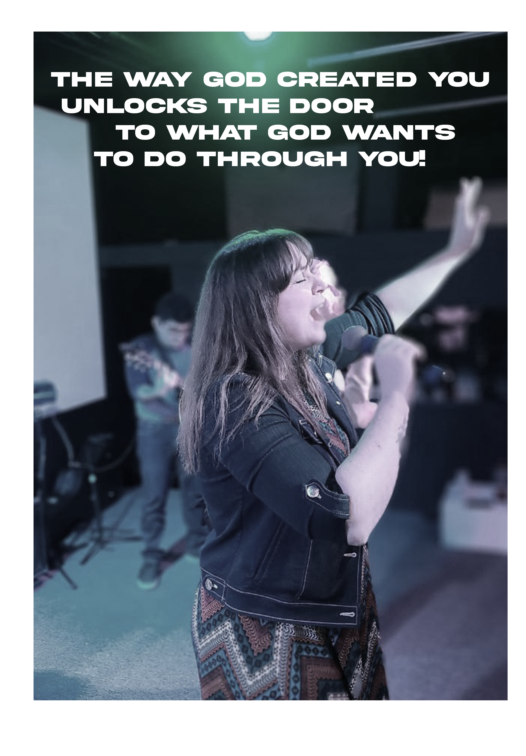

DISCOVERING YOUR SPIRITUAL GIFTS

“Now concerning spiritual gifts, brethren,
I do not want you to be ignorant.”
1 Corinthians 1:21

The second assessment that follows will help you discover your spiritual gifts. And yes, you do have them!
Spiritual gifts are not natural aptitudes, they are not your strengths or abilities, they are not character traits, they aren’t titles or positions you’ve been given. Spiritual gifts are God-given. And they were given to you by God for a purpose. They are “spiritual” gifts because they go far beyond your natural giftings!
As you go through the following test, prayerfully consider the results and what God could be speaking to you.
As in the first assessment, go with your first response. Don’t talk yourself into or out of an answer. The more honest you are, the more accurate your results will be.

SPIRITUAL GIFTS QUESTIONS
1. I like organizing services and events.
2. I enjoy starting new churches.
3. Working with my hands is fun for me.
4. I can tell when someone is not sincere.
5. I pray for lost people daily.
6. Encouraging others is a high priority in my life.
7. Believing God for our daily needs is important to me.
8. Influencing others for the kingdom of God through finances is extremely important to me.
9. I look for opportunities to pray for the sick.
10. I enjoy doing the little things that others do not.
11. Having people over to my house is something I do
often.
12. Spending hours in prayer for other people is very
enjoyable to me.
13. Education is very important to me.
14. I tend to motivate others to get involved.
15. My heart hurts when I see others hurting.
16. I believe God will use me to enact His miracles.
17. I enjoy sharing the gospel with other people groups and nationalities.
18. I’ve devoted considerable time to mastering my voice and or instrument.
19. Caring for the hurting is paramount in my eyes.
20. The willful sin of others really aggravates me.
21. I enjoy serving behind the scenes.
22. I like creating outlines of the Bible.
23. God has used me to interpret a heavenly language.
24. I enjoy the book of Proverbs more than any other book in the Bible.
25. I am passionate about managing details.
26. I prefer to pioneer new ministry projects.
27. I consider myself a craftsman or craftswoman.
28. I sense when situations are spiritually unhealthy.
29. I am greatly concerned about seeing the lost saved.
30. I try to come across loving and caring.
31. Asking God for a list of big things is exciting to me.
32. I find ways to give offerings above my tithe.
33. I believe miraculous healing is for this day and age.
34. Helping others is one of my highest achievements.
35. Creating a warm and welcoming home is important to me.
36. I am burdened to pray for situations in the world.
37. People seek me out to learn more about the Kingdom of God.

38. I prefer to take the lead whenever necessary.
39. I’m very sensitive to sad stories.
40. Miracles often happen when I’m nearby.
41. Living in another country to benefit the gospel is exciting to me.
42. I desire to serve the church through worship.
43. I enjoy connecting, caring for, and coaching others.
44. Confronting someone with sin in their life is not hard.
45. It bothers me when people sit around and do nothing.
46. I share Biblical truth with others in hopes of their personal
growth.
47. I pray in tongues daily.
48. When I study scripture God gives me unique insights.
49. Creating a task list is easy and enjoyable for me.
50. I am attracted to ministries that start new churches.
51. Building something with my hands is very rewarding to me.
52. I can pinpoint issues or problems before others.
53. I enjoy sharing the gospel with a total stranger.
54. I look for ways to be an encouragement to other people.
55. I trust that God has my back in every situation.
56. Making more money means that I can give more.
57. God has used me to bring healing to those who are sick.
58. Being a part of the process is fulfilling to me.
59. I tend to make total strangers feel at home.
60. People often describe me as a prayer warrior.
61. I enjoy knowing biblical details and helping others to understand.
62. I delegate responsibilities to accomplish tasks.
63. I am motivated to help those who are less fortunate.
64. I have a constant hunger to see God’s miraculous power.
65. I focus a lot on reaching the world for Christ.
66. I gain my deepest satisfaction through leading others in vocal or instrumental worship.
67. I enjoy walking with someone in times of difficulty.
68. I enjoy hearing passionate and clear preaching of the truth.
69. I like to do small things that others pass over.
70. I prefer to teach the Bible topically rather than verse by verse.
71. Praying in the Spirit is encouraging and important to me.
72. When faced with difficulty I tend to make wise decisions and choices.
SPIRITUAL GIFTS RATINGS
1 Almost Never
2 Seldom
4 Frequently
3 Sometimes
5 Almost Always

Total Gifts

1._____ 25._____ 49._____ _____ A._________________
2._____ 26._____ 50._____ _____ B._________________
3._____ 27._____ 51._____ _____ C._________________
4._____ 28._____ 52._____ _____ D._________________
5._____ 29._____ 53._____ _____ E._________________
6._____ 30._____ 54._____ _____ F._________________
7._____ 31._____ 55._____ _____ G._________________
8._____ 32._____ 56._____ _____ H._________________
9._____ 33._____ 57._____ _____ I._________________
10._____ 34._____ 58._____ _____ J._________________
11._____ 35._____ 59._____ _____ K._________________
12._____ 36._____ 60._____ _____ L._________________
13._____ 37._____ 61._____ _____ M._________________
14._____ 38._____ 62._____ _____ N._________________
15._____ 39._____ 63._____ _____ O._________________
16._____ 40._____ 64._____ _____ P._________________
17._____ 41._____ 65._____ _____ Q._________________
18._____ 42._____ 66._____ _____ R._________________
19._____ 43._____ 67._____ _____ S._________________
20._____ 44._____ 68._____ _____ T._________________
21._____ 45._____ 69._____ _____ U._________________
22._____ 46._____ 70._____ _____ V._________________ 23._____ 47._____ 71._____ _____ W._________________ 24._____ 48._____ 72._____ _____ X._________________
Gift Definitions and Scripture References

The following contains definitions of the Spiritual gifts. While not meant to be dogmatic or final, these definitions and supporting scriptures do correspond to characteristics of the gifts as expressed in the Gifts Questionnaire.

A. ADMINISTRATION
The gift of administration is the divine strength or ability to organize multiple tasks and groups of people to accomplish these tasks. Luke 14:28-30; Acts 6:1-7; 1 Corinthians 12:28

B. APOSTLESHIP
The gift of apostleship is the divine strength or ability to pioneer new churches and ministries through planting, overseeing, and training. Acts 15:22-35; 1 Corinthians 12:28;
2 Corinthians 12:12; Galatians 2:7-10; Ephesians 4:11-14

C. CRAFTSMANSHIP
The gift of craftsmanship is the divine strength or ability to plan, build, and work with your hands in construction environments to accomplish multiple ministry applications.
Exodus 30:22, 31:3-11; 2 Chronicles 34:9-13; Acts 18:2-3

D. DISCERNMENT
The gift of discernment is the divine strength or ability to spiritually identify falsehood and to distinguish between right and wrong motives and situations.
Matthew 16:21-23; Acts 5:1-11, 16:16-18; 1 Corinthians 12:10; 1 John 4:1-6

E. EVANGELISM
The gift of evangelism is the divine strength or ability to help non-Christians take the necessary steps to becoming a born-again Christian. Acts 8:5-6, 8:26-40, 14:21, 21:8; Ephesians 4:11-14

F. EXHORTATION
The gift of exhortation is the divine strength or ability to encourage others through the written or spoken word and Biblical truth. Acts 14:22; Romans 12:8; 1 Timothy 4:13;
Hebrews 10:24-25

G. FAITH
The gift of faith is the divine strength or ability to believe in God for unseen supernatural results in every arena of life. Acts 11:22-24; Romans 4:18-21; 1 Corinthians 12:9; Hebrews 11

H. GIVING
The gift of giving is the divine strength or ability to produce wealth and to give by tithes and offerings for the purpose of advancing the Kingdom of God on earth. Mark 12:41-44; Romans 12:8; 2 Corinthians 8:1-7, 9:2-7
I. HEALING
The gift of healing is the divine strength or ability to act as an intermediary in faith, prayer, and by the laying-on of hands for the healing of physical and mental illnesses.
Acts 3:1-10, 9:32-35, 28:7-10; 1 Corinthians 12:9, 28

J. HELPS
The gift of helps is the divine strength or ability to work in a supportive role for the accomplishment of tasks in Christian ministry. Mark 15:40-41; Acts 9:36; Romans 16:1-2; 1 Corinthians 12:28

K. HOSPITALITY
The gift of hospitality is the divine strength or ability to create warm, welcoming environments for others in places such as your home, office, or church. Acts 16:14-15; Romans 12:13, 16:23; Hebrews 13:1-2; 1 Peter 4:9

L. INTERCESSION
The gift of intercession is the divine strength or ability to stand in the gap in prayer for someone, something, or someplace, believing for profound results. Hebrews 7:25; Colossians 1:9-12, 4:12-13; James 5:14-16

M. KNOWLEDGE
The gift of knowledge is the divine strength or ability to understand and to bring clarity to situations and circumstances often accompanied by a word from God. Acts 5:1-11;
1 Corinthians 12:8; Colossians 2:2-3

N. LEADERSHIP
The gift of leadership is the divine strength or ability to influence people at their level while directing and focusing them on the big picture, vision, or idea. Romans 12:8;
1 Timothy 3:1-13, 5:17; Hebrews 13:17

O. MERCY
The gift of mercy is the divine strength or ability to feel empathy and to care for those who are hurting in any way. Matthew 9:35-36; Mark 9:41; Romans 12:8; 1 Thessalonians 5:14

P. MIRACLES
The gift of miracles is the divine strength or ability to alter the natural outcomes of life in a supernatural way through prayer, faith, and divine direction.
Acts 9:36-42, 19:11-12, 20:7-12; Romans 15:18-19; 1 Corinthians 12:10, 28

Q. MISSIONARY
The gift of missions is the divine strength or ability to reach others outside of your culture and nationality, while in most cases living in that culture or nation. Acts 8:4, 13:2-3, 22:21; Romans 10:15

R. MUSIC / WORSHIP
The gift of music/worship is the divine strength or ability to sing, dance, or play an instrument primarily for the purpose of helping others worship God.
Deuteronomy 31:22; 1 Samuel 16:16; 1 Chronicles 16:41-42; 2 Chronicles 5:12-13, 34:12; Psalm 150

S. PASTOR / SHEPHERD
The gift of pastor/shepherd is the divine strength or ability to care for the personal needs of others by nurturing and mending life issues. John 10:1-18; Ephesians 4:11-14; 1 Timothy 3:1-7;
1 Peter 5:1-3

T. PROPHECY
The gift of prophecy is the divine strength or ability to boldly speak and bring clarity to scriptural and doctrinal truth, in some cases foretelling God’s plan. Acts 2:37-40, 7:51-53, 26:24-29; 1 Corinthians 14:1-4; 1 Thessalonians 1:5

U. SERVICE
The gift of serving is the divine strength or ability to do small or great tasks in working for the overall good of the body of Christ. Acts 6:1-7; Romans 12:7; Galatians 6:10; 1 Timothy 1:16-18; Titus 3:14

V. TEACHING
The gift of teaching is the divine strength or ability to study and learn from the Scriptures primarily to bring understanding and depth to other Christians. Acts 18:24-28, 20:20-21; 1 Corinthians 12:28; Ephesians 4:11-14

W. TONGUES (and Interpretation)
The gift of tongues is the divine strength or ability to pray in a heavenly language to encourage your spirit and to commune with God. The gift of tongues is often accompanied by interpretation and should be used appropriately.
Acts 2:1-13; 1 Corinthians 12:10, 14:1-14

X. WISDOM
The gift of wisdom is the divine strength or ability to apply the truths of Scripture in a practical way, producing the fruitful outcome and character of Jesus Christ. Acts 6:3,10; 1 Corinthians 2:6-13, 12:8

PUTTING IT ALL TOGEtHER

“Therefore we also, since we are surrounded by so great a cloud of witnesses, let us lay aside every weight, and the sin which so easily ensnares us, and let us run with endurance the race that is set before us, looking unto Jesus, the author and finisher of our faith.”
Hebrews 12:1-2

- Think about the results. Does this make some things make sense? Does this give you a better insight to your strengths and weaknesses?
- Consider the opportunities. Does this clarify some ways and places you can make a difference?
- Find ways to grow. Join the Dream Team and serve in an area where your gifting is an asset. Join a small group where you can learn more and grow in your gifting!

Evaluation Sheet

Name:_______________________________

What is my personality type and leadership style? (DISC)

________________________________________ (People or Tasks, Reserved or Outgoing)

What are two primary spiritual gifts or natural abilities I have?

1._______________________________ 2. ______________________________

What two areas am I experienced in and/or most passionate about?

1._______________________________ 2. ______________________________

Based on the answers, with what type of team or small group could I connect?

_________________________________________________________________________

Circle your answer:
I believe God has gifted and called me to do great things.

Yes No Still unsure

For your reference, we’ve included a list of teams you can get involved in upon completion of Next Steps.

A-Team (Administration): This team utilizes their gifts of administration and organization to assist with the administrative needs of Redemption Church. They also work alongside Dream Team leaders to seamlessly transition new Dream Team members into serving.

Altar Team: This team meets and prays with people who come near the stage for prayer and are committed to prayer during the week.

Community Outreach: This team is involved in countless ministries with a focus on bringing God’s love to our communities and world.

Creative Arts: This team is always dreaming of a way to make the gospel visual and captivating. Graphic design, acting, videography, live art performance… the opportunities are endless.

Greeters: This friendly team loves people and makes them feel at home here at Redemption Church. They welcome guests with a smile, encouragement and personal touch so that hearts are open to the Gospel message.

Host: This friendly team ensures guest have a great experience from the moment they enter the Sanctuary. Hosts welcome guests and members, distribute announcement cards and assist people in finding their seats.

Communications Team: This team connects guests to the Church community, providing resources and information on all of our current events, ministry opportunities and services at Redemption Church.

Kids Check-in: This team welcomes families as they arrive at our Redemption Church Kids areas and facilitates the check-in process that ensures children are cared for effectively and efficiently.

Next Steps Team: As the official hosts of our Growth Track, this team greets guests as well as provides materials and assistance throughout our four classes.

Online Team: This team helps us minister to those who attend Redemption Church online, and maintain a healthy web & social media presence.

Prayer Chair Team: This team serves behind the scenes to prepare the sanctuary by straightening and praying for each chair prior to services.

Small Group Leadership: We believe that real life change takes place in the context of relationships. As a Small Group Leader, you have the greatest opportunity to connect with others, fulfill your passions, develop your gifts and live out the Great Commission.

Student Ministry: Join a team that is focused on the next generation. Help us host student small groups, activities, and worship.

Technical Production: Bring your creativity and tech savvy to this team that reaches thousands by delivering the Word and worship through audio engineering, camera, lighting, web streaming, and other visual elements.

Treehouse Kids: This team leads children into a real relationship with Jesus through Bible stories, worship, prayer, hands-on activities, and personal interactions for the elementary to nursery age children.

Ushers: Help prepare people for a positive worship experience by welcoming and assisting them to a seat, facilitating the offering and maintaining a distraction-free environment.

Worship Arts: Through vocals, instruments, or audio engineering, this dynamic team prepares the way for our guests to encounter the presence of the living God.

studyMORE

Gifts

Romans 12:6-8 6
Having gifts that differ according to the grace given to us, let us use them: if prophecy, in proportion to our faith; 7 if service, in our serving; the one who teaches, in his teaching; 8 the one who exhorts, in his exhortation; the one who contributes, in generosity; the one who leads,6 with zeal; the one who does acts of mercy, with cheerfulness.

Prophecy, teaching, exhortation, generosity, leadership, mercy

1 Corinthians 12:4-11
4 Now there are varieties of gifts, but the same Spirit; 5 and there are varieties of service, but the same Lord; 6 and there are varieties of activities, but it is the same God who empowers them all in everyone. 7 To each is given the manifestation of the Spirit for the common good. 8 For to one is given through the Spirit the utterance of wisdom, and to another the utterance of knowledge according to the same Spirit, 9 to another faith by the same Spirit, to another gifts of healing by the one Spirit, 10 to another the working of miracles, to another prophecy, to another the ability to distinguish between spirits, to another various kinds of tongues, to another the interpretation of tongues. 11 All these are empowered by one and the same Spirit, who apportions to each one individually has he wills.

Wisdom, knowledge, faith, healing, miracles, prophecy, discernment, tongues, interpretation,
1 Corinthians 12:28-30
28 And God has appointed in the church first apostles, second prophets, third teachers, then miracles, then gifts of healing, helping, administrating, and various kinds of tongues. 29 Are all apostles? Are all prophets? Are all teachers? Do all work miracles? 30 Do all possess gifts of healing? Do all speak with tongues? Do all interpret? 31 But earnestly desire the higher gifts.

Apostles, prophets, teachers, miracles, healing, tongues, interpretation

Ephesians 4:11-12
11 And he gave the apostles, the prophets, the evangelists, the shepherds and teachers, 12 to equip the saints for the work of ministry, for building up the body of Christ,

5 fold ministry: Apostle, prophet, evangelist, pastor/shepherd, teacher

Steps for PERSONALITY ASSESSMENT

How to take the simpleDISCovery Personality Assessment:

Step 1: Answer each question in boxes 1-4 honestly by circling the number that best describes you. Allow yourself 2-1/2 minutes to complete this step.

Step 2: Add the total of circled numbers in box 1 and write the number on the total line. Do the same in box 2, 3, and 4.

Step 3: Identify the box with the highest totaled number and the second highest totaled number which will specify your dominant personality traits. Box 1= the “D” personality.
Box 2= the “I” personality. Box 3= the “S” personality. Box 4= the “C” personality. Write your dominant personality traits sequence in the top right hand corner (DI, ID, SC, CD and so on).

Step 4: Read the description of your dominant personality trait (D, I, S, C) and the description of your two highest personality traits together (DI, ID, SC, CD and so on).

How to take the simpleGIFTS assessment:

Step 1: Answer the Spiritual gifts questions honestly with the corresponding number
1 almost never – 2 seldom – 3 sometimes – 4 frequently – 5 almost always. Allow yourself six minutes to answer all questions.

Step 2: Add each line left to right and place the totaled number in the total column.

Step 3: Identify your highest totaled number with the corresponding letter and the spiritual gift it represents.

Step 4: Read & Pray about your gifts.

