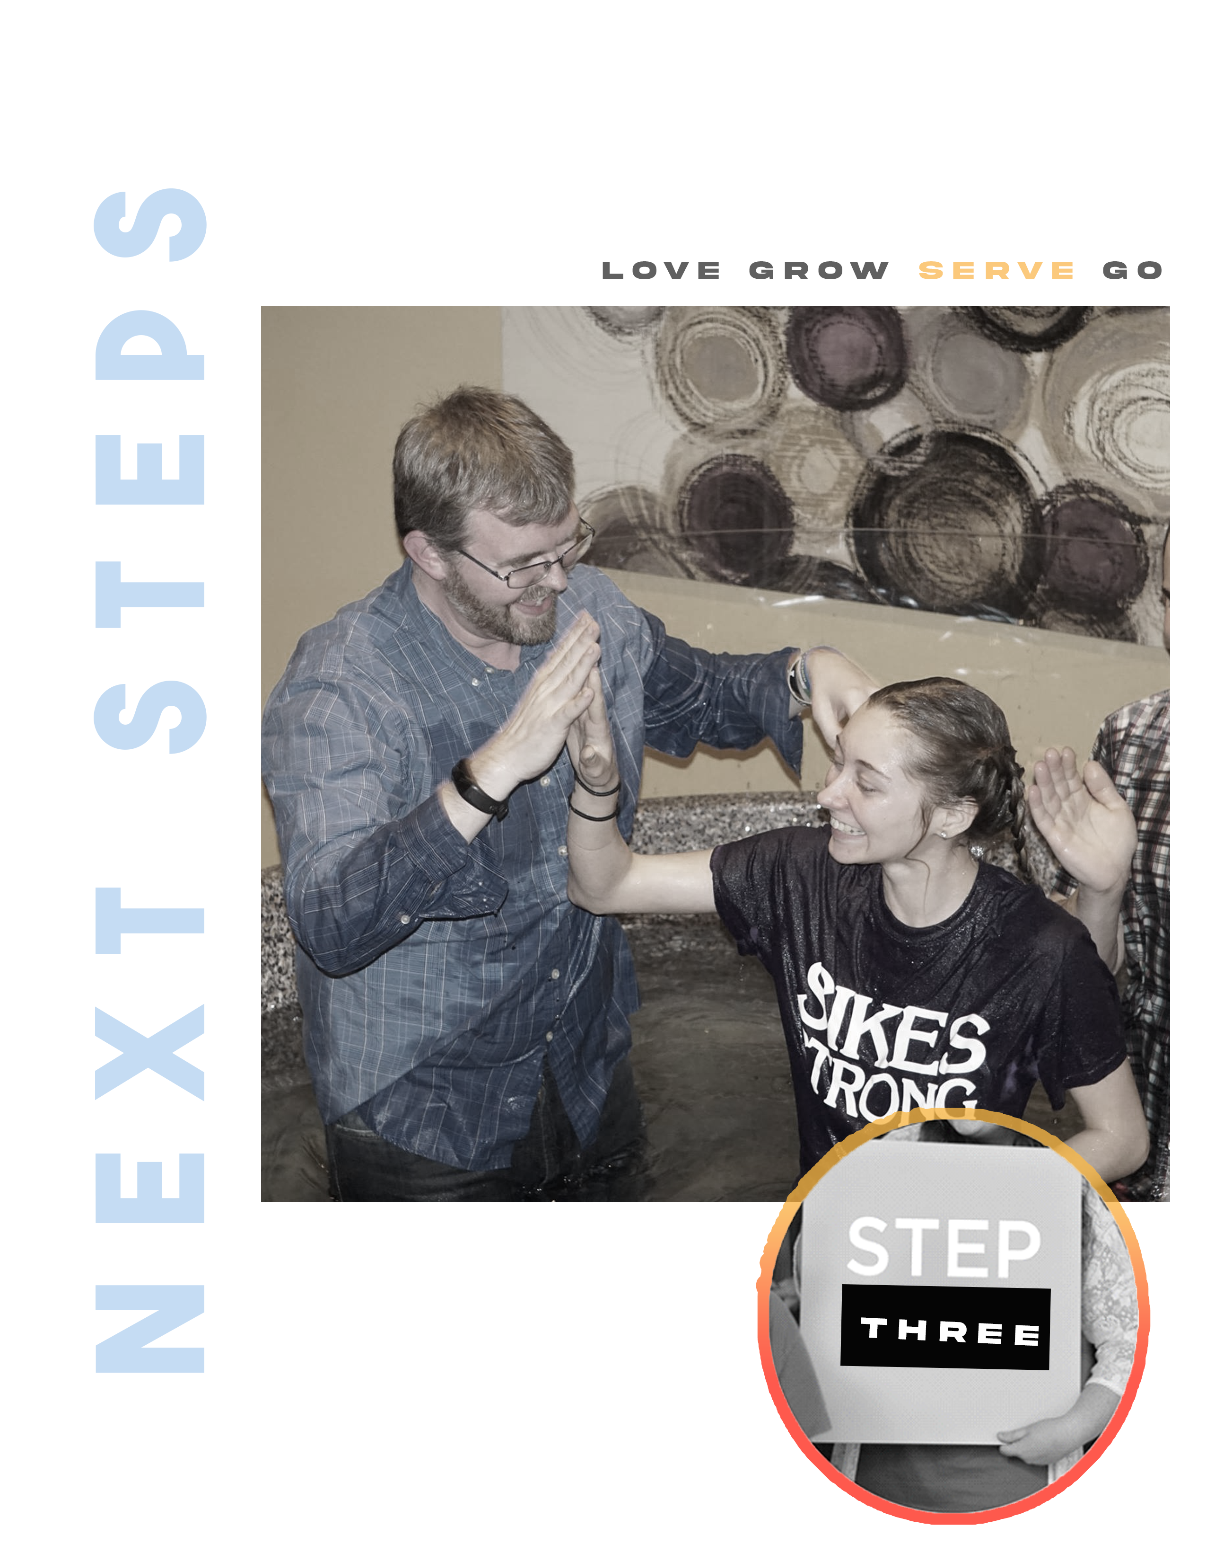

W H Y Y O U ‘ L L L O V E I T H E R E

stepTHREE

WHERE TWO OR THREE GATHER IN MY NAME,
I AM THERE WITH THEM.

MATTHEW 18:20

OUR HOPE FOR YOU

The purpose of today is to get down into the details of what makes us different from other churches. God has given this church a unique vision, and we want to show you how you can be a part of that. We want to share with you our focus as a church, what we value, and a few principles that will help us step fearlessly into the purpose that God has for our lives.

“Let there be _______ ___________ among you so there won’t be any splits in the church. I plead with you to be of one mind, united in ___________ and _____________.”
1 Corinthians 1:10 (LB)

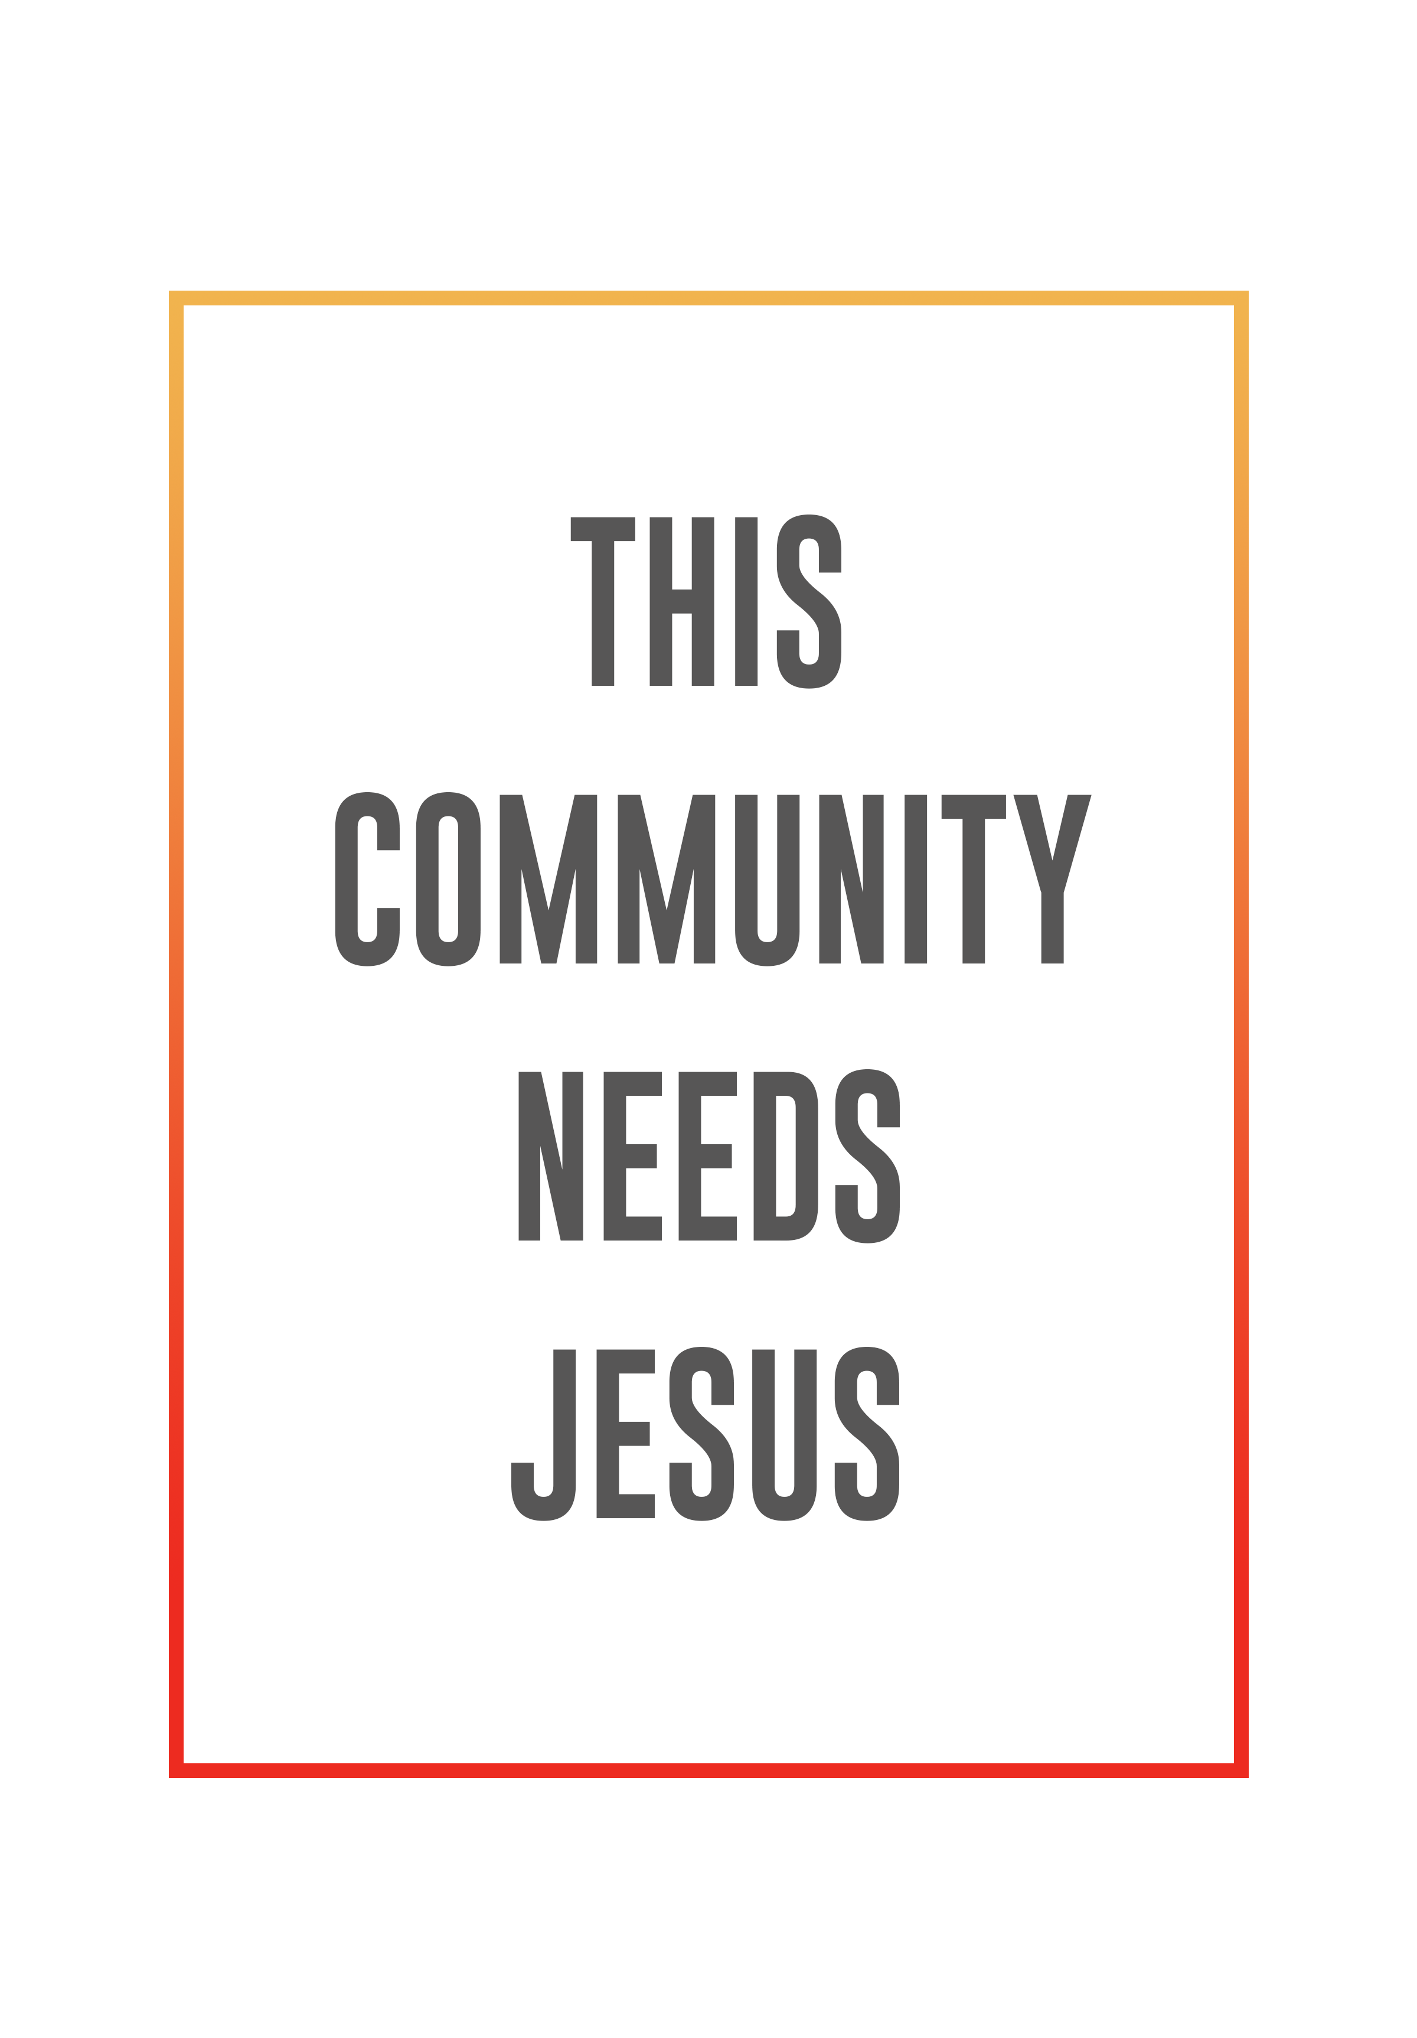
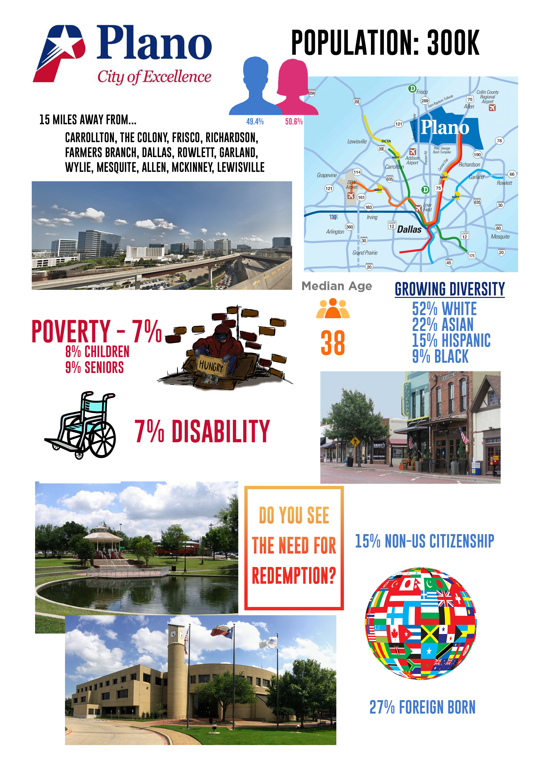
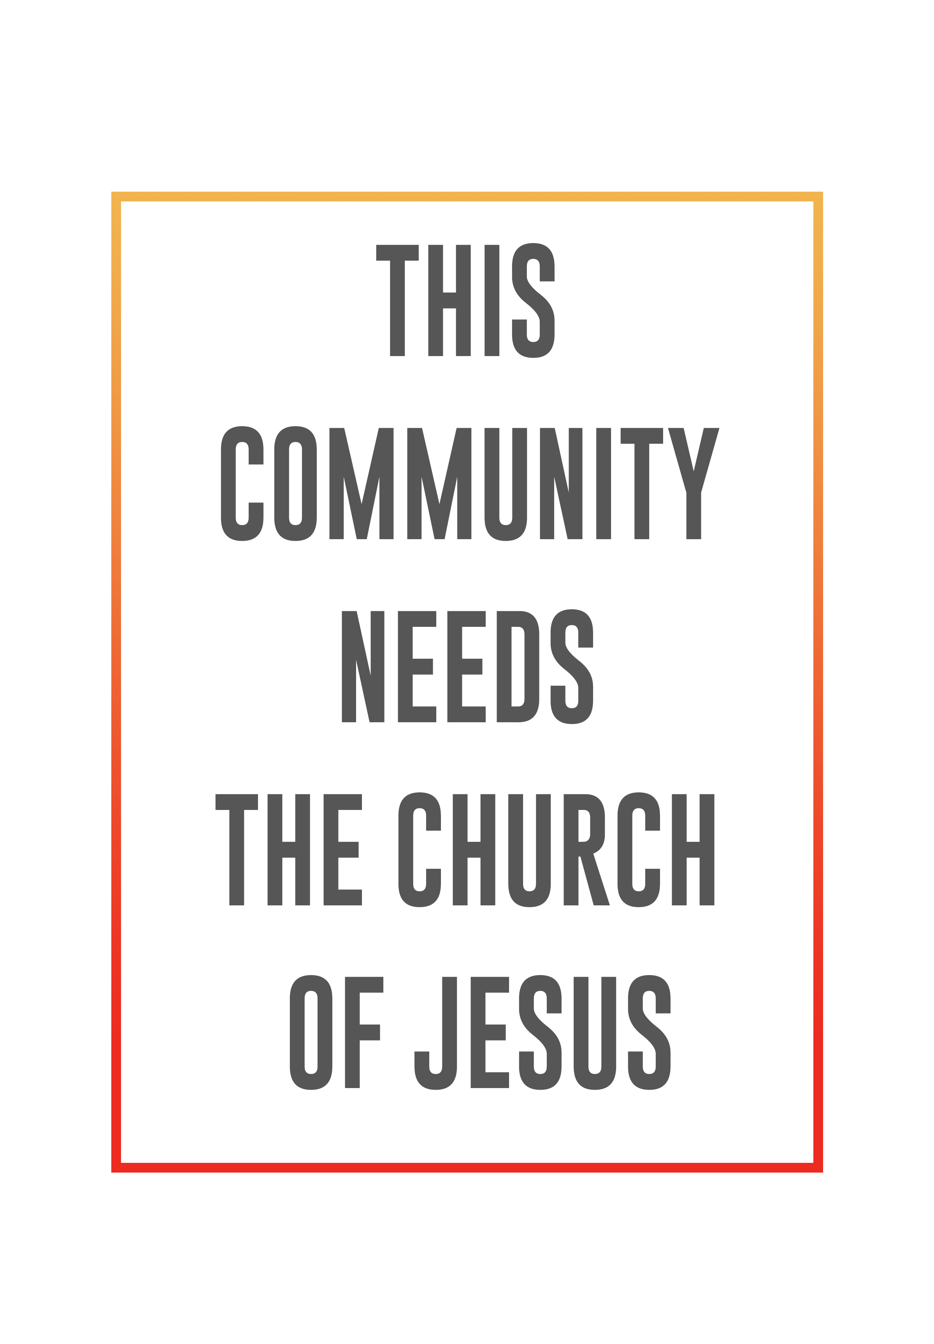

THE SEVEN VALUES:

1. ___________________ _____________________ CHURCH.

And if the Spirit of him who raised Jesus from the dead is living in you, he who raised Christ from the dead will also give life to your mortal bodies because of his Spirit who lives in you. Romans 8:11

“The grace of the Lord Jesus Christ, and the love of God, and the fellowship of the Holy Spirit be with you all.” 2 Corinthians 13:14

WHAT IS THE HOLY SPIRIT?

Ruwach – a wind, breath, a violent exhalation, blast of breath.

“The earth was without form, and void; and darkness was on the face of the deep. And the Spirit of God was hovering over the face of the waters.” Genesis 1:2

Pneuma – a current of air, blast of breath, a strong breeze.

“It is the Spirit who gives life; the flesh counts for nothing. The words that I speak to you are spirit, and they are life.” John 6:63

- The Holy Spirit is our .

“And I will pray the Father, and He will give you another Helper, that He may abide with you forever.” John 14:16

- The Holy Spirit is our .

“But the Helper, the Holy Spirit, whom the Father will send in My name, He will teach you all things, and bring to your remembrance all things that I said to you.” John 14:26

We embrace the supernatural and believe supernatural things are possible.

2. ____________________ __________________ CHURCH

“The whole Bible was given to us by inspiration from God and is useful to teach us what is true and to make us realize what is wrong in our lives; it straightens us out and helps us do what is right. It is God’s way of making us well prepared at every point, fully equipped to do good to everyone.” 2 Timothy 3:16-17 (LB)

We believe that the Holy Bible, and only the Bible, is the authoritative Word of God. It alone is the final authority in determining all doctrinal truths. In its original writing, it is inspired, infallible, and inerrant. A vibrant relationship with God is sustained through Bible study and prayer.

“The earth is filled with your love, Lord; teach me your decrees.” Psalm 119:64

- ____________________ that God’s Word is my highest authority.

- God’s Word with an open heart.

- to God’s Word with obedience.

“Do not merely listen to the word, and so deceive yourselves. Do what it says.” -James 1:22

3. __________________________________________ CHURCH

“For the Son of Man came to see and save the lost.” Luke 19:10

It’s been said that the only institution that exists for the benefit of its non-members is the church. We embrace that completely! Everything we do is geared toward giving glory to God and getting as many lost people saved as possible.

4. __________________-___________________ CHURCH.

- LOVE God. Attend weekend services.
- GROW in faith. Join or start a small group.
- SERVE others. Complete Next Steps.
- GO change the world. Join the Dream Team.

5. ______________________________________ CHURCH

“For God so loved the world that He gave His only begotten Son, that whoever believes in Him should not perish but have everlasting life.” John 3:16

The Gospel is the ultimate demonstration of God’s generous nature towards mankind. The Bible consistently teaches that God ___________ us so that we may __________ others.

The ______________ people on earth are givers!

We _______________ givers!

THREE AREAS OF GIVING:

- Give of our .

“See then that you walk circumspectly, not as fools but as wise, redeeming the time, because the days are evil.” Ephesians 5:15-16

- Give of our .

“A spiritual gift is given to each of us so we can help each other.”
1 Corinthians 12:7 (NLT)

- Give of our .

“If your gift is… giving, give generously.” Romans 12:8 (NLT)

Jesus gave His Church a mandate to reach the world around them in three areas:

“You shall be witnesses to me in Jerusalem, and in all Judea and Samaria, and to the ends of the earth.” Acts 1:8

- “In Jerusalem” – OUR CITY

“Pure and undefiled religion before God and the Father is this: to visit orphans and widows in their trouble.” James 1:27
The primary way we reach our city is by going beyond these walls through our daily life and through ___________________ __________________ efforts.

- “In Judea and Samaria” – OUR NATION

“To the weak I became as weak, that I might win the weak. I have become all things to all men, that I might by all means save some.” 1 Corinthians 9:22

The primary way we reach our State & Nation is by starting new churches and strengthening existing churches and through prayer.

3. “To the ends of the Earth” – OUR WORLD

“And He said to them, “Go into all the world and preach the gospel to every creature.” Mark 16:15

Redemption Church strategically invests a portion of its resources in missions works
all around the world with a focus on missionaries, unreached people groups, children, and church planting.

6. ____________________________ CHURCH

Serve the Lord with gladness. Psalm 100:2

The worst kept secret:
Every member is a gifted minister.
Every task is important.
Every member is a 10 in some area.

7. A CHURCH OF _________________________________.

Be devoted to one another in love. Honor one another above yourselves. Romans 12:10

A. We celebrate one another.
B. We value one another.
C. We are accountable to one another.


DREAM TEAM HONOR COVENANT

As an essential part of the Redemption Church Leadership family, you have a responsibility to develop and exhibit mature Christian behavior. This should be the basic premise of your desire to participate in a servant-leader position here at Redemption Church.

While serving the Body of Christ as a servant-leader at Redemption Church, you pledge to always present a Godly appearance. In both attire and behavior, you should strive to demonstrate Biblical standards in all situations.

As Christians, the way we present ourselves to others is of vital importance to the way others perceive Christ. Our conduct should never be an embarrassment to Christ but should exemplify the best qualities of a mature believer and servant-leader.

Exemplifying the highest moral commitment, Redemption Church’s leaders are to maintain a disciplined life of Bible reading, prayer, and fasting. We seek to walk humbly before God and refrain from such things as:

- Illegal activity
- profanity
- addiction & out of control behavior
  - drug, alcohol, & gambling dependences
- dishonest gain
- pornography
- sexual immorality
- immodest dress
- all behaviors which might cause Christ to grieve and others to stumble

By providing an example in speech and action, we encourage others to grow in Christ and become servant-leaders themselves. This is a way of life measured by the heart and commitment of each leader in the Redemption Church family. We should regard it as an essential part of our development, not as an imposition or restriction.

Printed Name:

Signature: ____________________________ Date: ____/____/____

