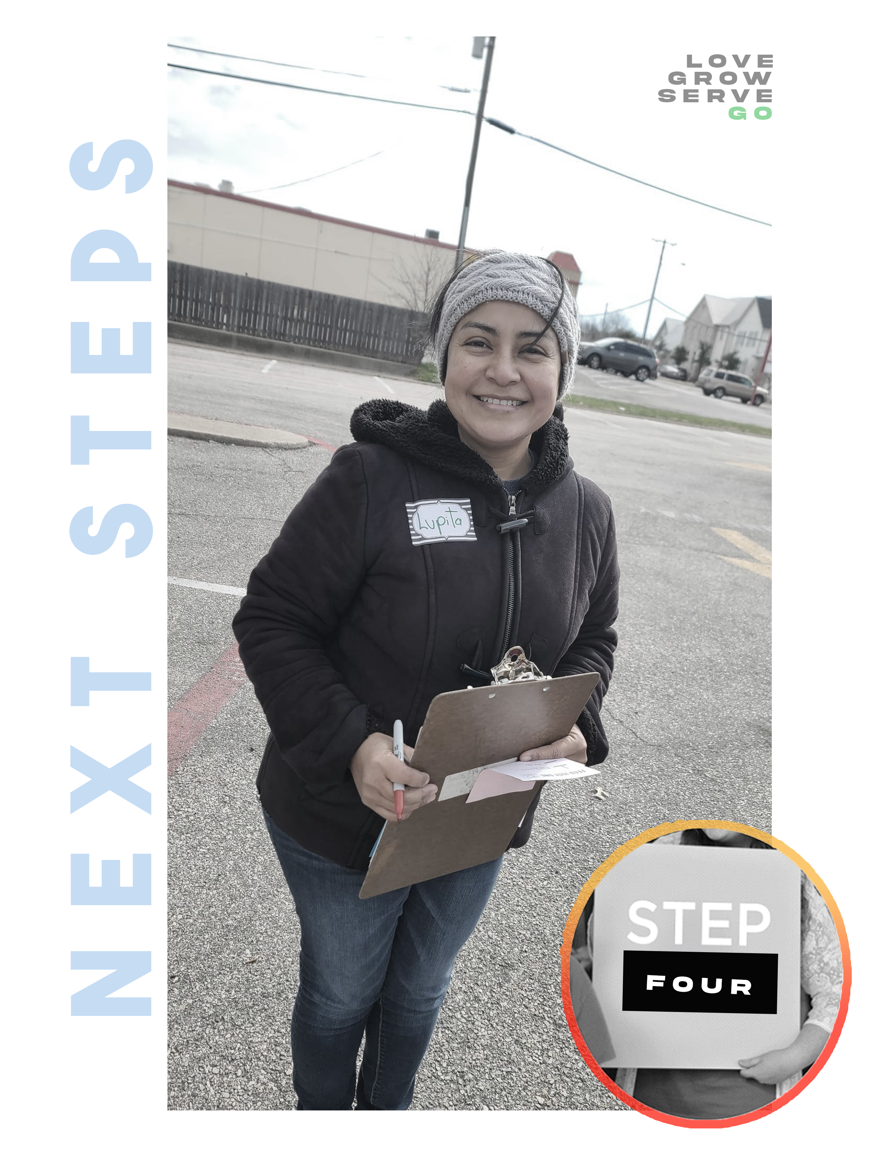

BEFORE you were created,

GOD created the thing

HE IS ASKING you to do.

G O C H A N G E T H E W O R L D
StepFOUR

FOR WE ARE GOD’S WORKMANSHIP,
CREATED IN CHRIST JESUS FOR GOOD WORKS.

EPHESIANS 2:10

OUR HOPE FOR YOU
Today at STEP FOUR our hope is to provide you with clear “next steps” to get involved in a team and step into your purpose.

DREAM TEAM

We were created with a purpose, and that purpose is to make a difference in someone else’s life. The best way for you to do that is by stepping into a fulfilling place where you can make a difference. God has a place for you where your unique abilities and passions can touch the lives of others. At Redemption Church, the Dream Team is the community where that happens.

________________________________________________________________________

He has saved us and called us to a holy life—not because of anything we have
done but because of his own purpose and grace.
This grace was given us in Christ Jesus before the beginning of time.
2 Timothy 1:9

…we are laborers together with God
1 Corinthians 3:9

VISION OF THE DREAM TEAM

- MY TEAM IS MY ____________________.

“I thank my God every time I remember you. In all my prayers for all of you, I always pray with joy because of your partnership in the gospel from the first day until now, being confident of this, that he who began a good work in you will carry it on to completion until the day of Christ Jesus.” Philippians 1:3-6 (NIV)

- MY TEAM IS MY ___________________.

“If you have any encouragement from being united with Christ, if any comfort from his love, if any fellowship with the Spirit, if any tenderness and compassion, then make my joy complete by being like-minded, having the same love, being one in spirit and purpose. Do nothing out of selfish ambition or vain conceit, but in humility consider others better than yourselves. Each of you should look not only to your own interests, but also to the interests of others.” Philippians 2:1-4 (NIV)

3. MY TEAM IS MY ______________________.

“Not that I have already obtained all this, or have already been made perfect, but I press on to take hold of that for which Christ Jesus took hold of me. Brothers, I do not consider myself yet to have taken hold of it. But one thing I do: Forgetting what is behind and straining toward what is ahead, I press on toward the goal to win the prize for which God has called me heavenward in Christ Jesus.” Philippians 3:12-14 (NIV)

4. MY TEAM IS MY _____________________.

“Finally, brethren, whatever things are true, whatever things are noble, whatever things are just, whatever things are pure, whatever things are lovely, whatever things are of good report, if there is any virtue and if there is anything praiseworthy—meditate on these things. The things which you learned and received and heard and saw in me, do these, and the God of peace will be with you. I can do all things through Christ who strengthens me.” Philippians 4:8-9, 13

VALUES OF THE DREAM TEAM

As a member of the Dream Team, we embrace the following values in order to serve in a way that brings honor to God and one another!

- WE VALUE ______________________.

We prioritize connecting with new people. We are ALL greeters! People matter to God, so they matter to us.

“Do nothing out of selfish ambition or vain conceit. Rather, in humility value others above yourselves, not looking to your own interests but each of you to the interests of the others.” Philippians 2:3-4

- WE VALUE _________________________.

We do life together. We build relationships with our team! Real Life change happens… real leaders are developed… when we take a step towards intentional relationships.

“I thank my God every time I remember you. In all my prayers for all of you, I always pray with joy because of your partnership in the gospel from the first day until now.” Philippians 1:3-5

3. WE VALUE ____________________________.

We are a people of purpose, working together on purpose. Because of this, we make deliberate decisions to empower one another and honor one another. We don’t elevate ourselves above any other member of our team.

“He is the one we proclaim, admonishing and teaching everyone with all wisdom, so that we may present everyone fully mature in Christ.” Colossians 1;28

4 WE VALUE ___________________________.

At Redemption Church, we believe in celebrating the wins! There is nothing more powerful than a life changed by Christ. We get to be a part of that every week!

“In the same way, I tell you, there is rejoicing in the presence of the angels of God over one sinner who repents.” Philippians 4:8-9, 13

QUALIFICATIONS & LEADERSHIP COMMITMENT OF A DREAM TEAM MEMBER
“The same goes for those who want to be servants in the church: serious, not deceitful, not free with the bottle, not in it for what they can get out of it. They must be reverent before the mystery of the faith, not using their position to try to run things. Let them prove themselves first. If they show they can do it, take them on. No exceptions are to be made for women—same qualifications: serious, dependable, not sharp-tongued, not fond of wine. Servants in the church are to be committed to their spouses, attentive to their own children, and diligent in looking after their own affairs. Those who do this servant work will come to be highly respected, a real credit to this Jesus-faith.”
1 Timothy 3:8-13 (The Message)

A DREAM TEAM MEMBER:
- Is sincere, worthy of respect, and of a good reputation.
- Supports Redemption Church with time, talent, & treasure.
- Has a genuine desire to serve and minister to other people.
- Leads, motivates, and teaches other people.
- Creates positive group dynamics and resolves conflict within the group.
I believe that I meet the qualifications for serving, and I agree to the following
(Initial each statement)

_______ to become a member of Redemption Church.
_______ to fulfill the vision of Redemption Church.
_______ to fulfill the responsibilities outlined in this Dream Team training.
_______ to abide by the Leadership Honor Covenant as outlined above in 1 Timothy 3.
_______ to complete Next Steps as soon as possible.

By signing below, I certify that the information contained in this application is complete, accurate, and not misleading in any way. Should my application be accepted, I agree to submit to the policies and procedures of Redemption Church membership, and to refrain from unscriptural conduct in the performance of my services on behalf of Redemption Church.

Signature of Applicant: _______________________________Date: ____/____/____

TO BEGIN SERVING ON THE DREAM TEAM

- Complete and sign the Dream Team Leadership Application and Honor Covenant.
- Attend STEP ONE and become a church member if you have not already done so.

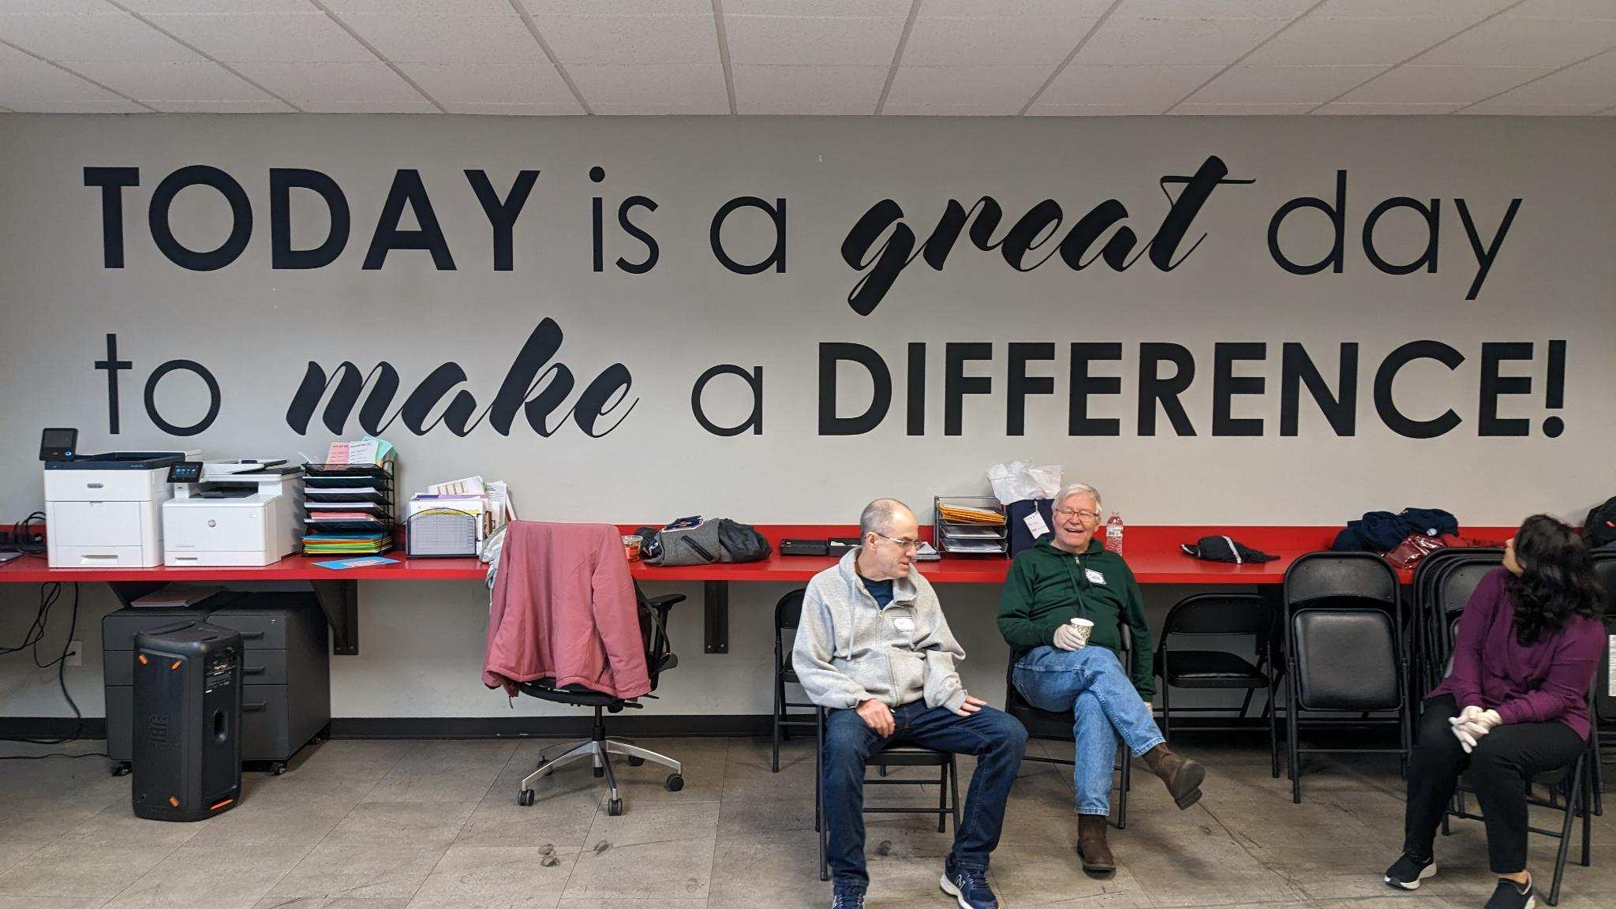
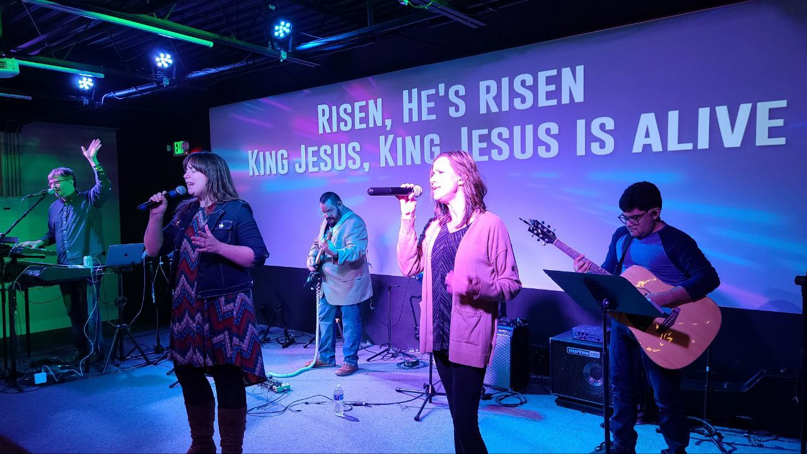

For your reference, we’ve included a list of teams you can get involved in upon completion of Next Steps.

A-Team (Administration): This team utilizes their gifts of administration and organization to assist with the administrative needs of Redemption Church. They also work alongside Dream Team leaders to seamlessly transition new Dream Team members into serving.

Altar Team: This team meets and prays with people who come near the stage for prayer and are committed to prayer during the week.

Community Outreach: This team is involved in countless ministries with a focus on bringing God’s love to our communities and world.

Creative Arts: This team is always dreaming of a way to make the gospel visual and captivating. Graphic design, acting, videography, live art performance… the opportunities are endless.

Greeters: This friendly team loves people and makes them feel at home here at Redemption Church. They welcome guests with a smile, encouragement, and personal touch so that hearts are open to the Gospel message.

Host: This friendly team ensures guests have a great experience from the moment they enter the Sanctuary. Hosts welcome guests and members, distribute announcement cards, and assist people in finding their seats.

Communications Team: This team connects guests to the Church community, providing resources and information on all our current events, ministry opportunities and services at Redemption Church.

Kids Check-in: This team welcomes families as they arrive at our Redemption Church Kids areas and facilitates the check-in process that ensures children are cared for effectively and efficiently.

Next Steps Team: As the official hosts of our Growth Track, this team greets guests as well as provides materials and assistance throughout our four classes.

Online Team: This team helps us minister to those who attend Redemption Church online and maintain a healthy web & social media presence.

Prayer Chair Team: This team serves behind the scenes to prepare the sanctuary by straightening and praying for each chair prior to services.

Small Group Leadership: We believe that real life change takes place in the context of relationships. As a Small Group Leader, you have the greatest opportunity to connect with others, fulfill your passions, develop your gifts, and live out the Great Commission.

Student Ministry: Join a team that is focused on the next generation. Help us host student small groups, activities, and worship.

Technical Production: Bring your creativity and tech savvy to this team that reaches thousands by delivering the Word and worship through audio engineering, camera, lighting, web streaming, and other visual elements.

Treehouse Kids: This team leads children into a real relationship with Jesus through Bible stories, worship, prayer, hands-on activities, and personal interactions for the elementary to nursery age children.

Ushers: Help prepare people for a positive worship experience by welcoming and assisting them to a seat, facilitating the offering and maintaining a distraction-free environment.

Worship Arts: Through vocals, instruments, or audio engineering, this dynamic team prepares the way for our guests to encounter the presence of the living God.

