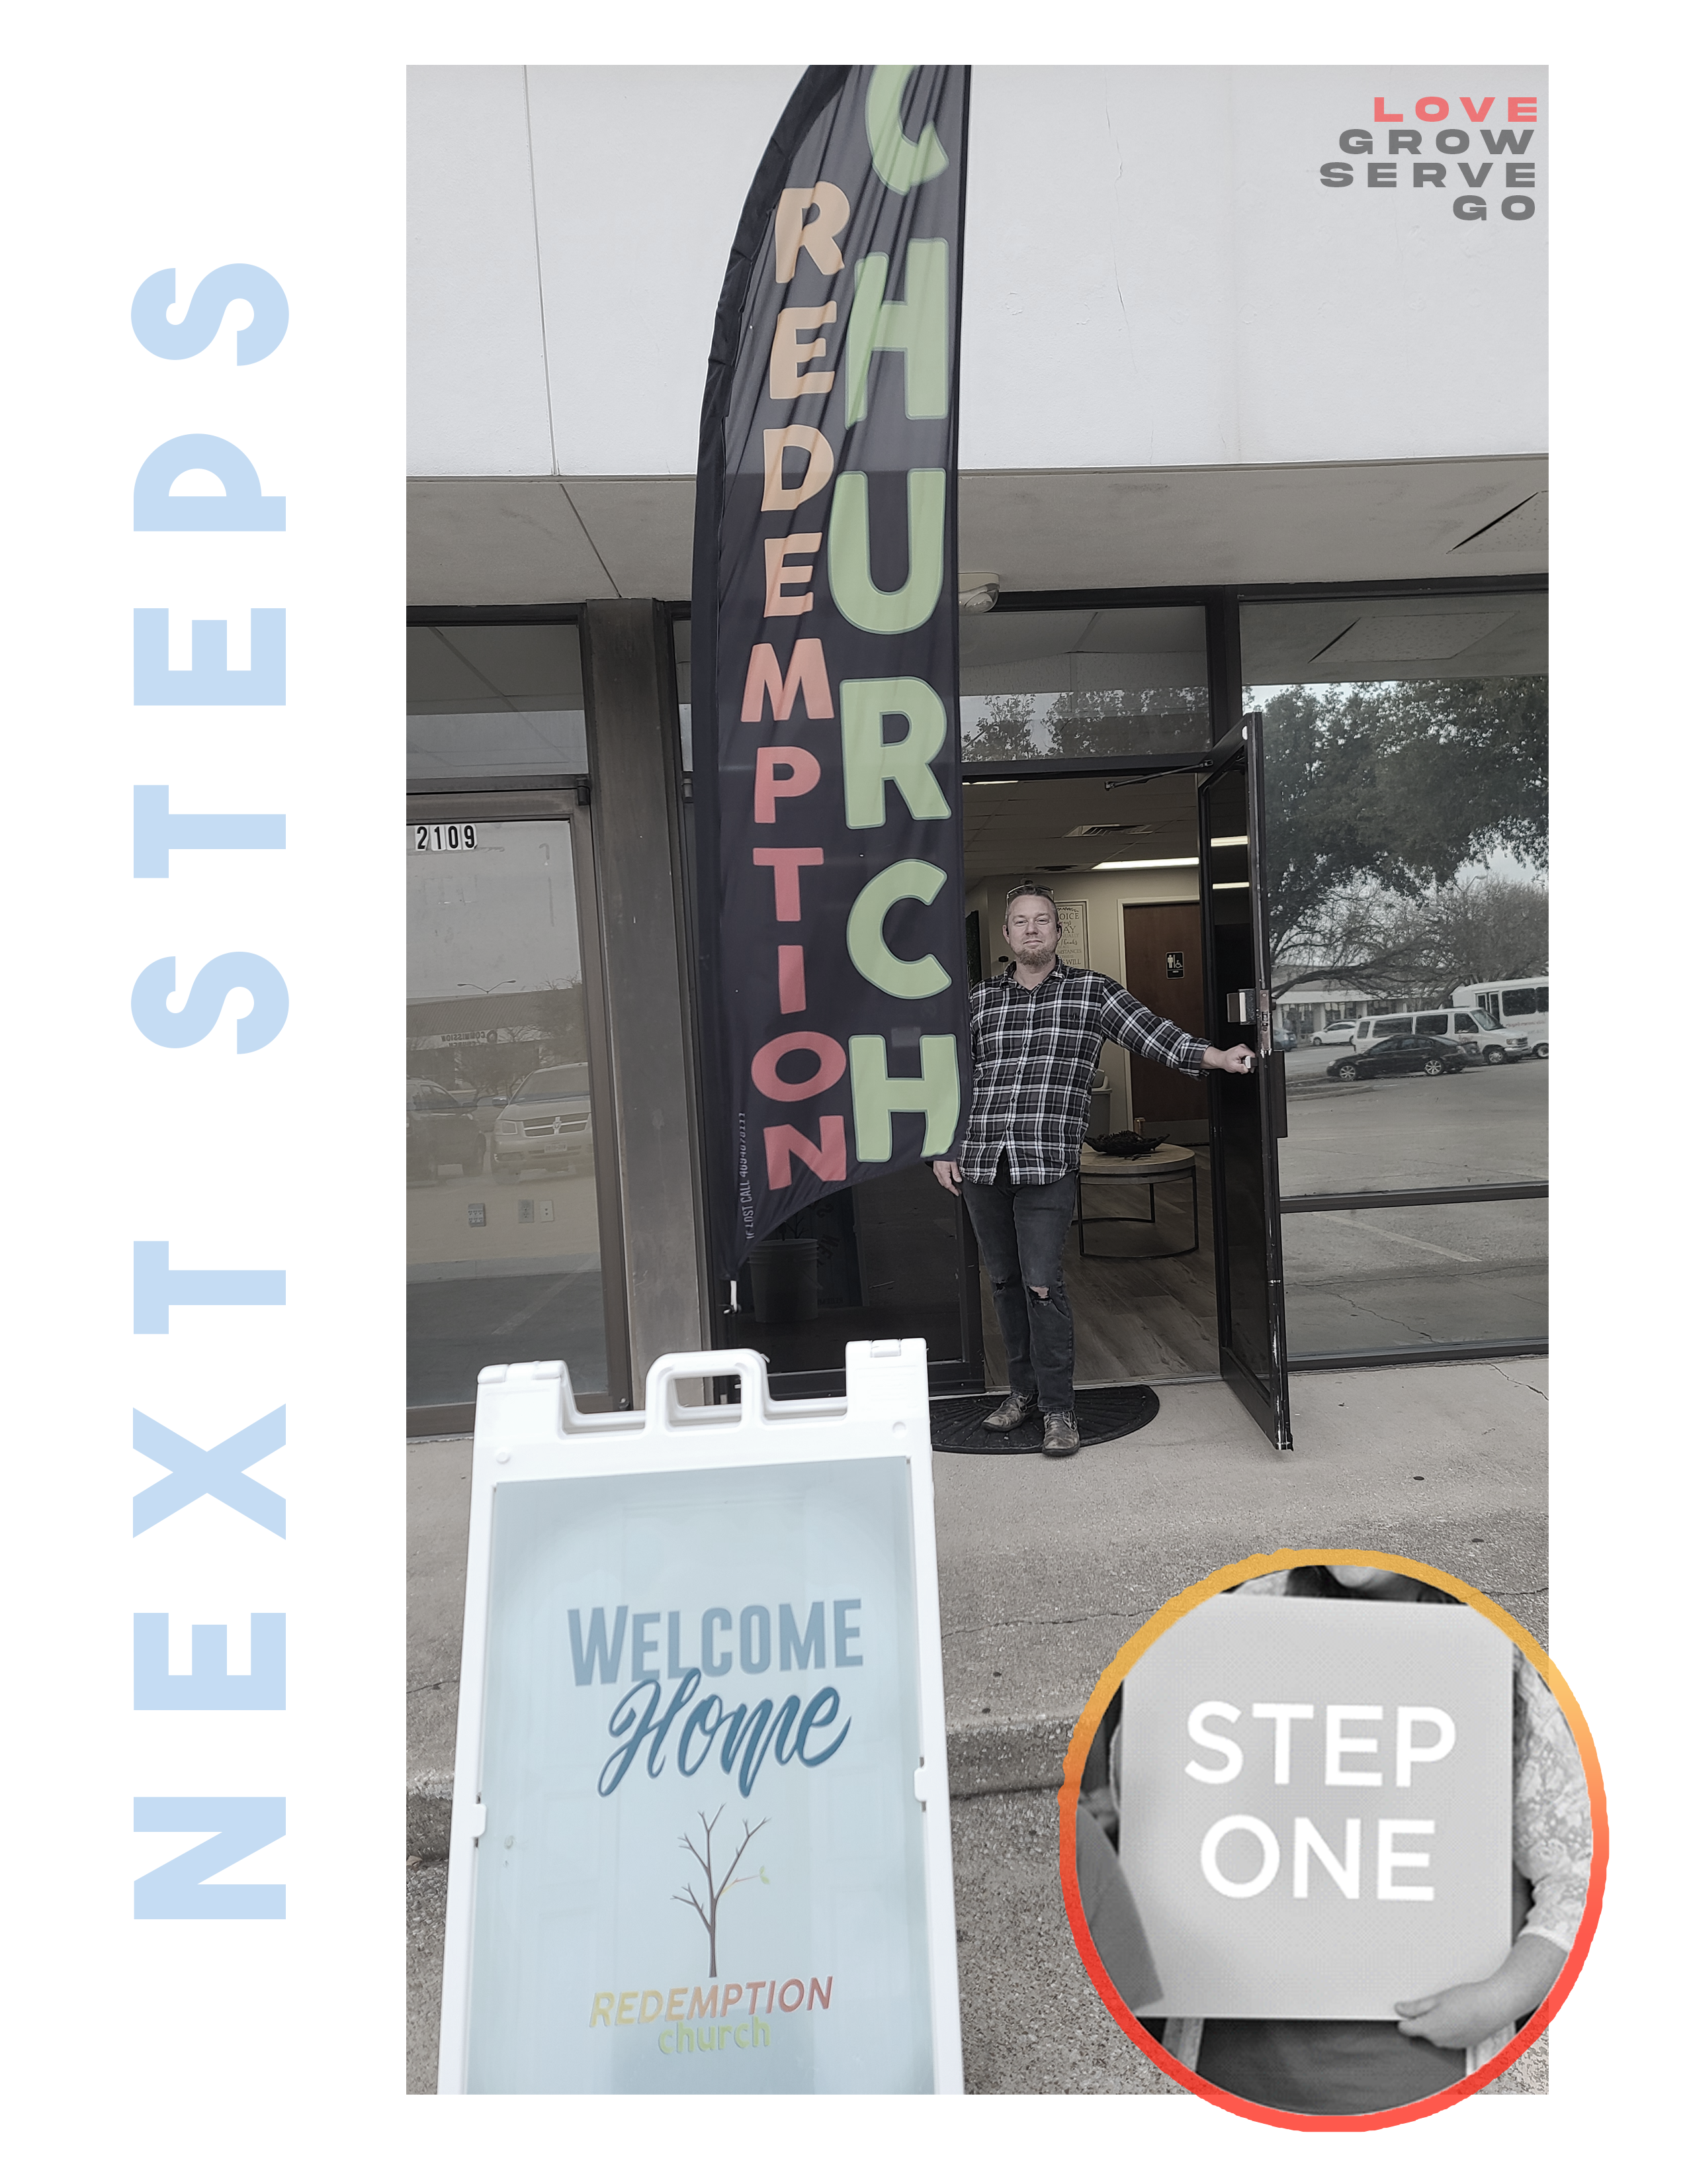

W H O W E A R E
stepONE

I HAVE COME THAT THEY MAY HAVE LIFE AND HAVE IT TO THE FULLEST.

JOHN 10:10

WELCOME TO NEXT STEPS!
We’re glad you’ve chosen to find out more about Redemption Church! Today is the basic introduction to what we value as a church family. Since we have members from many different church backgrounds, today was designed to clearly explain who we are and what we value.

NEXT STEPS guides you to discover your purpose and live the life God created for you. NEXT STEPS is made up of four steps that equip you to follow Jesus, connect to the church, discover your purpose, and serve others.

stepONE – WHO WE ARE
Step One happens in conjunction with Pastor’s Meet & Greet. Today, you’ll hear the Redemption Church story and find out what we’re all about. At the end, you’ll get a chance to become a member of this amazing family!

stepTWO – WHO YOU ARE
Discover your personality and gifts and see how they indicate your purpose in life and your best fit in ministry. We believe everyone was created with a God-given purpose, and one of the reasons we exist as a church is to help you discover that purpose and get plugged in to it.

stepTHREE – WHY YOU’LL LOVE IT HERE
Explore the ministry focus of Redemption Church and find out what makes us unique. We use Step Three to answer some important questions that you’re probably already asking!

stepFOUR – JOIN THE TEAM
We want to get you connected to a team as quickly as possible…because there’s nothing as fulfilling as making a difference in someone else’s life! Connect to the opportunities available at Redemption Church to live out your purpose and serve others by using your gifts.
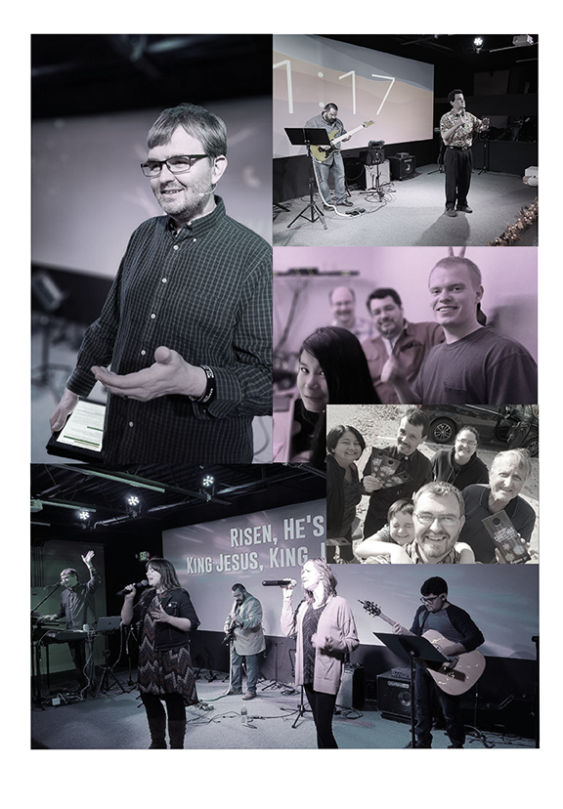

OUR PRAYER FOR YOU

“I keep asking that the God of our Lord Jesus Christ, the glorious Father, may give you the Spirit of wisdom and revelation, so that you may know him better. I pray that the eyes of your heart may be enlightened in order that you may know the hope to which he has called you, the riches of his glorious inheritance in his holy people.”
Ephesians 1:17-18 (New International Version)

OUR STORY

Redemption Church is a dream that the 1st century Gospel of Jesus Christ, is still able to change lives in the 21st century. We believe that your faith should be POWERFUL & SIMPLE.
Powerful Faith - The same power that raised Christ from the dead is available for you.
Simple Faith– A faith that speaks your language and you can share with others.

It is our goal to help people connect with God so that they might reach their full potential. From that guiding principle, Redemption Church focused on reaching out to the non-churched community by building relationships. The life-giving message of the Gospel, the passion and joy of Worship services, and the simple engaging style of Redemption Church has changed many of the lives you see serving.

It is not our goal to be a “mega church,” but a Mighty Church.
“For the weapons of our warfare are not of this world, but mighty through God to the pulling down of strong holds” – 2 Corinthians 10:4 (King James Version)

The Mighty God is at work at Redemption Church. We are involved in community outreach missions as well as global missions. We meet in small groups and live out a 1st Century Church faith in homes and neighborhoods. We teach the gospel of Jesus and see people surrender their life. We see God do miracles and we invite you to see for yourself how exciting church can be when the faith focus is simple and people are free to go after God with passion!

Simple & Powerful Faith in the Gospel of Jesus.
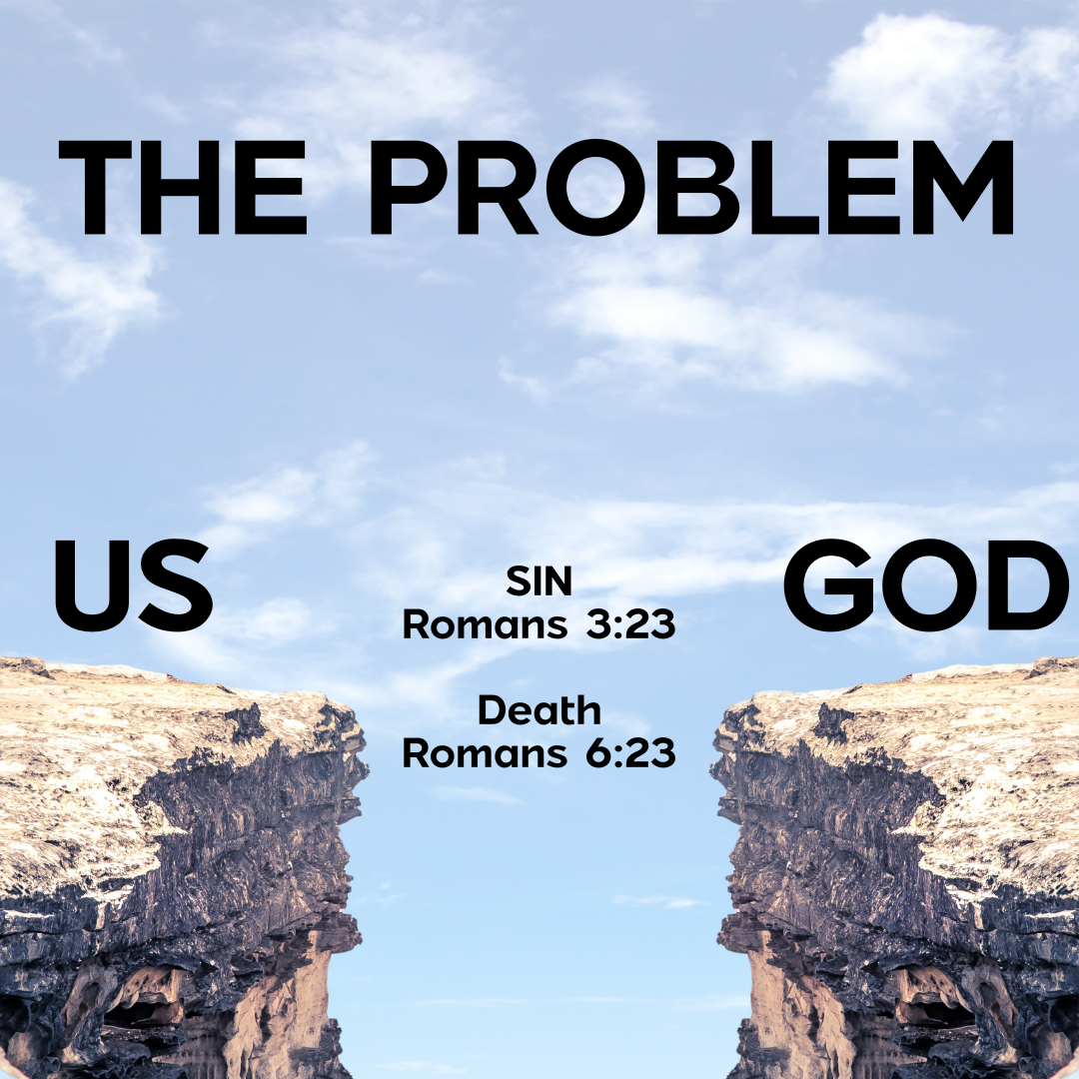
Romans 6:23 The wages of sin is death…

Sin always leads to death — it destroys our peace, purpose, and relationship with God.
Romans 3:23 all have sinned and fall short of the glory of God

Sin is choosing our own way instead of God's way — in our thoughts, words, actions, or attitudes.
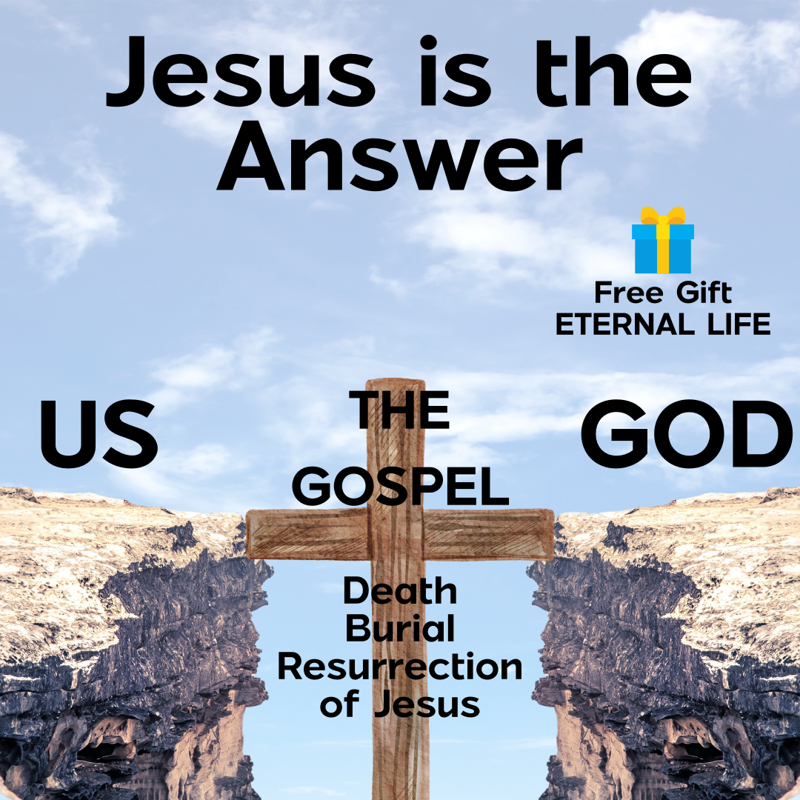
Romans 6:23 For the wages of sin is death, but the gift of God is eternal life in Christ Jesus our Lord.

God has the free gift of eternal life for us THROUGH Jesus.
1 Corinthians 15:3-4 Christ died for our sins according to the Scriptures, that he was buried, that he was raised on the third day according to the Scriptures.

The Gospel (Good News) is that Jesus died for us, was buried, but rose again!
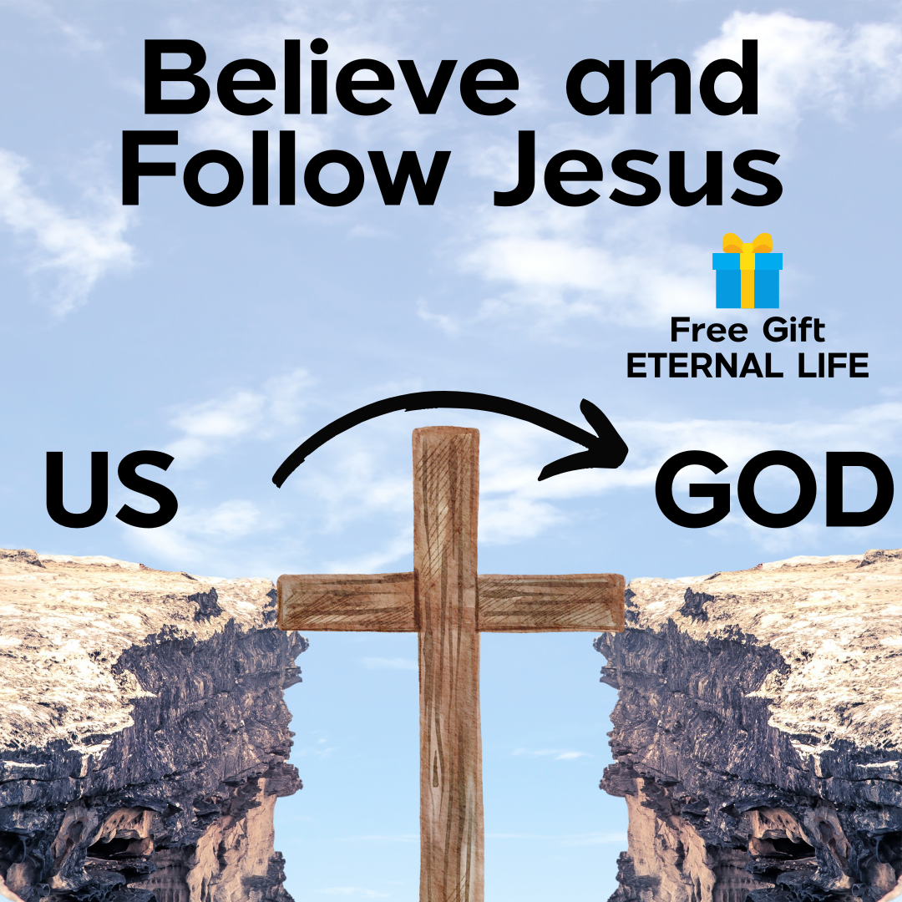
Do you believe in the death, burial, & resurrection of Jesus?

Are you following Jesus?

Do you know your next step?
John 8:12 I am the light of the world. Whoever follows me will never walk in darkness, but will have the light of life.
John 3:16 For God so loved the world that he gave his one and only Son, that whoever believes in him shall not perish but have eternal life.

WE WOULD LOVE TO TALK TO YOU ABOUT YOUR NEXT STEPS IN CHRIST.
Next Steps in Following Jesus
1. Believe the Good News
Trust that Jesus is Savior and Lord; He died, was buried, and rose again for you.
(John 3:16; Romans 10:9; 1 Corinthians 15:3-4)

2. Repent and Turn to God
Turn away from sin and follow Jesus.
(Acts 2:38; Luke 5:32)

3. Be Baptized
Show the world your new life in Christ.
(Acts 2:41; Romans 6:4)

4. Experience the Holy Spirit
Let God’s Spirit lead and empower you.
(Acts 1:8, 2:38; Galatians 5:22-23)

5. Learn and Grow
Grow your faith through Scripture, prayer, and community.
(Matthew 28:19-20; Acts 2:42)

6. Share the Good News
Tell others about what Jesus has done for you.
(Matthew 5:14-16; 2 Corinthians 5:20)

7. Make a Difference
Use your gifts to serve and love others.
(Ephesians 2:10; 1 Peter 4:10)

Do you know your next step?
We WOULD LOVE to talk to you about what comes next.
Interested?
Let us know or text us at 469-467-8111 with the words #Ready4Next

YOUR STORY
The focus of Redemption Church is four-part:
1. Love God.

2. Grow in Faith.

3. Serve others.

4. Go change the world.

THIS IS THE DNA of REDEMPTION CHURCH:
LOVE-GROW-SERVE-GO

stepONE

LOVE GOD: Attend Weekend Service

Our Love for God is not confined to any one day of the week, but we express it publicly on Sundays as a family of believers! We set aside TIME to emphasize our love for God through worship and community.

At Weekend Service, We:
1. WORSHIP: We “praise God in the sanctuary” (Psalm 150:1)

2. CONNECT with the Body of Christ: Scripture says that only iron can sharpen iron. (Proverbs 27:17). So when we connect with one another, we grow stronger and sharper.

3. HEAR the preached Word of God: Faith comes by hearing, hearing by the word of God. (Romans 10:17).

4. PRAY together: It is important to pray in private, but there’s something altogether different when we pray together and for each other. In Acts 4, when a group of believers gathered in a second-floor room, the place was shaken by their prayers.
Our goal for every worship service is that you would Love God more than before.

stepTWO

GROW IN FAITH: Join a Small Group

There are two things we need as believers — First, we need to sense that we are a part of something bigger than ourselves. Second, we need to sense that we are impacting others in close relationships.

In Acts 2 when the Redemption Church was born and throughout the Book of Acts, we see the power of meeting in small groups:

• “So continuing daily with one accord in the temple, and breaking bread from HOUSE TO HOUSE, they ate their food with gladness and simplicity of heart, praising God and having favor with all the people. And the Lord added to the church daily those who were being saved.” (Acts 2:46-47)

• “[They met] daily in the temple and in every HOUSE.” (Acts 5:42)

• “I kept back nothing that was helpful, but proclaimed it to you, and taught you publicly and from HOUSE TO HOUSE.” (Acts 20:20)

Reasons Small Groups Are Important

Small Groups provide opportunities for:

- BIBLE STUDY: I need people to strengthen and balance the Word of
God in my life.
2. FELLOWSHIP: I need people who know the real me.
3. PRAYER: I need people to pray for me personally.
4. SUPPORT: I need people who will protect me.
5. OUTREACH: I need people with whom I can share my story.

“So now I am giving you a new commandment: Love each other. Just as I have loved you, you should love each other. Your love for one another will prove to the world that you are my disciples."
JESUS in John 13:34-35 (NLT)

HOW SMALL GROUPS WORK

Our small groups meet once a week in places all around our metroplex and and provide a place for you to connect, grow, and discuss the issues and challenges of life. Regardless of your age, interest, or location, there is a group out there for you. Small groups are also where we pray, care for one another, and are missed if we don’t show up! If you would like to join a small group, simply visit our information table or text 469-467-8111 to learn more. We would love for you to get connected.

There are three things you should know about small groups:

1. They are “Connect Groups.”

Our connect groups are as varied as we are; group leaders use their gifts and passions to create a group that allows others to find a deeper connection to Faith and others in the faith. Whatever the age, interest, or location there is a group that is just right for you!

2. We have THREE SEMESTERS every year.

New groups start and stop three times a year –spring, summer, and fall. This gives you a chance to try a new group and connect with new people through out the year.

3. You can HOST a group.

We believe that everyone has areas of strength and gifting that could benefit others. The first step in becoming a small group leader is to attend the Small Group Leader Training. These classes are offered before a new semester and give an overview of what it takes to start a group. You’ll discover that it’s easier than you think.

stepTHREE

SERVE OTHERS: Complete Next Steps

“ONE ANOTHER” is found 59 times in the 27 books of the New Testament. Jesus wants us to know the responsibility we have one to another. That we should care for one another—serve one another.

But, how? How do I do this?

Next Steps answers your questions. The Next Steps journey is where you can discover the unique gifts God has given you — and how you can use those gifts to serve others.

In this step we will help you discover your UNIQUE GIFTS, so that you fulfill your God PURPOSE.

stepFOUR

GO CHANGE THE WORLD: Join the Dream Team.

The Redemption Church Dream Team is the core of our church! Every person who serves in any of the Redemption Church ministry teams is part of ONE team: the Dream Team.

If you lean your ladder up against the wrong building, you can climb all you want but never arrive at the place you wish to be.

You have to lean the ladder in the right place. And what’s the right place? Making a difference in the life of others. And we do that at Redemption Church through the Dream Team.

Don’t look out only for your own interests, but take an interest in others, too.
-Philippians 2:4 (New Living Translation)

LOVE-GROW-SERVE-GO

This is the DNA of Redemption Church. This is the four part spiritual journey of every believer. So allow us to welcome you to a journey to find the best you that you can be. Welcome to the Redemption Church family!

tellmeMORE

REDEMPTION CHURCH MEMBERSHIP COVENANT

Being in agreement with the values and ideas presented in Next Steps, I now feel led by the Holy Spirit to unite with the Redemption Church family. In doing so, I commit myself to God and to the other members to do the following:

1. I will protect the unity of my church:

  - By acting in love toward other members.

  - By refusing to gossip.

  - By trusting and following the leaders.

“So then, let us aim for harmony in the church and try to build each other up.” Romans 14:19 (New Living Translation)

“May God, who gives this patience and encouragement, help you live in complete harmony with each other, as is fitting for followers of Christ Jesus.” Romans 15:5 (New Living Translation)

“Do not let any unwholesome talk come out of your mouths, but only what is helpful for building others up according to their needs.” Ephesians 4:29 (New International Version)

“Have confidence in your leaders and submit to their authority, because they keep watch over you as those who must give an account. Do this so that their work will be a joy, not a burden, for that would be of no benefit to you.” Hebrews 13:17 (New International Version)

2. I will share the responsibility of my church:

  - By praying for its growth.

  - By inviting the unchurched to attend.

  - By warmly welcoming those who visit.

“To the church...we give thanks to God always for you all, making mention of you in our prayers.” 1 Thessalonians 1:1-2 (King James Version)

“Go out into the highways…and compel them to come in, that my house may be filled.”
Luke 14:23 (King James Version)

“Therefore receive one another, just as Christ also received us to the glory of God. Romans 15:7 (New King James Version)

3. I will fulfill the purpose of my church:

  - By discovering my gifts and talents.

  - By being equipped to serve by my pastors.

  - By developing a servant’s heart.

  - By reaching out to others.

“As each one has received a gift, minister to one another, as good stewards of the manifold grace of God.” 1 Peter 4:10 (New King James Version)

“He gave...some to be pastors and teachers for the equipping of the saints for the work of ministry.” Ephesians 4:11-12 (New King James Version)

“Each of you should look not only to your own interests, but also to the interests of others. Your attitude should be the same as that of Christ Jesus...by taking on the very nature of a servant.” Philippians 2:4-5, 7 (New International Version)

4. I will support the testimony of my church:

  - By attending church and small groups faithfully.

  - By living a godly life.

  - By giving regularly.

“And they continued steadfastly in the apostles’ doctrine and fellowship, in the breaking of bread, and in prayers.” Acts 2:42 (New King James Version)

“Not forsaking the assembling of ourselves together…exhorting one another.” Hebrews 10:25 (King James Version)

“Let your conduct be worthy of the Gospel of Christ.” Philippians 1:27 (New King James Version)

“On the first day of the week let each one of you lay something aside, storing up as he may prosper.” 1 Corinthians 16:2 (Living Bible)

“’A tithe of everything from the land… belongs to the LORD; it is holy to the LORD.” Leviticus 27:30 (New International Version)

Protect the unity
Share the responsibility
Fulfill the purpose
Support the testimony

tellmeMore

SEVEN WAYS THE 1st CENTURY CHURCH REVEALED THEIR LOVE FOR GOD

- They Experienced the New Birth.

“Unless one is born of water and the Spirit, he cannot enter the kingdom of God” -John 3:5 (King James Version)
“For you have been born again, not of perishable seed, but of imperishable, through the living and enduring word of God. -1 Peter 1:23 (New International Version)

- They shared the Gospel of Jesus Christ. The Kingdom of God has come, and through Jesus’ death on the cross and resurrection, we can be restored to relationship with Him!

“Therefore let all the house of Israel know assuredly that God has made this Jesus, whom you crucified, both Lord and Christ. …Repent, and let every one of you be baptized in the name of Jesus Christ for the remission of sins; and you shall receive the gift of the Holy Spirit” -Acts 2:36-38 (New King James Version)

- They anticipated the soon coming of Jesus Christ:

“Our citizenship is in heaven, from which we also eagerly wait for the Savior, the Lord Jesus Christ, who will transform our lowly body that it may be conformed to His glorious body, according to the working by which He is able even to subdue all things to Himself” -Philippians 3:20-21 (New King James Version)

- They lived differently than unbelievers.

“Now may the God of peace Himself sanctify you completely; and may your whole spirit, soul, and body be preserved blameless at the coming of our Lord Jesus Christ.” -I Thessalonians 5:23 (English Standard Version)

- They believed Jesus is God.

“Without controversy great is the mystery of godliness: God was manifested in the flesh, justified in the Spirit, seen by angels, preached among the Gentiles, believed on in the world, received up in glory” -I Timothy 3:16 (King James Version)

- They gathered in Small Groups during the week in houses.

“how I did not shrink from declaring to you anything that was profitable, and teaching you in public and from house to house” -Acts 20:20 (English Standard Version)

- They gathered together for worship.

“Glorify the LORD with me; let us exalt his name together. -Psalm 34:3 (New International Version).

How will you love God MORE today?

Thank you for joining us to learn more Redemption Church and our vision to LOVE GOD.

The date and time for our next step is

__________________________

studyMORE

PRAYER GUIDE

…Your kingdom come, your will be done, on Earth as it is in heaven…
Matthew 6:10

But you shall receive power when the Holy Spirit has come upon you; and you shall be my witnesses in Jerusalem, and in all Judea and Samaria, and to the end of the earth. Acts 1:8

Pray for the Leaders of Our Country
- President Joe Biden & Vice President Kamala Harris
- Supreme Court Justices – John Roberts, Clarence Thomas, Ketanji Brown Jackson, Amy Coney Barrett, Sonia Sotomayor, Brett M. Kavanaugh, Samuel Alito Jr., Elena Kagan, Neil Gorsuch
- U.S. Senators (Texas) – Ted Cruz, John Cornyn
- U.S. Representatives (Texas) – Nathaniel Moran, Dan Crenshaw, Keith Self, Pat Fallon, Lance Gooden, Jake Ellzey, Lizzie Fletcher, Morgan Luttrell, Al Green, Michael McCaul, August Pfluger, Kay Granger, Ronny Jackson, Randy Weber, Monica De La Cruz, Veronica Escobar, Pete Sessions, Sheila Jackson Lee, Jodey Arrington, Joaquin Castro, Chip Roy, Troy Nehls, Tony Gonzales, Beth Van Duyne, Roger Williams, Michael Burgess, Michael Cloud, Henry Cuellar, Sylvia Garcia, Jasmine Crockett, John Carter, Colin Allred, Marc Veasey, Vicente Gonzalez, Greg Casar, Brian Babin, Lloyd Doggett, Wesley Hunt

Pray for the Leaders of Our State
- Governor Greg Abbott
- Mayors –

Pray for the Leaders of Our Church
- Staff Families – Chris & Sarah Fluitt (Will, Hudson, Josh), Marshal & Jessica Blessing (Lazer, Beatrix, Vanessa, George), Jeremy & Vicky Skinner, Rob & Lupita Cortez (Robert)
- Church Board – Chris Fluitt, Marshal Blessing, Ron Muller
- Ministry Leaders

Pray for Our Vision
- LOVE. Pray that all of us could come to love God with all our hearts. Pray for the lost to be saved and feel the love of Jesus Christ in our Weekend Services.
- GROW. Pray for leaders, hosts, and small groups. Pray for MORE DISCIPLES and GROWING DISCIPLES.
- SERVE. Pray that through our Growth Track process, people would take their next steps into service. Pray for our community outreach.
- GO. Pray for all those who serve on the Dream Team in taking the Gospel into the world around us.

Pray for Redemption Church Ministries
- Treehouse Kids
- Students
- Worship Team
- Small Groups
- Next Steps

Pray for Redemption Church Missions
- Matt & Julie Hattabaugh (Trentyn & Kaitlyn) – Beirut, Lebanon
- Vitaly (Daniel, Samuel – Maykop, Russia
- Yoel & Maria Rodriguez – Cifuentes & Santa Clara, Cuba
- Barnabas Pandit – Katmandu, Nepal
- Underground Missionaries in Asia

studyMORE

QUESTIONS ABOUT TITHING

What is tithing?
“Tithe” means “a tenth part.”

What is the difference between a tithe and an offering?
A “tithe” is giving the first tenth of my income.
An “offering” is anything I give in addition to my tithe.

Why should I tithe?
Because God commands it.
“A tenth of all you produce is the Lord’s.”
Leviticus 27:30

Because Jesus commanded it.
“Yes, you should tithe, and you shouldn’t leave the more important things undone either.”
Matthew 23:23

Tithing demonstrates that God has first place in my life.
“The purpose of tithing is to teach you to always put God in first place in your lives.”
Deuteronomy 14:23 (LB)

Tithing reminds me that everything I have was given to me by God.
“Always remember that it is the Lord your God who gives you the ability to produce wealth.”
Deuteronomy 8:18

Tithing expresses my love to the Lord.
“Each of you should bring a gift in proportion to the way the Lord your God has blessed you.”
Deuteronomy 16:17

God says that refusing to tithe is stealing from Him.
“God says ‘Will a man rob God? Yet you are robbing me!’ But you ask, ‘How do we rob you?’ God says ‘In tithes and offerings ... Bring your whole tithe to My house.’ ” Malachi 3:8-10

Tithing gives God a chance to prove He exists and wants to bless you.
“Bring your whole tithe to My storehouse. Test me in this” says the Lord, “and see if I will not throw open the floodgates of heaven and pour out so much blessing that you won’t have room enough for it!” Malachi 3:10
What should I tithe?
The tithe should come from the first part of what I earn.
“Honor the Lord by giving him the first part of all your income.”
Proverbs 3:9-10

Where should I give my Tithe?
The tithe should be given where I worship.
“Bring your whole tithe to My Storehouse (Temple).”
Malachi 3:10

When should I Tithe?
The tithe should be given weekly.
“On the first day of every week, set aside some of what you have earned and give it as an offering. The amount depends on how much the Lord has helped you earn.”
1 Corinthians 16:2 (LB)

