Setting description
Redemption Church is a non-denominational church plant in Plano Tx. We sublease from a store front Church and have an evening service. We have slowly grown over the last years, mainly by winning brand new people to Christ or calling those hurt by Church back home.
Our Church this year rolled out a new more accessible and people focused vision and with it a Next Steps membership onboarding system. It has been a big burst of energy for us and we have doubled our volunteers.
The Next Steps is great for allowing a simple way to join the church, learn about one’s God given ability and calling, and join the Church in service.
This Christian Education course helped me notice a lack of Disciple making plan within our next steps curriculum. As it is, it is possible to make it through our Next Steps and the Church still does not know where someone is on their faith journey!
My task is to add a way to gauge the needed discipleship level benchmarks and add it to our Next Steps process.
When someone is signed up and attends the 1st of 4 Next Step sessions, they will also be scheduled a one on one Faith Journey conversation. This conversation will be used to ASSESS where they are on their faith journey.
This plan
- Fits into our context of onboarding membership and volunteering through Next Steps.
- Includes different ages and stages.
- Incorporates Pre-Christian – Christian – Disciple – Apostle Pathway
- Provides recruitment, training/mentoring
- Provides the opportunity for development and coaching
- Creates a new area for leadership and volunteer service.
- Provides opportunity for assessment and evaluation

A look at our Church vision in fractal format of 4 core ministries. Grow Faith is our Discipleship ministry. It is quickly growing more complex. We continually see the need for specific Bible studies, classes, small groups, fellowships…
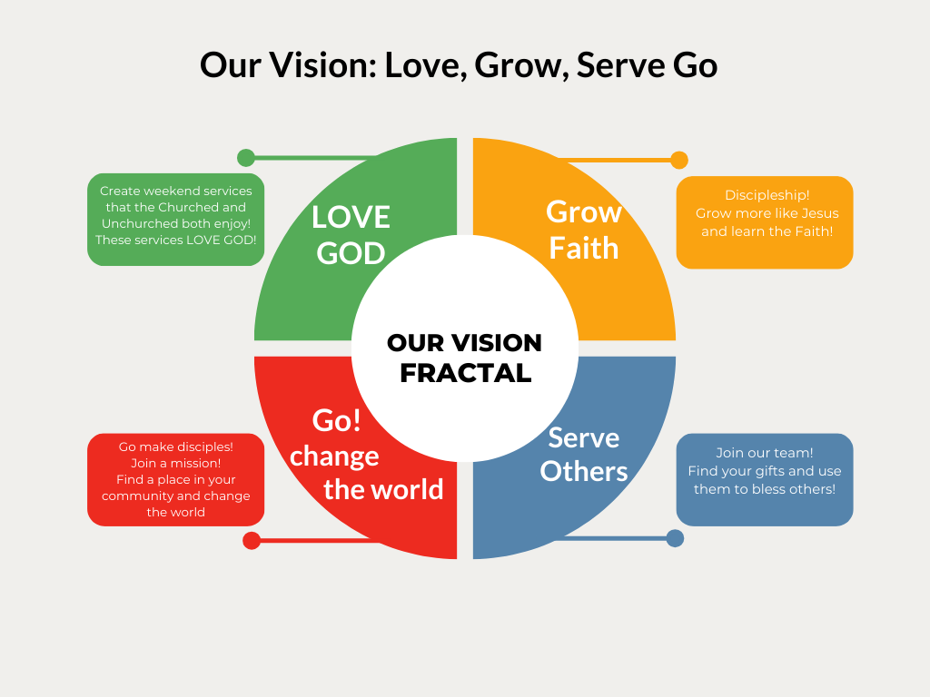

Here is a visual representation of our Next Steps classes. There are four classes that range from membership with being a part of the team.

Please note that the FAITH JOURNEY will be scheduled after everyone takes next steps 1 and should be completed before they take the 4th and final next steps class.
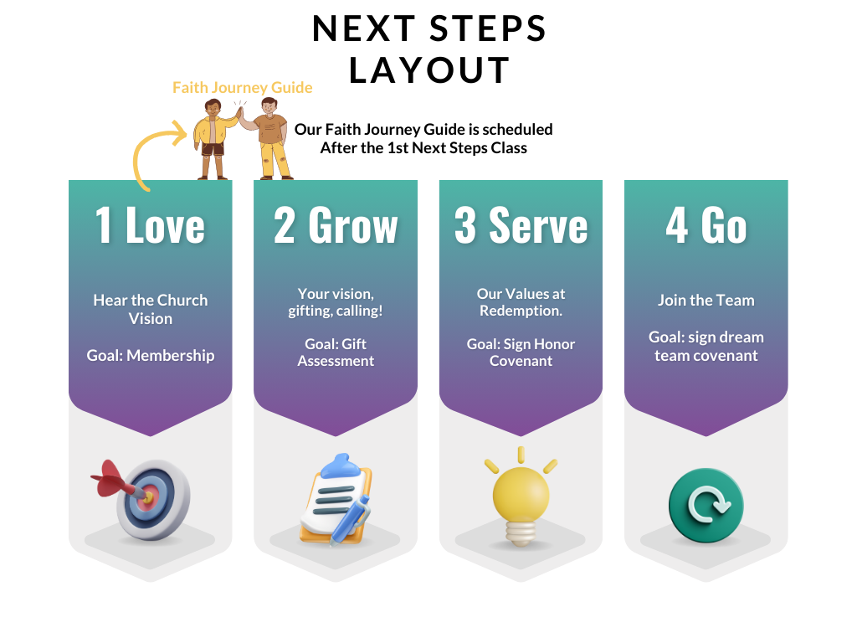

Faith Journey Guide

This Faith Journey guide is meant to be a conversation from someone who is an active leader within the Church.
The conversation is mainly questions to ascertain the prospects discipleship progress.
The meeting will be scaled to fit appropriate ages and stages of the prospect. (It is helpful for the leader to fit the age and stage of the candidate) (Some stages may require child-care. We might have to think outside the box as we have limited time inside our subleased storefront. We might borrow someone’s home or bring help to Starbucks)
The meeting will be done in a public setting with someone of the same gender. Male and male. Female and female. (Minors will have a scaled down guide with a parent/guardian present)
The UPBEAT meeting will be no longer than 30 minutes.
It is meant to feel like a conversation. We need to try to avoid taking a lot of notes and have eye contact and fully experience the person.
The leader must avoid answering their questions or trying to correct theology. This meeting is meant to connect them to yourself and ascertain their need. The focus of the meeting is OTHERS and not ourselves.
Conversation questions. Let’s talk about:
- Faith in God. Describe what it means to have faith. Describe your faith in God.
- What is the Gospel/good news?
  - (Do they mention death burial resurrection of Jesus or God’s love?)
- What is sin and repentance?
- Describe baptism.
  - Have you ever been baptized? Tell us about it?
  - Do you have questions about baptism? Would you be interested in a Bible study?
- Describe your experience with prayer.
  - Do you understand the importance of prayer?
  - Do you enjoy prayer?
- Describe your experience with God’s Word? (Do they own a Bible?)(We can get them one!)
- Describe your experience with worship.
- Do you understand communion?
- Have you ever shared your faith? How did you share? If no, why not?
- Have you ever experienced the joy of giving and serving? Talk about it.
- What is your knowledge and experience with the Holy Spirit?
- Describe your leadership experience. (not just church but vocational/job experiences)
- What is God’s plan for your life? (Do they have a calling for more?)
The conversations over these prompts will lead us to ascertain their faith journey.
The colored sections ascertain these levels.
Pre-Christian or Christian, Disciple, Apostle

Let’s understand the levels.
Pre-Christian or Christian
The conversation does not need to go long. The leader should ascertain quickly if they are pre-Christian or Christian. If they are pre-Christian there is no need to dig into discipleship and apostleship at this time.
IMPORTANT: Leader you could take this time to lead them into a faith relationship at this point. We expect all our leads to be able to do this.
Here is how…
Tell them the story of how you came to Christ. UNDERLINE these points in your testimony. And then lead them through these points.
- Why you need salvation. (Sin/separate from God - Romans 3:23)
- How God gives salvation. (In love Christ died for us – Romans 5:8)
- How we receive salvation. (Faith/Believe in Jesus John 3:16. Lead them into repentance – Acts 3:19. Read romans 10:9 to them and see if they will confess the Lord.) (((CELEBRATE)))
- The results of salvation (Eternal life Romans 6:23, 1 John 1:9 forgiven)
Let us know the results of this conversation immediately so we can follow up!

If they are Christian but not yet a disciple, tell them your testimony of jumping into discipleship.
Disciple
Are they in the range of discipleship?
BAPTISM - We care greatly about baptism. WE ARE CALLED TO BAPTIZE ALL BELIEVERS! We want to baptize!! And we also want people to understand the role baptism in God’s plan. We have a Bible study for anyone not baptized, and also anyone who does not understand baptism. If they fit either criterion we want to know. (Mentioned in Follow Up section)
We are looking for spiritual disciplines in this area of assessment.
We have discipleship small groups, and it would be our goal to get them signed up.
Every disciple needs to be plugged in and serving. Ask them where they see themselves serving at Redemption? This is what they are being asked in the “next steps” process.
If they are a strong disciple, we want to tag them for possible leadership training.
Apostle
Apostle means “sent one.”
You never know how long you will have someone with a call on their life. We must prioritize using, blessing, equipping them ASAP. No where is this truer than in those God has a plan to send.
We are interested in their calling. Make note of this so we can follow up.

Ending the meeting
At the close of the meeting thank them for allowing you to be a part of their faith journey and close in prayer. Ask if there are any needs you can pray over and then pray!
Give them a gift bag we prepared.
- Bible study journal
- Pen
- Church T-Shirt
Make sure they know the dates of the Next Steps classes.

Faith Guide leader follow up.
After the meeting is over, we need an email follow-up with your assessment.
The assessment needs to be simple.
- What level do they fall into? Pre-Christian, Christian, Disciple, Apostle?
- Any helpful info you learned. (Came to faith!, interested in baptism, strong disciple, an apostle)
- Any concerns?

Now we disciple.
The discipleship, “Grow Faith” fractal leader will look over the assessment and decide how to progress.
If they accepted Christ in the Faith Journey meeting – The candidate’s info is forwarded to the pastor to follow up. (celebrate)
If they expressed interest in Baptism – The candidate’s info will be forwarded to our baptism Bible Study leader.
If they are believers but lack that fluency with Scripture, we forward their info onto our 12 week “through the Bible” study leader.
If they are a strong disciple or apostle, we will be connecting our small group coordinator that we found prospective leaders. The small group coordinator will reach out and will also be present at the 4th week Next Steps class.
Wherever they are on the faith journey we need to help them take their next steps. We must GROW FAITH!
Wherever they are on their faith journey, there is a place for them to serve at Redemption. Rubbing shoulders with fellow volunteers and leaders as well as the humble joy of service, is going to progress them on their faith journey.

Now we evaluate.
1 month after the final next steps class we follow up to evaluate…
- The progress of our candidate.
- Their experience with Next Steps.
- Their experience with the Faith Journey meeting.
- The transition into discipleship.
- How they are enjoying life at Redemption Church.
- Are they serving? Are they enjoying it?
- Have they found a small group?
- Is there anything we can do to serve them better?
This evaluation would likely be carried out 1 on 1 much like our faith journey meeting. Because we are also evaluating the faith journey meeting leader, we would likely use another person to help us evaluate.

Yearly we will take these evaluations and have assessment meetings with our Faith Group leaders, Next Steps coordinator, and “Grow Faith” coordinator. The goal is to continually get better and fix the hiccups that usually come up in transitioning a person along the process. By evaluating the experience feedback and measurables like candidate progress we will have a good idea of our success or need for change.

Opportunities for leadership development.
Our plan provides recruitment. Next steps, plus assessing their discipleship pathway, helps us locate and recruit our next servant leaders!
Our plan provides training/mentoring. We must have more than 1 Faith Journey leader, but we will start with 1. This faith journey leader will train 1 other leader by bringing them along to observe the conversation, then observing them hold the conversation, and finally setting them free to lead on their own.
Through assessment and training we have the opportunity for development and coaching. Eventually we see our best leader in this area overseeing this ministry which will provide another layer for leadership. WE ALWAYS NEED LEADERS! Creating this position will give another spot for someone to step up for the Kingdom of God.

Jr Faith Journey Guide
There is no such thing as Jr Faith! Faith at any age is supernaturally powerful.
The “Jr” is a description of the age of the candidate and not a description of the faith.
his is a scaled down version for youth who are going through Next Steps. They likely will be going through next steps with their families. BUT THEY MAY ALSO be going through next steps because they love their church and want to get involved. Perhaps their parents already are through next steps and involved.
Why youth?
Youth matter in the Kingdom of God!
We want to see them grow into apostles! Let’s start now on that journey of faith formation.
Some of our kids are ready to be our best volunteers and serve God by serving their Church!
The age recommendation of the Jr Faith Journey is 8-13 years old. Once they are 14 we recommend the Faith Journey guide over the Jr Faith journey guide.

Let’s talk.
Tell me about God. Tell me about Jesus? (note key words. Ex: Creator, Savior, Love, relationship, faith)
We are looking to fulfill the benchmarks of
- Knowing Jesus
- Trusting(faith) Jesus
- Loving Jesus
Talk to me about prayer.
-Is there someone we can pray for together? Let’s pray together.
Talk to me about worship.
Talk to me about God’s Word.
We are looking to fulfill the benchmarks of
- Powerful prayer.
- A worshipper who enjoys God.
- Trusts in Scripture and becoming fluent in the Word.
Talk to me about baptism.
-Have you been baptized?
Talk to me about the Hoy Spirit.
How can God use you?
We are looking to fulfill the benchmarks of
- Baptized in water.
- Baptized in Spirit. (A growing experience with God’s Spirit)
- Bold in Faith. Can see themselves being used by God. Starting to understand their gifting.

Talk to me about giving.
Talk to me about serving others.
What would it look like for you give and serve at Church?
We are looking to fulfill the benchmarks of
- Giving selflessly
- Living like Christ
- Servant leadership
Upon the conclusion of your conversation please give our candidate a gift bag!
- A google gift card
- A T-shirt
- A kid’s sermon note taking journal
- A pen
After the meeting is over, we need an email follow-up with your assessment.
The assessment needs to be simple.
- What benchmarks are they accomplishing?
- What are they lacking? Any suggestions?
- Any helpful info you learned.
- Any concerns?
We will share this assessment with Sunday School teachers, youth workers, and parents as well as our benchmark goals posted below.
Make sure they know the dates for next steps.

Here are some expected benchmark progressions along the process from pre-Christian to Apostle.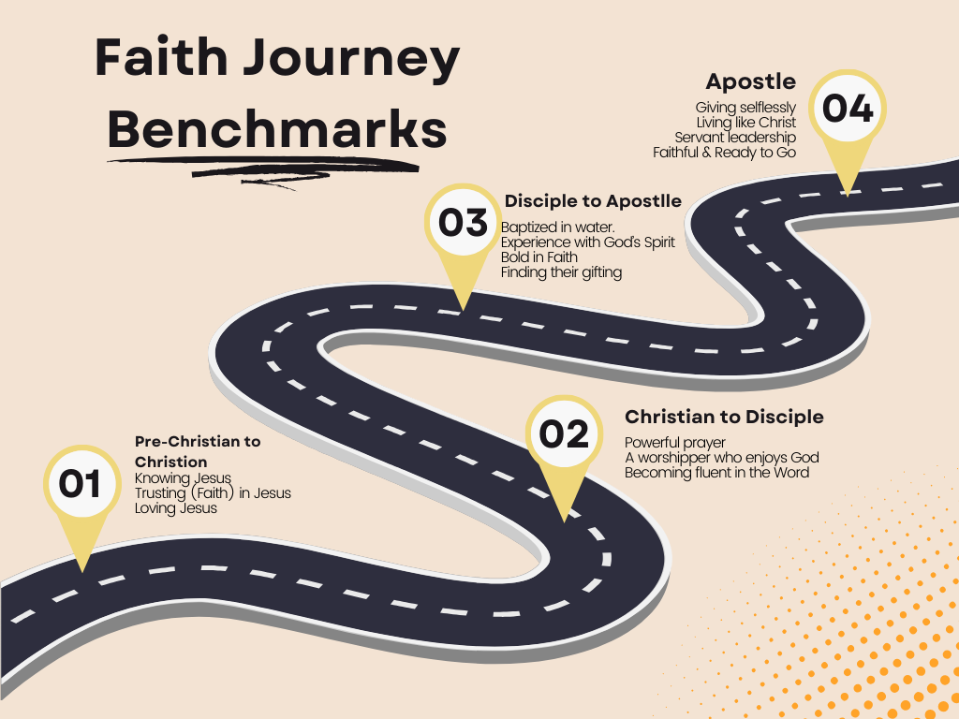

DISCIPLESHIP Benchmarks goals by age.
3-5 yrs old
- Knowing Jesus
- Trusting(faith) Jesus
- Loving Jesus
5-8 yrs old
- Powerful prayer. (Faith!)
- A worshipper who enjoys God.
- A trust in Scripture and becoming fluent in the Word.
9-13 yrs old
- Baptized in water.
- Baptized in Spirit. (A growing experience with God’s Spirit)
- Bold in Faith. Can see themselves being used by God. Starting to understand their gifting.
14+
- Giving selflessly
- Living like Christ
- Servant leadership

These are goals and reminders that we must facilitate growth. We are on the clock with the children under our care.

Conclusion
We must make disciples. We must develop relationships in order to make disciples. We must better assess where people are in their faith journey, and we must have a process to progress them on that journey.
This is a complex plan in that 1 person cannot do it alone. It will take a team, leadership, follow-up, and evaluation while being consistent.
It is also simple plan, because it is meeting someone face to face over coffee and learning more about them. From their it is working together with people who are already ready to lead a small group or Bible study to connect the candidate.
The plan is assessable to the person who just walked into the church and decided to take a next steps class to learn more about the Church. It is designed to transform outsiders into insiders as well as growing disciples.

