Jesus in the Tabernacle 2 – Outer Court & Brazen Altar
• GOALS & GUIDELINES:
• ICEBREAKER: Tell us about the hardest death you ever Had to deal with.
• AGREEMENT PRAYER
- PRAISE
• SCRIPTURE READ

The Tabernacle was a physical building in Exodus, but it is more than physical. A spiritual picture of Jesus is found within every element of the Tabernacle. Last week we talked about the tabernacle itself. Q- How was the physical tabernacle structure a picture of Jesus? (The incarnation was likened by John as a tabernacle dwelling. Like Jesus, it was not beautiful on the outside. The true beauty in Christ & the tabernacle are found once we enter in.)

This week we will talk about the 1st furniture piece - the brazen altar. The altar was located in the “outer court” of the tabernacle. As we study the tabernacle we will discover that there are 3 areas to the tabernacle. Each area is significant and has much to teach us about Jesus.

Walking up to the tabernacle the first image you will see is a curtain fence with only one way into the court. Q- What should this remind us of? (John 10:9 - Jesus) (Additionally the curtain was Blue, Purple, Scarlet representing heaven, royalty, & blood)

As you go through that gate and enter the outer court, a solemn site would confront you. Directly in
your way would be the brazen altar with its sacrifices and perpetual fire. Q- What would happen at the altar?
Q- Is there any significance to the Brazen Altar coming first as you enter God’s dwelling?

The altar was where the death of an animal would occur. The altar had four horns in each of the corners
where the sacrificial animal was bound. These sacrifices went on daily and the command from God was that the fire for this altar was to never go out.

Something else should stand out as you look around... Q-What material is used throughout the outer court?

Everything was made from bronze. The altar itself was made from acacia wood but was completely covered in bronze. All of the utensils were bronze... even the wooden poles used to carry the altar were covered in bronze. Q- Anyone want to guess what bronze is symbolic of in scripture?

A fire that never goes out. Continual sacrificial death. Bloodshed. And bronze everywhere.. It represents God’s continual judgment upon sin. Q- Do we sometimes forget how God feels about sin? Talk about it.

This altar has its fulfilment at the cross. This altar was a picture of the sacrifice for sin that Jesus would
offer at Calvary. But unlike the continual sacrifices of unwilling animals that occurred at the brazen altar in the tabernacle, Jesus was a willing sacrifice that would end all sacrifices. At the brazen altar the animals had to be tied down to the four horns for they didn’t want to die. Yet Jesus went willingly went to the cross saying ‘greater love has no man than to lay down his life for his friends.’

An Israelite would never approach God’s continual judgment of fire without a sacrifice. If Christ is your sacrifice you will never have to experience God’s fiery judgment. But there is a continual fiery place of judgment for those not covered by the blood of the lamb. Q- Tell us about that place called hell.

The Altar was not a place to run from. It was a place to run toward. The altar was also a place of refuge. Many in Israel’s history fled to the altar when they thought they may die and grabbed hold of the horns of the altar. With Jesus as our sacrifice we can come to this altar and grab ahold of grace.
Internal Q- A life in Christ must include an altar. Is Jesus your sacrifice? Are you headed toward God’s judgment? Let’s confess our sin and ask Him to redeem us? Let’s thank Him for His altar and for His sacrifice.
VISION- We need to come with a sacrifice if we are going to approach God’s dwelling.
Goals and Guidelines
- Grow in relationship with each other
- Grow in relationship with God
- Grow in number and multiply
- This is a non-denominational meeting where everyone's thoughts, ideas, and opinions are to be respected. Everyone is welcome and we encourage all to share their feelings.
- We will not argue or debate!
- We place God's Word as the highest authority.
- We all share equally in the ownership of this Connect Group, therefore we will all participate in hosting meetings from house to house on a weekly basis.
- We will be committed to attendance and arriving on time.
- When sharing, we follow 3 simple rules...
Stay on subject, Keep it short & Keep all comments appropriate.
- We will build confidence and trust with each other and become transparent.
- What is said in here stays in here. No gossip!
- Last but not least… We will invite others to our Connect Group!

Exodus 27:1-3 & 8 NIV

“Build an altar of acacia wood, three cubits high; it is to be square, five cubits long and five cubits wide. 2 Make a horn at each of the four corners, so that the horns and the altar are of one piece, and overlay the altar with bronze. 3 Make all its utensils of bronze… 8 ..it is to be made just as you were shown on the mountain.

Exodus 27:9-11 & 16-19 NIV

9 “Make a courtyard for the tabernacle. The south side shall be a hundred cubits long and is to have curtains of finely twisted linen, 10 with twenty posts and twenty bronze bases and with silver hooks and bands on the posts. 11 The north side shall also be a hundred cubits long and is to have curtains, with twenty posts and twenty bronze bases and with silver hooks and bands on the posts.

16 “For the entrance to the courtyard, provide a curtain twenty cubits long, of blue, purple and scarlet yarn and finely twisted linen—the work of an embroiderer—with four posts and four bases. 17 All the posts around the courtyard are to have silver bands and hooks, and bronze bases. 18 The courtyard shall be a hundred cubits long and fifty cubits wide, with curtains of finely twisted linen five cubits high, and with bronze bases. 19 All the other articles used in the service of the tabernacle, whatever their function, including all the tent pegs for it and those for the courtyard, are to be of bronze.

John 10:9 NIV
I am the gate; whoever enters through me will be saved.

VISION- We need to come with a sacrifice if we are going to approach God’s dwelling.

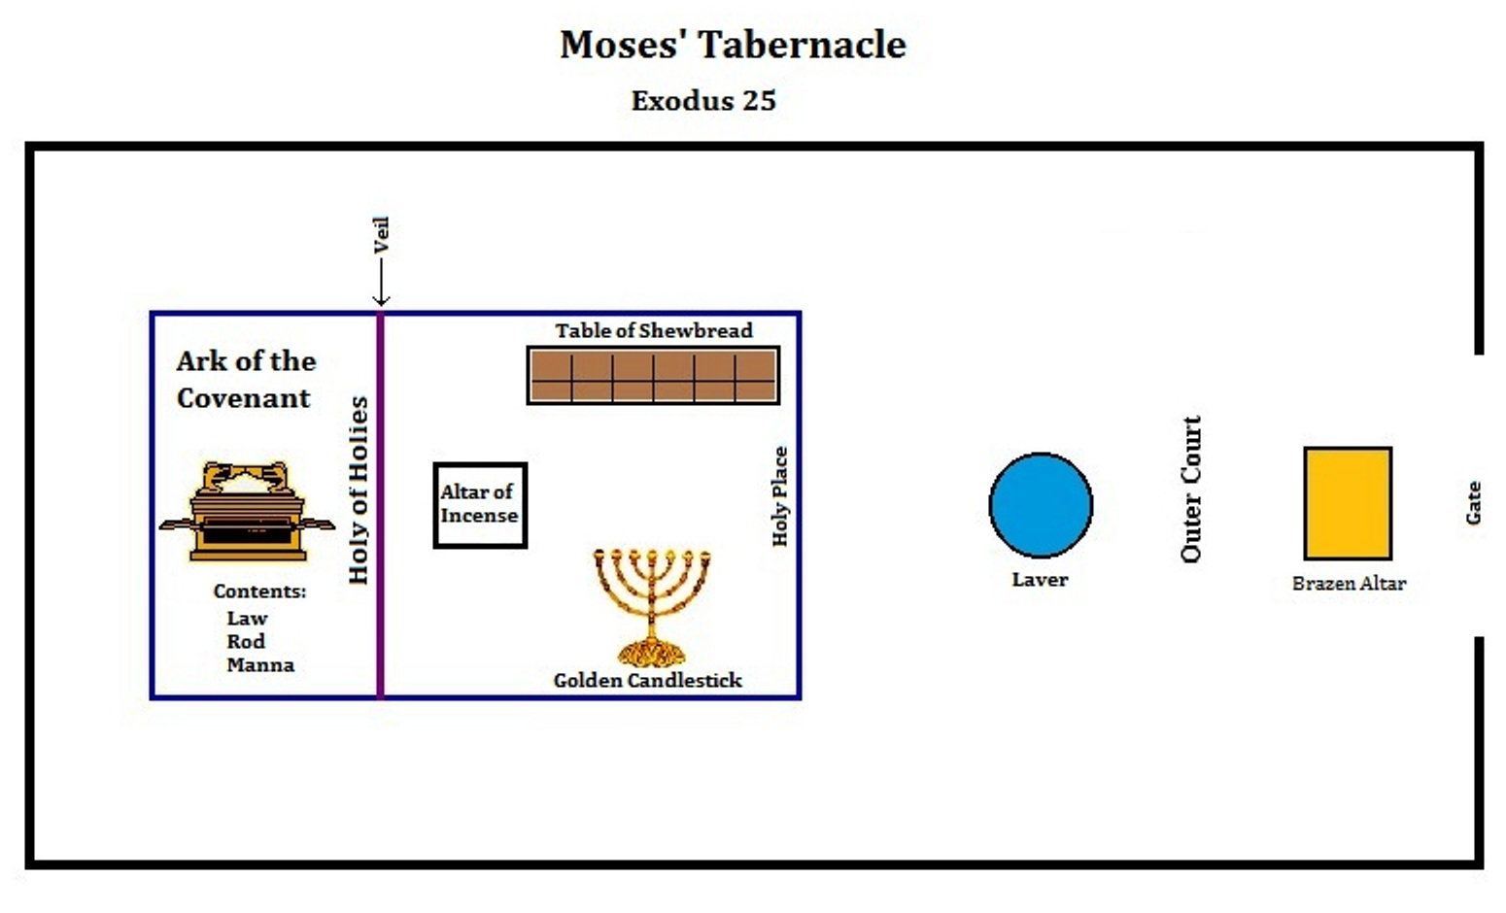
Bird’s Eye View of the Tabernacle Layout. Notice the Outer Court.
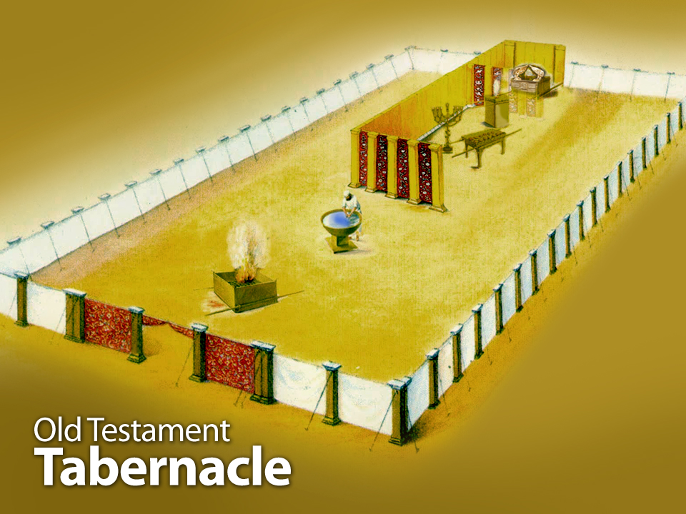
Only 1 way into God’s dwelling. You must enter at the gate, and the first thing you will see is…?
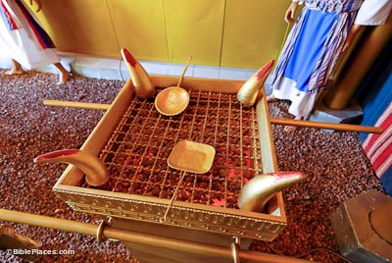
…The Brazen Altar.
Blood, unquenchable fire, & bronze represent God’s judgment of sin. Notice the 4 horns of the altar. The sacrifice would be tied to these horns, yet Jesus freely offered himself. We too are urged to offer our bodies as LIVING sacrifices. (Romans 12:1)

