Jesus in the Tabernacle 3 – Bronze Laver
• GOALS & GUIDELINES:
• ICEBREAKER: Tell us about bath time as a kid.
• AGREEMENT PRAYER
- PRAISE
• SCRIPTURE READ
A spiritual picture of Jesus is found within every element of the Tabernacle. We talked about the outside ugliness of the tabernacle and its inner beauty. Q- How did you enter the outer court of the tabernacle and what does it represent? (There was one gate of entry. Jesus is that Gate) Q- What was the first furniture you would see upon entry into the Tabernacle outer court? What does it symbolize for us? (The Brazen Altar. The cost for sin that Jesus paid on the Cross)

As you moved forward through the tabernacle you would come to the bronze laver. This laver was for the priests to wash from before ministering at the altar or in the holy place. As you approach the laver and peer in you are faced with a horrible sight! As you peer into the laver you are faced with... yourself! The laver was made from the polished bronze that the women used for their mirrors. (Ex 38:8) Q-What was God trying to say here?

In the bronze laver we have water, washing, and a bronze mirror. Q- What is likened to water and washing in scripture? (The Word {Ephesians 5} & baptism {Acts 22:16}) Q- What is likened to a mirror in scripture? (The Word {James 1:23})

There are symbolisms of baptism within the bronze laver. Baptism is a part of a life in Christ, but there is some things that don’t fit this symbolism of the priest washing at the laver. Q- Thoughts on what that might be?
EVERYTIME the priest wanted to enter the presence of God, he had to wash at the brazen altar. Priests did this daily. This is not true of baptism. You don’t need to be baptized EVERYTIME you want to be in God’s presence. We don’t suggest you are baptized daily. Also the priest washes their own self, and in baptism we are baptized by someone else. Instead of Baptism, what God is perfectly illustrating is the constant need to be washed with the water of His word.

As we live in this world, the ways and thoughts of the world rub off onto us just as the earth dirties your feet when you go barefoot. It is inevitable that wrong thinking and some wrong practices will rub off onto us. So how do we clean ourselves of this daily dirt? This is where the word of God comes in. As you receive God’s Word it has a perpetual washing effect.
Q- What are some ways we can receive this cleansing word?

We will give you 3 ways! #1Scripture! As you read Scripture and meditate on His ways it is like pouring water over dirty feet and hands. #2Prayer! As you speak with Jesus, the Word, He will cleanse you. #3The Ministry of the Holy Spirit! It is known as the “Spirit of Truth” that leads you into all truth. The Word of Truth can be reveled through the gifts of the Spirit. We can experience these 3 daily. Scripture/Prayer/Spirit

The Word is a washing water, purifying from worldly ideas, attitudes and behaviors. But that is not all. The bronze laver was also made from mirrors so that those who washed could see themselves. Q- How is the Word like a mirror? And which of our scriptures reveals that the Word is like a mirror?

If we are to progress we must see ourselves. We need to see our unforgiveness, fear, lies, lust, hypocrisy, greed, hatred.. in short – Our Sin! Q- What does bronze symbolize? (judgment) Q- How does the Word represent judgement? (John 12:48)
We will be judged by the word. We must have the Word in our lives. We must let Him confront and correct.
Internal Q- Are you receiving the Word daily? Why not? What is stopping you? What will you do to change this? Do you understand that one day we will all be judged by the Word? What sin is the Word confronting in your life right now? {Pray}

VISION- We need to be washed in the Word daily. We need to see ourselves at the bronze laver.
Goals and Guidelines
- Grow in relationship with each other
- Grow in relationship with God
- Grow in number and multiply
- This is a non-denominational meeting where everyone's thoughts, ideas, and opinions are to be respected. Everyone is welcome and we encourage all to share their feelings.
- We will not argue or debate!
- We place God's Word as the highest authority.
- We all share equally in the ownership of this Connect Group, therefore we will all participate in hosting meetings from house to house on a weekly basis.
- We will be committed to attendance and arriving on time.
- When sharing, we follow 3 simple rules...
Stay on subject, Keep it short & Keep all comments appropriate.
- We will build confidence and trust with each other and become transparent.
- What is said in here stays in here. No gossip!
- Last but not least… We will invite others to our Connect Group!

Exodus 30:18-20 NIV

“Make a bronze basin, with its bronze stand, for washing. Place it between the tent of meeting and the altar, and put water in it. 19 Aaron and his sons are to wash their hands and feet with water from it. 20 Whenever they enter the tent of meeting, they shall wash with water so that they will not die.

Exodus 38:8 NIV

They made the bronze basin and its bronze stand from the mirrors of the women who served at the entrance to the tent of meeting.

James 1:23 NIV

23 Anyone who listens to the word but does not do what it says is like someone who looks at his face in a mirror 24 and, after looking at himself, goes away and immediately forgets what he looks like. 25 But whoever looks intently into the perfect law that gives freedom, and continues in it—not forgetting what they have heard, but doing it—they will be blessed in what they do.

Ephesians 5:25-27 (NIV)

…Christ loved the church and gave himself up for her 26 to make her holy, cleansing her by the washing (Laver) with water through the word, 27 and to present her to himself as a radiant church, without stain or wrinkle or any other blemish, but holy and blameless.

John 12:48 (NIV) There is a judge for the one who rejects me and does not accept my words; the very words I have spoken will condemn them at the last day.

VISION- We need to be washed in the Word daily. We need to see ourselves at the bronze laver.

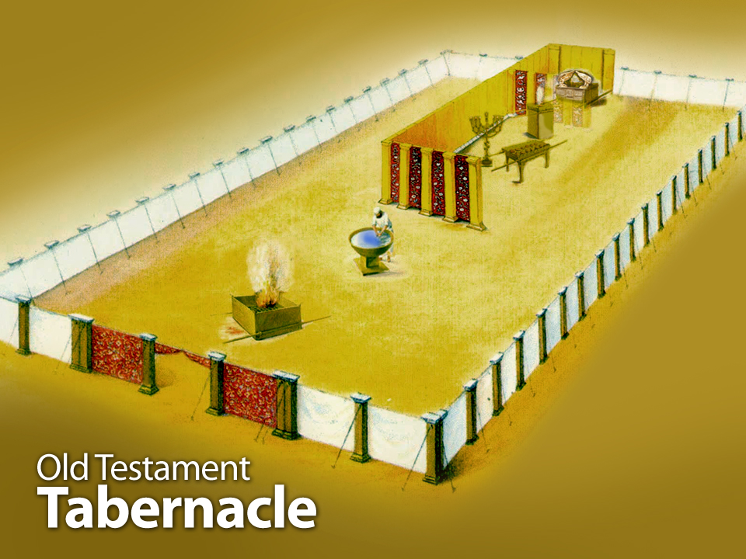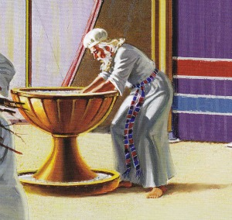
The bloody mess of the sacrifice at the brazen altar would be washed away at the bronze laver.

Washing at the Bronze Laver was required in order for the priest
to enter into the inner court also called the Holy Place.
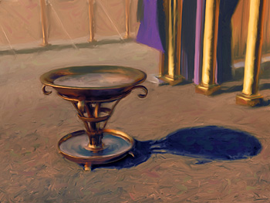
It wasn’t just a splash of water. There was need for a full body cleaning.
The feet of the Priest needed to also be washed.
The Word of God can cleanse every part of our life.
