Jesus in the Tabernacle 4 – Table of Showbread
• GOALS & GUIDELINES:
• ICEBREAKER: Tell us about your favorite kind of bread…
• AGREEMENT PRAYER
- PRAISE
• SCRIPTURE READ
A spiritual picture of Jesus is found within every element of the Tabernacle. We have talked about the outer court that featured bronze, an altar, and a washing laver. The outer court emphasized judgement & sacrifice, but as we leave the outer court and enter inside the tabernacle we find something brand new.

Past the brazen laver was a curtain, and past that curtain was a room called the Holy Place. Only priests & Levites (descendants of Levi) were allowed in the Holy Place. Coming into the Holy Place the first article on the right is the Table of Showbread. This table had twelve loaves of bread on it. Lev 24:5-9 tells us that the showbread was made of fine flower and set on the table, sprinkled lightly with frankincense. The bread could be eaten by the priests only and was replaced weekly, on Sabbath.

Q- How does this Table of Showbread represent Jesus? Q- What materials was the Table made of? What might they symbolize?

The Table was made of acacia wood and overlaid with gold. Acacia wood is an amazing lumber that is resistant to rotting. It represents Jesus’ humanity who never sinned. And then the gold symbolizes Deity. Jesus is fully human & fully God. He is acacia wood overlaid in gold. What a beautiful picture of the incarnation!

Q- What about the bread? How does that represent Jesus? (John 6:35)(Pulverized grain=Jesus on the Cross)
Q- The bread was “unleavened” how does that represent Jesus?

Leaven is symbolic of sin & pride that puffs up bread. Jesus was sinless. The bread that represents Jesus is unleavened. Jesus declares Himself to be the bread that will solve our hunger. There were also 12 loaves that represent all the 12 tribes of Israel, just like Jesus is the provision for all. No one is left out of his provision. They just need to walk up and receive like the priest would walk up to the table of showbread. God wants you to come to His presence to RECEIVE!

Q- Perhaps the table reminds you of communion? Talk about it.

Communion is a remembrance of the Lord and his sacrifice. It includes food & drink. Notice in Exodus 25:29 that it mentions pitchers & bowls. The Table in the Holy Place offered food & drink, bread & wine. The wine was to be drunk by the priest unto the Lord, and also the wine would be poured out unto the Lord. The Priest would pour the drink upon the ground as an offering. This shows us how Jesus’ blood was poured out upon the earth for everyone. It also encourages us to pour out offerings of worship and obedience to the Lord.
We are to feed on the person of Jesus. He is everything we need. His flesh is real food. His blood is real drink. Q- How do we feed on Jesus? How do we get our life from Him?

We are invited past the outer court. Jesus invites us to go further. We are invited into eternal life. That invitation isn’t in the future, it is NOW. “Whoever eats my flesh and drinks my blood HAS eternal life.”

The bread is called “Bread of the presence” in Exodus 25:30. We need God’s presence. We need more than words of scripture printed in a book. We need God’s presence. We need relationship with Jesus the Word. We need this DAILY BREAD of His presence. Let’s ask for His presence now.
Internal Q- Do you experience God’s Word daily? Do you experience His presence daily? Are you having a daily relationship with the bread of life? Will you pursue this relationship with Jesus? Specifically decide how you will pursue this relationship every day. {Pray}

VISION- Feed on the bread of life daily. Experience His presence daily.
Goals and Guidelines
- Grow in relationship with each other
- Grow in relationship with God
- Grow in number and multiply
- This is a non-denominational meeting where everyone's thoughts, ideas, and opinions are to be respected. Everyone is welcome and we encourage all to share their feelings.
- We will not argue or debate!
- We place God's Word as the highest authority.
- We all share equally in the ownership of this Connect Group, therefore we will all participate in hosting meetings from house to house on a weekly basis.
- We will be committed to attendance and arriving on time.
- When sharing, we follow 3 simple rules...
Stay on subject, Keep it short & Keep all comments appropriate.
- We will build confidence and trust with each other and become transparent.
- What is said in here stays in here. No gossip!
- Last but not least… We will invite others to our Connect Group!

Exodus 25:3-30 NIV

23 “Make a table of acacia wood—two cubits long, a cubit wide and a cubit and a half high. 24 Overlay it with pure gold and make a gold molding around it. 25 Also make around it a rim a handbreadth wide and put a gold molding on the rim. 26 Make four gold rings for the table and fasten them to the four corners, where the four legs are. 27 The rings are to be close to the rim to hold the poles used in carrying the table. 28 Make the poles of acacia wood, overlay them with gold and carry the table with them. 29 And make its plates and dishes of pure gold, as well as its pitchers and bowls for the pouring out of offerings. 30 Put the bread of the Presence on this table to be before me at all times.

Leviticus 24:5-9 NIV

“Take the finest flour and bake twelve loaves of bread, using two-tenths of an ephah[a] for each loaf. 6 Arrange them in two stacks, six in each stack, on the table of pure gold before the Lord. 7 By each stack put some pure incense as a memorial[b] portion to represent the bread and to be a food offering presented to the Lord. 8 This bread is to be set out before the Lord regularly, Sabbath after Sabbath, on behalf of the Israelites, as a lasting covenant. 9 It belongs to Aaron and his sons, who are to eat it in the sanctuary area, because it is a most holy part of their perpetual share of the food offerings presented to the Lord.”

John 6:35 NIV

Jesus declared, “I am the bread of life. Whoever comes to me will never go hungry, and whoever believes in me will never be thirsty.

John 6:54-56 (NIV)

54 Whoever eats my flesh and drinks my blood has eternal life, and I will raise them up at the last day. 55 For my flesh is real food and my blood is real drink. 56 Whoever eats my flesh and drinks my blood remains in me, and I in them.

VISION- Feed on the bread of life daily. Experience His presence daily.

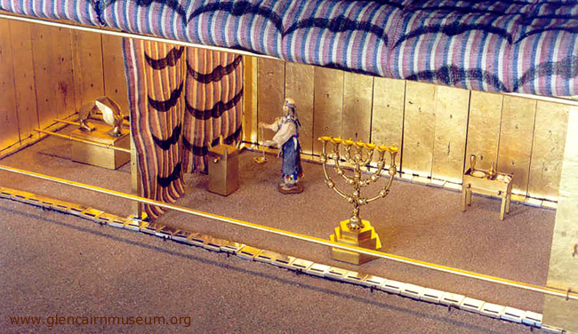
The Inner Court is also called the Holy Place. The Table of Showbread is found within. Only a Priest of the Lord can come partake of this table.
The Table is acacia wood overlaid in gold. Here we see a depiction of the incarnation. Acacia wood represents Christ’s sinless humanity and the gold represents his Deity.
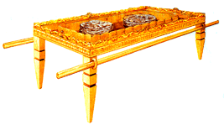
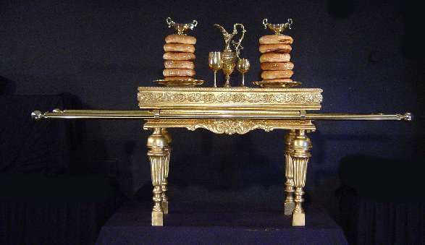
A place of provision within his presence.
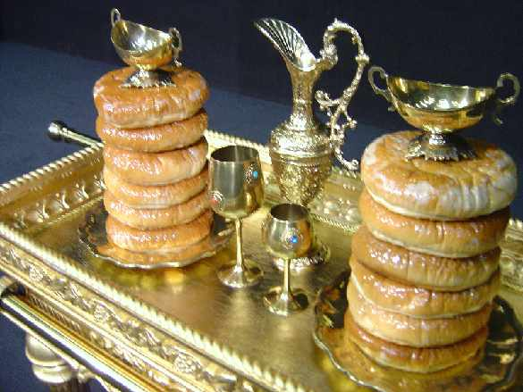
The bread is unleavened – representing a sinless Christ.
This was a daily bread for those who enter His presence.
The presence of wine is also representative of communion.

