Jesus in the Tabernacle 5 – The Lampstand
• GOALS & GUIDELINES:
• ICEBREAKER: Talk about attempting to do something in the dark…
• AGREEMENT PRAYER
- PRAISE
• SCRIPTURE READ
Jesus is found in every element of the tabernacle. Every fabric, every metal, every wood, every furniture piece, everything points to Jesus.

The outer court received light from the sun, but inside the inner court known as the “holy place,” a light source was needed. God gave Moses specific instruction for building a lampstand. Q- What material was the lampstand made of?

Many of the furniture pieces are made of acacia wood and overlaid with gold, but not the lampstand. It is made of gold singularly. We spoke last week that acacia wood represented humanity & gold represented deity. Right away we should understand that the light source within the tabernacle would be divine.

The priests needed a light source in order to do their work. Q- Why wouldn’t God put a window in the tabernacle or allow the priests to carry an external light? Is there a message here…?

God came up with the design for the tabernacle. His design would satisfy every need. We need to understand that God’s design will satisfy all our needs! We also don’t need to bring an external light with us because God wants to be our light source. Even in the Old Testament God was pointing us to his design of a singular light source. Q- WHO is the light source for the entire world? Use our scripture… (John 8:12)

Jesus is the lampstand. He declared that He is the light of the world. We will never walk in darkness when He is our light source. He is the light of life.

In our icebreaker we talked about attempting to do something in the dark. It is always easier to do something in the light. We are more effective in our relationships when we have the light of Jesus. Trying to build our lives, education, careers, and experience personal growth is so much better in God’s light. Good luck trying to serve people without the light of life! Without His light we often bump around, stump our toes, and become frustrated. We need a light source. It is God’s design that we have the light source of Jesus.

The Light, Jesus Christ, declares another light of the world. Q- What is this light? (Matthew 5:14)
Jesus says YOU are the light of the world. He then says the proper place for such a light is on a lampstand to give light to everyone in the house. God designed a light source. We understand that Jesus is that light source, but do you understand that God has designed you to shine His light? Q- How can we be a light source for the world?

Upon the lampstand are 7 cups. The cups are filled with oil and a trimmed wick to bear light. There are many lamps yet one lampstand. Exodus 25:36 says that they are all ONE PIECE of pure gold. Q- What do you think this represents? (We are all separate light bearers yet we are all one in Jesus Christ – the Light.)

Q- How often was the light to burn on the lampstand? Q- What needed to be maintained on the lampstand? And what does this symbolize?

The lampstand needed oil and wicks trimmed. The oil represents the Holy Spirit that only Jesus can give. The wick trimming represents the cutting away of unprofitable things from our life so that the light/Jesus would shine brighter. Jesus is the lampstand, but He calls you and me to shine His light.

Internal Q- Is Jesus your light source? Have you been trying to work in darkness? Are you His light source to the world? Are you shinning constantly with filled oil and trimmed wick?{Pray}

VISION- God designed a light source. It is Jesus and it is you, with Jesus within you.
Goals and Guidelines
- Grow in relationship with each other
- Grow in relationship with God
- Grow in number and multiply
- This is a non-denominational meeting where everyone's thoughts, ideas, and opinions are to be respected. Everyone is welcome and we encourage all to share their feelings.
- We will not argue or debate!
- We place God's Word as the highest authority.
- We all share equally in the ownership of this Connect Group, therefore we will all participate in hosting meetings from house to house on a weekly basis.
- We will be committed to attendance and arriving on time.
- When sharing, we follow 3 simple rules...
Stay on subject, Keep it short & Keep all comments appropriate.
- We will build confidence and trust with each other and become transparent.
- What is said in here stays in here. No gossip!
- Last but not least… We will invite others to our Connect Group!

Exodus 25:31-33 & 36-38 NIV 31 “Make a lampstand of pure gold. Hammer out its base and shaft, and make its flowerlike cups, buds and blossoms of one piece with them. 32 Six branches are to extend from the sides of the lampstand—three on one side and three on the other. 33 Three cups shaped like almond flowers with buds and blossoms are to be on one branch, three on the next branch, and the same for all six branches extending from the lampstand. 36 The buds and branches shall all be of one piece with the lampstand, hammered out of pure gold. 37 “Then make its seven lamps and set them up on it so that they light the space in front of it. 38 Its wick trimmers and trays are to be of pure gold.

Exodus 27:20-21 NIV “Command the Israelites to bring you clear oil of pressed olives for the light so that the lamps may be kept burning. 21 In the tent of meeting, outside the curtain that shields the ark of the covenant law, Aaron and his sons are to keep the lamps burning before the Lord from evening till morning. This is to be a lasting ordinance among the Israelites for the generations to come.

John 8:12 (NIV)

…Jesus said, “I am the light of the world. Whoever follows me will never walk in darkness, but will have the light of life.”

Matthew 5:14-16 NIV “You are the light of the world. A town built on a hill cannot be hidden. 15 Neither do people light a lamp and put it under a bowl. Instead they put it on its stand, and it gives light to everyone in the house. 16 In the same way, let your light shine before others, that they may see your good deeds and glorify your Father in heaven.

VISION- God designed a light source. It is Jesus and it is you, with Jesus within you.

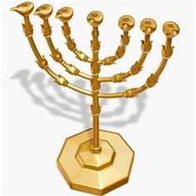
The Lampstand was made of Gold and no other materials. It represents divine Deity with no division. Christ’s Church should shine the light without division as well.
It was up to the priests to keep the light burning in the Holy Place.
They would refill the oil and trim the wicks.
Perhaps this reminds us of Jesus’ parable of the wise & foolish virgns?
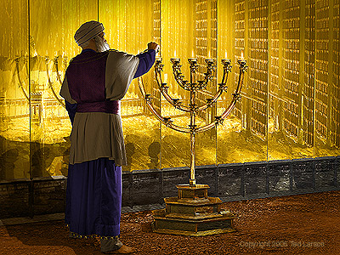
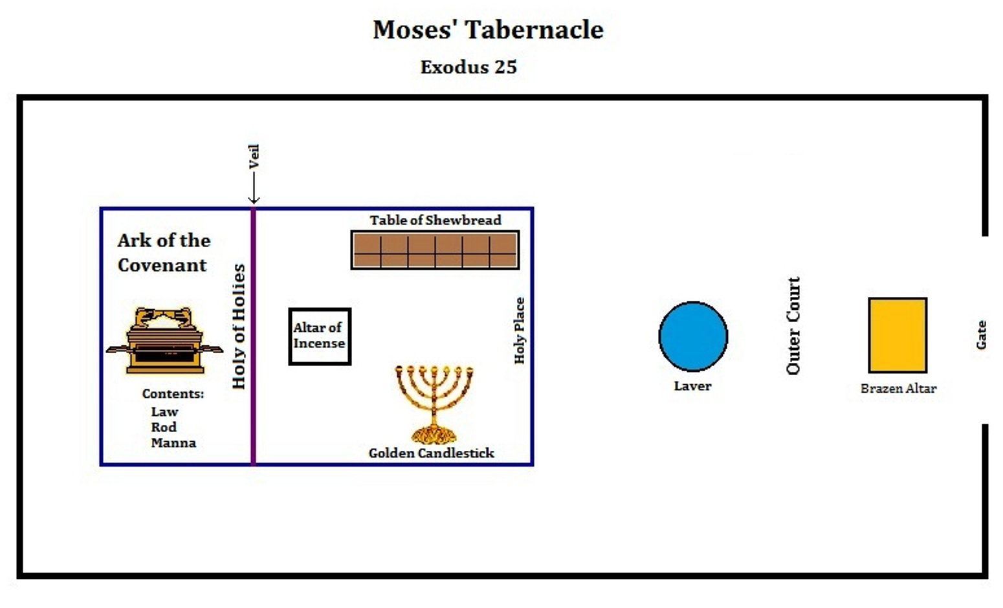
The Lampstand/Golden Candlestick was the only light source in the Holy Place.
God’s design provides all that we need.

