Jesus in the Tabernacle 6 – The Altar of Incense
• GOALS & GUIDELINES:
• ICEBREAKER: I love the smell of…
• AGREEMENT PRAYER
- PRAISE
• SCRIPTURE READ
Jesus is found in every element of the tabernacle. From the outer court to the holy of holies, it is all about Jesus. The last 2 meetings we have discussed the elements inside the Holy Place. Q- What was the major material used in the outer court and what did it represent? (Bronze represented judgment/sacrifice)

Q- What is the major material used inside the Holy Place and what might it be teaching us?

Gold is everywhere in the Holy Place and it represents Deity. Whereas the outer court is about judgment and sacrifice, in the Holy Place we receive from God. We receive bread & wine from the table, and light from His lampstand, and we also receive from the final furniture element in the Holy Place.

Inside the Holy Place the Altar of Incense is the piece closest to the last area of the tabernacle, the Holy of Holies, beyond the Veil. This altar is made from acacia wood with a gold overlay and is only to be used by the High Priest. On this altar the High Priest would burn sweet smelling incense. Q- How often would the burning of incense take place?

The burning of incense would be every morning & every evening. Q- Do you know what incense is a picture of in the Bible? What does incense symbolize? (Hint: look at scripture)

The altar of incense is specifically tied to prayer, such as Psalm 141 & Revelation 8. Q- Given this symbolism, how important is daily prayer in the life of a Christian? What do you think? Q- Can you think of any verses that reveals a Christ centered symbolism within the altar of incense?

Only the High Priest can offer up the incense in the tabernacle. Our High Priest is Jesus Christ. Hebrews 7 says He is our High Priest forever. Unlike earthly high priests who would die and another would replace them, Jesus will never be replaced.

Jesus makes intercession for us constantly. The golden altar of incense speaks of Christ’s intercession for us on the cross. Remember when Jesus prayed for us on the cross? “Father, forgive them. They know not what they do.” The altar of incense also symbolizes the life of a Christian offering up prayer & praise.

We are to offer up prayers, intercession, and praise – daily. Your prayer, intercession, & praise is a sweet smelling fragrance to God. He loves it. And just as the fire burnt continually on the altar of incense, the New
Testament tells us to pray continuously (1 Thes 5:17). This doesn’t mean that we are continually in one long
monotonous prayer throughout the day, but we should maintain an attitude where we are ready to offer up prayer and praise to God throughout the day. Q- How can we maintain an attitude of prayer & praise throughout the day?

The oil used at the altar of incense was one of a kind. The formula is in Exodus 30, but there is also a command that this formula is not to be used for any other purpose. God has copyrighted the use of this oil. Q- Why do you think God did this?

No one can replace or duplicate Christ! He is unique! For someone to take and use this particular fragrance upon himself would be to say that they are acceptable to God in and of themselves. Only through the acknowledgement of Jesus Christ, can the Holy of Holies be opened to us. Only through a lifestyle of prayer & praise can we go deeper.. past the veil and into God’s presence.
Internal Q- Do we understand that Jesus intercedes for us daily? Do we offer up praise & prayer daily? Are we thankful people who bring a sweet smelling fragrance to God? Do we have a continual fire in our life? Are we daily Christians or weekly Christians?{Pray}
VISION- We need an altar of incense. We need prayer & praise daily.
Goals and Guidelines
- Grow in relationship with each other
- Grow in relationship with God
- Grow in number and multiply
- This is a non-denominational meeting where everyone's thoughts, ideas, and opinions are to be respected. Everyone is welcome and we encourage all to share their feelings.
- We will not argue or debate!
- We place God's Word as the highest authority.
- We all share equally in the ownership of this Connect Group, therefore we will all participate in hosting meetings from house to house on a weekly basis.
- We will be committed to attendance and arriving on time.
- When sharing, we follow 3 simple rules...
Stay on subject, Keep it short & Keep all comments appropriate.
- We will build confidence and trust with each other and become transparent.
- What is said in here stays in here. No gossip!
- Last but not least… We will invite others to our Connect Group!

Exodus 25:31-33 & 36-38 NIV 31 “Make an altar of acacia wood for burning incense. 2 It is to be square, a cubit long and a cubit wide, and two cubits high[a]—its horns of one piece with it. 3 Overlay the top and all the sides and the horns with pure gold, and make a gold molding around it. 4 Make two gold rings for the altar below the molding—two on each of the opposite sides—to hold the poles used to carry it. 5 Make the poles of acacia wood and overlay them with gold. 6 Put the altar in front of the curtain that shields the ark of the covenant law—before the atonement cover that is over the tablets of the covenant law—where I will meet with you.
7 “Aaron must burn fragrant incense on the altar every morning when he tends the lamps. 8 He must burn incense again when he lights the lamps at twilight so incense will burn regularly before the Lord for the generations to come. 9 Do not offer on this altar any other incense or any burnt offering or grain offering, and do not pour a drink offering on it. 10 Once a year Aaron shall make atonement on its horns. This annual atonement must be made with the blood of the atoning sin offering for the generations to come. It is most holy to the Lord.”

Psalm 141:2 NIV May my prayer be set before you like incense; may the lifting up of my hands be like the evening sacrifice.

Revelation 8:3-4 (NIV) Another angel, who had a golden censer, came and stood at the altar. He was given much incense to offer, with the prayers of all God’s people, on the golden altar in front of the throne. 4 The smoke of the incense, together with the prayers of God’s people, went up before God from the angel’s hand.

Hebrews 7:23-25 NIV 23 Now there have been many of those priests, since death prevented them from continuing in office; 24 but because Jesus lives forever, he has a permanent priesthood. 25 Therefore he is able to save completely those who come to God through him, because he always lives to intercede for them.
VISION- We need an altar of incense. We need prayer & praise daily.

Notice the location of the Altar of Incense. It is the nearest object to the veil.
The high priest was to keep the fire of the altar of incense going daily
and offer sweet incense in the morning and evening.
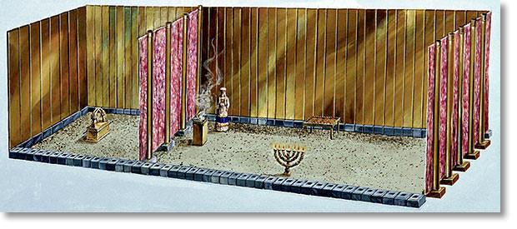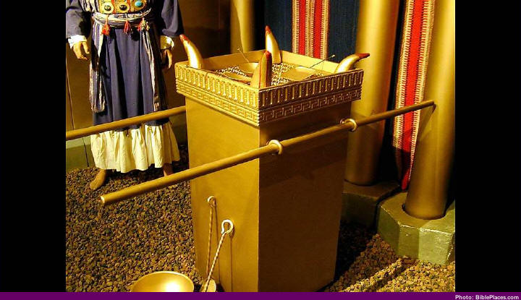
Notice the 4 horns. We saw those horns used on the brazen altar. There is not animal sacrificed here but there is a free will submission in worship at the altar of incense.
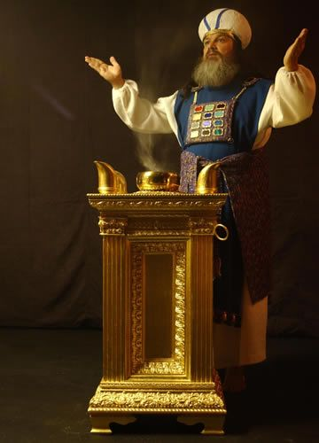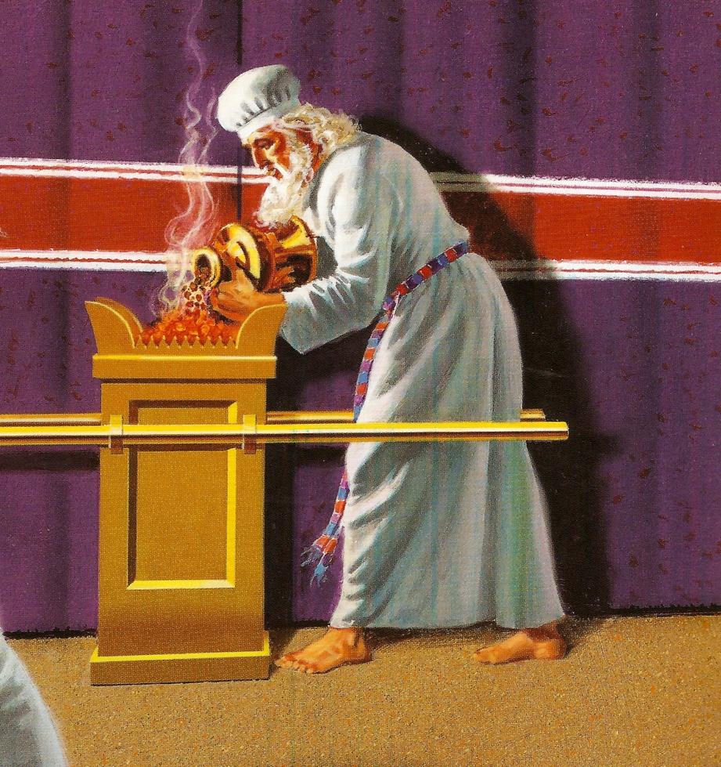
God wants daily worship.
God commands that we keep the fire burning daily!

Jesus, our high priest forever, continually offers up intercession for us, which is symbolic of incense.

