Jesus in the Tabernacle 7 – The Veil
• GOALS & GUIDELINES:
• ICEBREAKER: Tell us about a time you received VIP access…
• AGREEMENT PRAYER
- PRAISE TO BE DONE AT INTERNAL Q!!!
• SCRIPTURE READ
Q- Can we list the furniture pieces we have discussed in our series? Can we do them in order?
We have walked into the outer court and past the Brazen Altar & Brazen Laver. We have entered the inner court/Holy Place and witnessed the table of showbread, the lampstand, and the altar of incense. Q- With those elements behind us, what lies before us? (The veil, the holy of holies, the ark of the covenant)

The Outer court showed us that Jesus is the Way. The Holy place showed us that Jesus is the Truth. The Holy of Holies will give us a glimpse of Jesus as our Life. The presence and power of God present within the Holy of Holies is that same presence that is essential to living the Christian life today.

There is a veil that separates the Holy Place from the Holy of Holies. This was no ordinary veil. Q- Describe the veil from our reading in Exodus 26. Q- Anyone want to guess what the colors blue, purple, & scarlet symbolize? (Blue=The heavens, Purple=Royalty, Scarlet=redemption from sin/blood/the messiah)

This was no ordinary curtain. The ancient historian Josephus, reported that the veil was four inches thick and that it was renewed every year, and that horses tied to each side could not pull it apart. It was a very heavy cloth veil that no one could accidently pass through. Q- Why is it a good thing that someone couldn’t accidently wander past the heavy cloth?

Only the High Priest could enter the Holy of Holies, and they could only do it 1 time a year on the day of atonement. The high priest could only enter after much consecration. Anyone else who entered the holy of holies would die. Q- What is God trying to show us here?

God is not trying to show us that He doesn’t want us to come near him. God is showing us the cost of sin. God’s holy presence cannot mix with sin. The High Priest was only allowed to enter under an extreme measure of grace. The nature of His Holiness stands in judgment against the nature of sin. The barrier of the veil actually kept God’s judgment from killing all in the tabernacle! Q- Knowing that the veil is an essential barrier between God’s Holy presence and sinners, what does Mark 15:38 mean?

The 4 inch thick veil that horses could not rip, was ripped from the top to the bottom. It was ripped from heaven to earth as Jesus died on the cross. Q- What do you think the priests in the holy place thought when the veil ripped opening the Holy of Holies to them? (Have someone read Acts 6:7 on their phone – some came to faith eventually)

Q- What does our scripture in Hebrews 10 liken the curtain/veil to?

The body of Jesus is our veil. When his body was opened through the sacrifice on the cross, the veil in the temple was torn. The presence of God that was never available, is now available to all who come through the veil – Jesus Christ. He is the door for all to enter into God’s presence.

Q- How does this change things?

You don’t have to stop at the brazen altar or the laver. You don’t have to stop at the table of showbread, the lampstand, or the altar of incense. You can go beyond the veil. God wants you to come.

Internal Q- Have you gone beyond the veil? You can go into his presence daily. Through faith in Jesus you are welcomed in God’s presence. A sinner like you and me are accepted in the holy of holies. Let’s worship God and enter his presence together.
{worship (o come to the altar) then pray}
VISION- The body of Jesus is the veil. Jesus is our entry to God’s presence. Enter His presence daily.
Goals and Guidelines
- Grow in relationship with each other
- Grow in relationship with God
- Grow in number and multiply
- This is a non-denominational meeting where everyone's thoughts, ideas, and opinions are to be respected. Everyone is welcome and we encourage all to share their feelings.
- We will not argue or debate!
- We place God's Word as the highest authority.
- We all share equally in the ownership of this Connect Group, therefore we will all participate in hosting meetings from house to house on a weekly basis.
- We will be committed to attendance and arriving on time.
- When sharing, we follow 3 simple rules...
Stay on subject, Keep it short & Keep all comments appropriate.
- We will build confidence and trust with each other and become transparent.
- What is said in here stays in here. No gossip!
- Last but not least… We will invite others to our Connect Group!

Exodus 26:31-34 NIV 31 “Make a curtain of blue, purple and scarlet yarn and finely twisted linen, with cherubim woven into it by a skilled worker. 32 Hang it with gold hooks on four posts of acacia wood overlaid with gold and standing on four silver bases. 33 Hang the curtain from the clasps and place the ark of the covenant law behind the curtain. The curtain will separate the Holy Place from the Most Holy Place. 34 Put the atonement cover on the ark of the covenant law in the Most Holy Place.

Leviticus 26:2 NIV 2 The Lord said to Moses: “Tell your brother Aaron that he is not to come whenever he chooses into the Most Holy Place (Holy of Holies) behind the curtain in front of the atonement cover on the ark, or else he will die. For I will appear in the cloud over the atonement cover.

Hebrews 9:7 NLV ..only the high priest ever entered the Most Holy Place, and only once a year. And he always offered blood for his own sins and for the sins the people had committed..

Mark 15:37-38 (NIV) 37 With a loud cry, Jesus breathed his last. 38 The curtain of the temple was torn in two from top to bottom.

Hebrews 10:19-22 NIV 19 Therefore, brothers and sisters, since we have confidence to enter the Most Holy Place by the blood of Jesus, 20 by a new and living way opened for us through the curtain, that is, his body, 21 and since we have a great priest over the house of God, 22 let us draw near to God…
VISION- The body of Jesus is the veil. Jesus is our entry to God’s presence. Enter His presence daily.

The veil was 4 inches thick. It served as a barrier between us and God’s Holy Presence.
Only the High Priest was allowed past the veil, and it happened only 1 time a year.
The High Priest was allowed past the veil to make atonement for the sins of all.
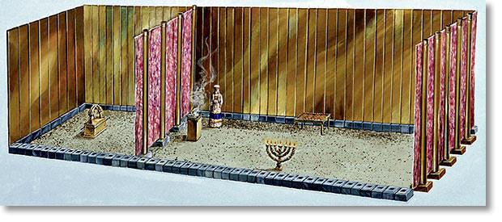
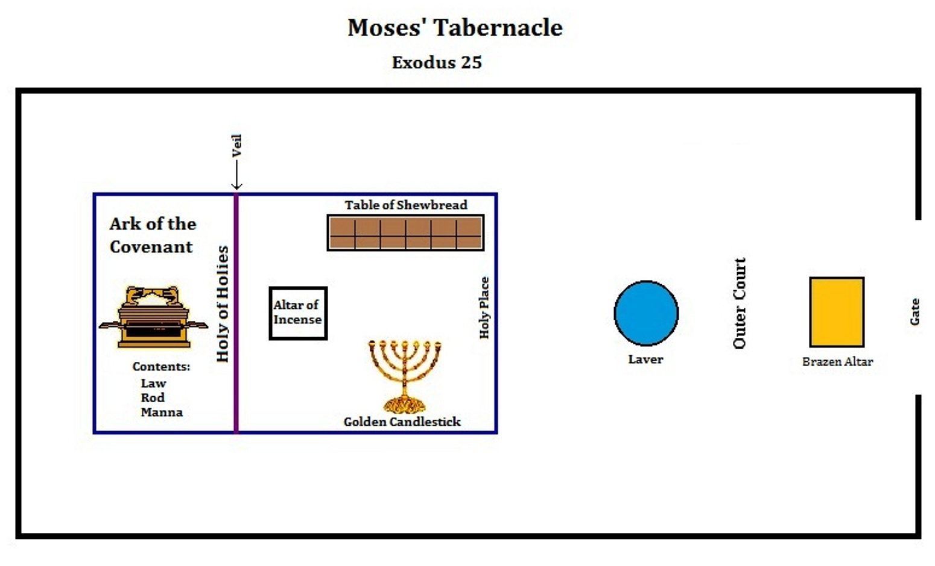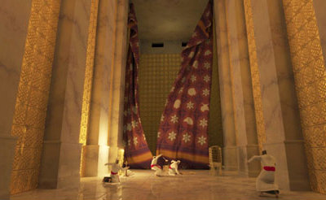
The veil was ripped from heaven to earth when Jesus died on the cross. Jesus made atonement once and for all. Hebrews says His body was the veil that was ripped allowing us entry into God’s presence.

