FIRST
STEPS

TABLE OF CONTENTS

STEP ONE 5

STEP TWO 18

STEP THREE 40

STEP FOUR 49

APPENDICES 55



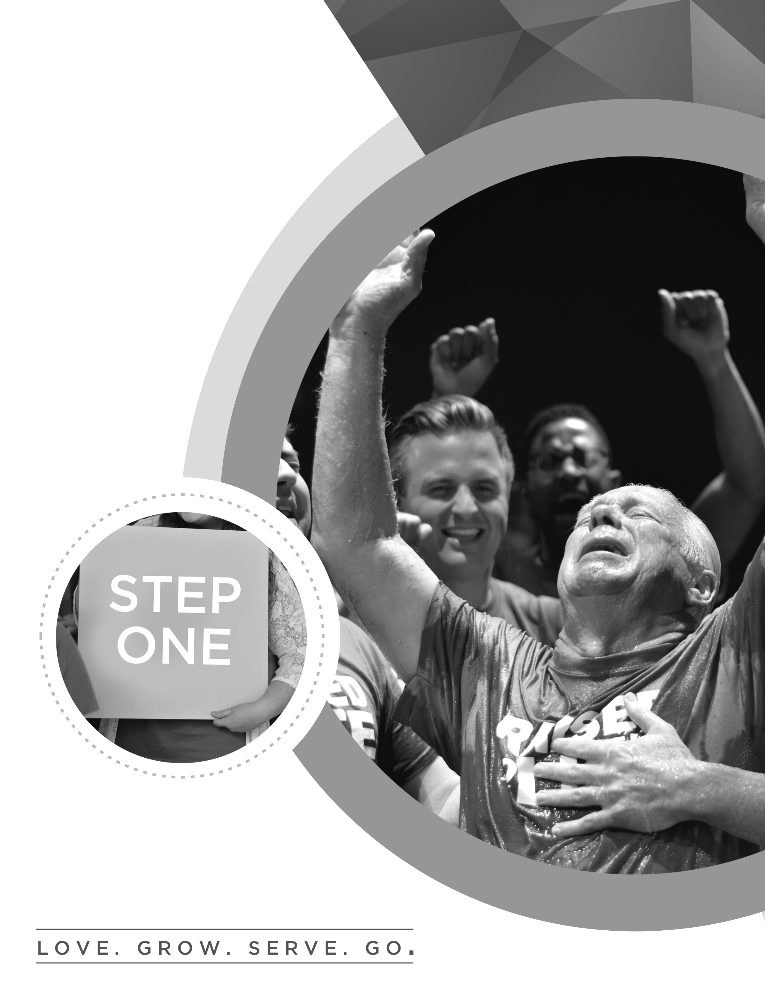
W H O W E A R E
stepONE

I HAVE COME THAT THEY MAY HAVE LIFE AND HAVE IT TO THE FULLEST.

JOHN 10:10

WELCOME TO FIRST STEPS!
We’re glad you’ve chosen to find out more about First Church! Today is the basic introduction to what we value as a church family. Since we have members from many different church backgrounds, today was designed to clearly explain who we are and what we value.

FIRST STEPS guides you to discover your purpose and live the life God created for you. FIRST STEPS is made up of four steps that equip you to follow Jesus, connect to the church, discover your purpose, and serve others.

stepONE – WHO WE ARE
Step One happens the first Sunday of every month in conjunction with Pastor’s Lunch. Today, you’ll hear the First Church story and find out what we’re all about. At the end, you’ll get a chance to become a member of this amazing family!

stepTWO – WHO YOU ARE
Discover your personality and gifts and see how they indicate your purpose in life and your best fit in ministry. We believe everyone was created with a God-given purpose, and one of the reasons we exist as a church is to help you discover that purpose and get plugged in to it. Step Two happens the second Sunday of every month.

stepTHREE – WHY YOU’LL LOVE IT HERE
Explore the ministry focus of First Church and find out what makes us unique. We use Step Three to answer some important questions that you’re probably already asking! Step Three happens the third Sunday of every month.

stepFOUR – JOIN THE TEAM
We want to get you connected to a team as quickly as possible…because there’s nothing as fulfilling as making a difference in someone else’s life! Connect to the opportunities available at First Church to live out your purpose and serve others by using your gifts. Step Four happens the fourth Sunday of every month.

OUR PRAYER FOR YOU

“I keep asking that the God of our Lord Jesus Christ, the glorious Father, may give you the Spirit of wisdom and revelation, so that you may know him better. I pray that the eyes of your heart may be enlightened in order that you may know the hope to which he has called you, the riches of his glorious inheritance in his holy people.”
Ephesians 1:17-18

OUR STORY

When Pastor Ken Gurley came to First Church, he dreamed of a church with a simple goal - helping people connect with God so that they might reach their full potential. From that guiding principle, First Church focused on reaching out to the non-churched community by building relationships. The life-giving message of the Gospel, the passion and joy of Sunday services, and the simple engaging style of First Church brought immediate growth.

Today, over one thousand people attend the weekend services and several thousand more are members at a distance through our Online Campus. God is at work at First Church. We invite you to see for yourself how exciting church can be when the focus is simple and people are free to go after God with passion!

YOUR STORY
The focus of First Church is four-part:
1. LOVE God.

2. GROW in Faith.

3. SERVE others.

4. GO change the world.

THIS IS THE DNA of FIRST CHURCH:
LOVE-GROW-SERVE-GO

stepONE

LOVE GOD: Attend Weekend Services

Our Love for God is not confined to any one day of the week, but we express it publicly on Sundays as a family of believers! We set aside Sunday to emphasize our love for God through worship and community.

At Weekend Services, We:

1. WORSHIP : We “praise God in the sanctuary” (Psalm 150:1)

2. CONNECT with the Body of Christ. Scripture says that only iron can sharpen iron. (Proverbs 27:17). So when we connect with one another, we grow stronger.

3. HEAR the preached Word of God. Faith comes by hearing, hearing by the word of God. (Romans 10:17).

4. PRAY together. Its important to pray in private, but there’s something altogether different when we pray together. In Acts 4, when a group of believers gathered in a second floor room, the place was shaken by their prayers.

stepTWO

GROW IN FAITH: Join a Small Group

There are two things we need as believers — First, we need to sense that we are a part of something bigger than ourselves. Second, we need to sense that we are impacting others in close relationships.

In Acts 2 when the First Church was born and throughout the Book of Acts, we see the power of meeting in small groups:

• “So continuing daily with one accord in the temple, and breaking bread from house to house, they ate their food with gladness and simplicity of heart, praising God and having favor with all the people. And the Lord added to the church daily those who were being saved.” (Acts 2:46-47)

• “[They met] daily in the temple and in every house.” (Acts 5:42)

• “I kept back nothing that was helpful, but proclaimed it to you, and taught you publicly and from house to house.” (Acts 20:20)

Reasons Small Groups Are Important

Small Groups provide opportunities for:

- Bible Study: I need people to strengthen and balance the Word of
God in my life.
2. Fellowship: I need people who know the real me.
3. Prayer: I need people to pray for me personally.
4. Support: I need people who will protect me.
5. Outreach: I need people with whom I can share my story.

“So now I am giving you a new commandment: Love each other. Just as I have loved you, you should love each other. Your love for one another will prove to the world that you are my disciples." John 13:34-35 (NLT)

HOW SMALL GROUPS WORK

Our small groups meet once a week in places all around our city and provide a place for you to connect, grow, and discuss the issues and challenges of life. Regardless of your age, interest, or location, we are sure there is a group out there for you. Small groups are also where we pray, care for one another, and are missed if we don’t show up! If you would like to join a small group, simply visit our website and check out the online directory of groups or visit the THE HUB Information Center. We would love for you to get connected.

There are three things you should know about small groups:

1. They are “Free Market” groups.

Our groups are as varied as we are; group leaders use their gifts and passions to create a group that allows others to join with them in serving God. Whatever the age, interest, or location there is a group that is just right for you!

2. We have three semesters every year.

New groups start and stop three times a year – thirteen weeks in the spring, six weeks in the summer, and another thirteen weeks in the fall. Each semester is kicked off with an on-site and online registration period accompanied by a new small group directory.

3. You can host a group.

We believe that everyone has areas of strength and gifting that could benefit others. The first step in becoming a small group leader is to attend the Small Group Leader Training. These classes are offered throughout the year to give you an overview of what it takes to start a group. You’ll discover that it’s easier than you think.

stepTHREE

SERVE OTHERS: Complete First Steps

“One Another” is found 59 times in the 27 books of the New Testament. Jesus wants us to know the responsibility we have one to another. That we should care for one another—serve one another.

But, how? How do I do this?

First Steps answers these questions. The First Steps journey is where you can discover the unique gifts God has given you — and how you can use those gifts to serve others.

stepFOUR
GO CHANGE THE WORLD: Join the Dream Team.

The First Church Dream Team is the core of our church! Every person who serves in any of the thirty First Church ministry teams is part of ONE team: the Dream Team.

Pastor Ken Gurley often says, “If you lean your ladder up against the wrong building, you can climb all you want but never arrive at the place you wish to be.”

You have to lean the ladder in the right place. And what’s the right place? Making a difference in the life of others. And we do that at First Church through the Dream Team.

Look not every man on his own things, but every
man also on the things of others. (Philippians 2:4)

This is the DNA of First Church. This is the four part spiritual journey of every believer. So allow us to welcome you to a journey to find the best you that you can be. Welcome to the First Church family!

tellmeMORE

FIRST CHURCH MEMBERSHIP COVENANT

Being in agreement with the values and ideas presented in First Steps, I now feel led by the Holy Spirit to unite with the First Church family. In doing so, I commit myself to God and to the other members to do the following:

1. I will protect the unity of my church:

By acting in love toward other members.

By refusing to gossip.

By trusting and following the leaders.

“So then, let us aim for harmony in the church and try to build each other up.” Romans 14:19 (NLT)

“May God, who gives this patience and encouragement, help you live in complete harmony with each other, as is fitting for followers of Christ Jesus.” Romans 15:5

“Do not let any unwholesome talk come out of your mouths, but only what is helpful for building others up according to their needs.” Ephesians 4:29 (NIV)

“Have confidence in your leaders and submit to their authority, because they keep watch over you as those who must give an account. Do this so that their work will be a joy, not a burden, for that would be of no benefit to you.” Hebrews 13:17

2. I will share the responsibility of my church:

By praying for its growth.

By inviting the unchurched to attend.

By warmly welcoming those who visit.

“To the church...we give thanks to God always for you all, making mention of you in our prayers.” 1 Thessalonians 1:1-2

“Go out into the highways…and compel them to come in, that my house may be filled.”
Luke 14:23

“Therefore receive one another, just as Christ also received us to the glory of God. Romans 15:7

3. I will fulfill the purpose of my church:

By discovering my gifts and talents.

By being equipped to serve by my pastors.

By developing a servant’s heart.

By reaching out to others.

“As each one has received a gift, minister to one another, as good stewards of the manifold grace of God.” 1 Peter 4:10

“He gave...some to be pastors and teachers for the equipping of the saints for the work of ministry.” Ephesians 4:11-12

“Each of you should look not only to your own interests, but also to the interests of others. Your attitude should be the same as that of Christ Jesus...by taking on the very nature of a servant.” Philippians 2:4-5, 7 (NIV)

4. I will support the testimony of my church:

By attending church and small groups faithfully.

By living a godly life.

By giving regularly.

“And they continued steadfastly in the apostles’ doctrine and fellowship, in the breaking of bread, and in prayers.” Acts 2:42

“Not forsaking the assembling of ourselves together…exhorting one another.” Hebrews 10:25

“Let your conduct be worthy of the Gospel of Christ.” Philippians 1:27

“On the first day of the week let each one of you lay something aside, storing up as he may prosper.” 1 Corinthians 16:2 (LB)

“A tithe of all the land is the Lord’s, and it is holy.” Leviticus 27:30

tellmeMORE

SEVEN WAYS THE FIRST CHURCH REVEALED THEIR LOVE FOR GOD

- They Experienced the new birth.

“Unless one is born of water and the Spirit, he cannot enter the kingdom of God” (John 3:5).

- They shared the Gospel of Jesus Christ. The Kingdom of God has come, and through Jesus’ death on the cross and resurrection, we can be restored to relationship with Him!

“Repent, and let every one of you be baptized in the name of Jesus Christ for the remission of sins; and you shall receive the gift of the Holy Spirit” (Acts 2:38).

- They anticipated the soon coming of Jesus Christ:

“Our citizenship is in heaven, from which we also eagerly wait for the Savior, the Lord Jesus Christ, who will transform our lowly body that it may be conformed to His glorious body, according to the working by which He is able even to subdue all things to Himself” (Philippians 3:20-21).

- They lived differently than unbelievers.

“Now may the God of peace Himself sanctify you completely; and may your whole spirit, soul, and body be preserved blameless at the coming of our Lord Jesus Christ.” (I Thessalonians 5:23).

- They believed Jesus is God.

“Without controversy great is the mystery of godliness: God was manifested in the flesh, justified in the Spirit, seen by angels, preached among the Gentiles, believed on in the world, received up in glory” (I Timothy 3:16).

- They gathered in small groups during the week in houses.

“I did not shrink back from declaring anything that was helpful to you as I taught you publicly and from house to house” (Acts 20:20).

- They gathered together for worship.

“On the first day of every week each one of you is to put aside and save, as he may prosper, so that no collections be made when I come” (I Corinthians 16:2, Acts 20:7).

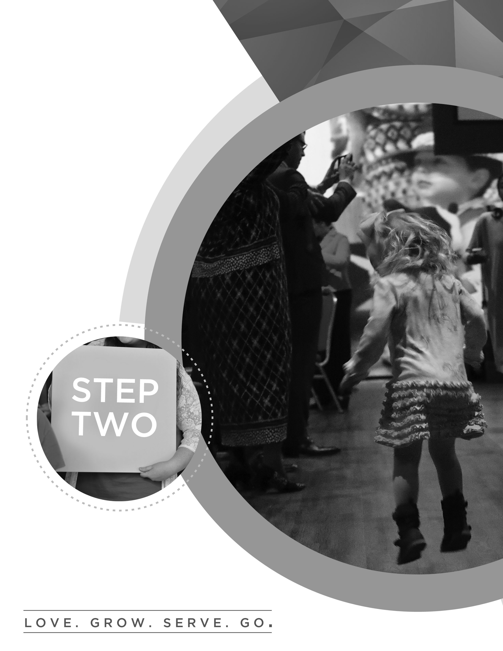

W H O Y O U A R E
stepTWO

FOR WE ARE GOD’S WORKMANSHIP,
CREATED IN CHRIST JESUS FOR GOOD WORKS.

EPHESIANS 2:10

OUr Hope for yoU

Today at STEP TWO, our hope is that you understand how your uniquely designed personality, along with the spiritual gifts God has given you, help reveal the path to God’s plan for your life. Proverbs 25:2 says it is God’s privilege to conceal things and our privilege to discover them. So today, we want to discover what God wants to do through you to make a positive difference in the world around you.

“For we are His workmanship, created in Christ Jesus for good works, which God prepared beforehand that we should walk in them.” Ephesians 2:10

THE GOAL OF THIS CLASS:
The goal of this class is a two-part understanding of God’s purpose.
First, my goal is to discover how my God-given design helps to reveal my destiny.
Second, I want to discover the amazing potential of my life.

If you can do those two things today, you’ll walk out of here on a road to fulfillment in God’s Kingdom that you never thought possible. Because your design, your destiny, and your potential set you up to do what Jesus did, to love like Jesus loved, and to make a difference as Jesus made a difference.

“Most assuredly, I say to you, he who believes in Me, the works that I do he will do also; and greater works than these he will do, because I go to My Father.” John 14:12

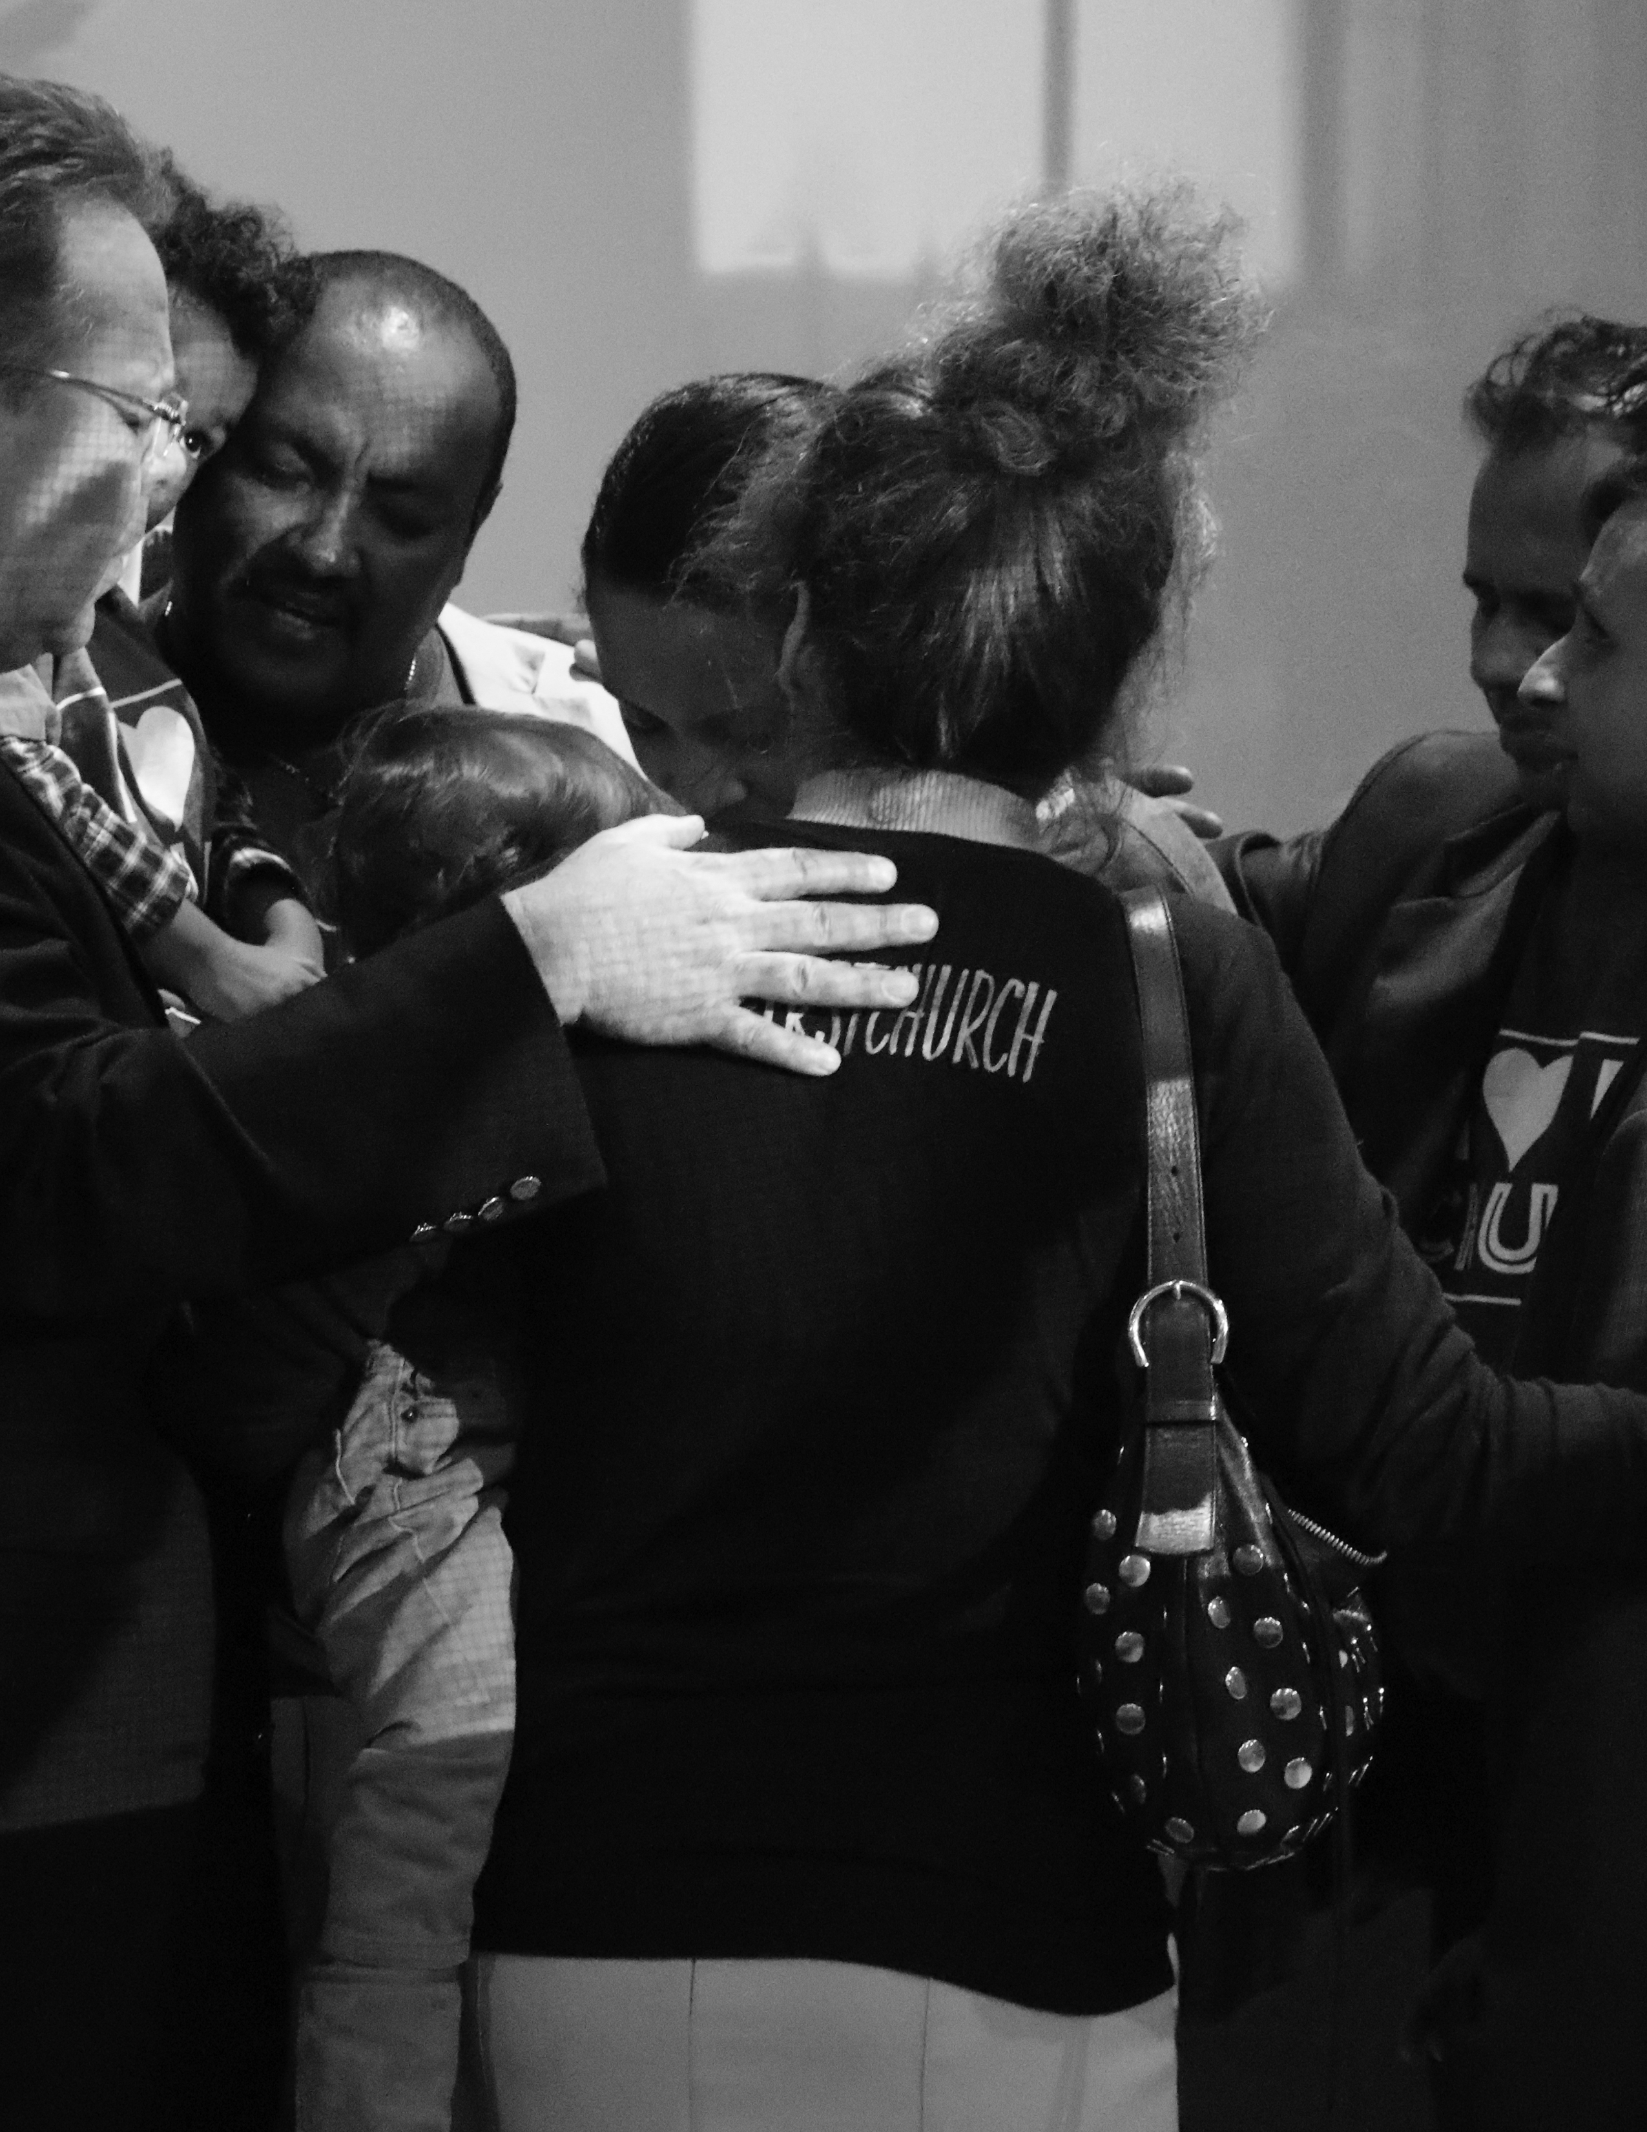
DISCOVERING YOUR PERSONALITY

1. Examining Four Personality Types
“D” dominant 3%
“I” influential 11%
“S” steady 69%
“C” compliant 17%

“I will praise you, for I am fearfully and wonderfully made.” Psalm 139:14

2. Elements that Help to Develop Your Personality
There are four things that contribute to the development of your personality.
- Family History – the way you were raised
- Training – the things you’ve been taught
- Mentors – the people who taught you
- Life Experiences – the life you’ve lived

THEREFORE IF ANYONE IS IN CHRIST
HE IS A NEW CREATION
OLD THINGS HAVE PASSED AWAY
BEHOLD ALL THINGS HAVE BECOME NEW!
2 CORINTHIANS 5:17

THE PERSONALITY ASSESSMENT

On the following pages, you’ll uncover the truth about the way God made you. Shy, outgoing, loud, quiet…it’s all part of God’s plan to use you to make a difference. And God doesn’t make mistakes. As we go through the questions that follow, answer quickly and go with your first response. There is no right answer or wrong answer. Why? Because the way God created you unlocks the door to what God wants to do through you!

simpleDISCovery My Personality / Leadership Style _____________________

Never Rarely Sometimes Often Always
1 2 3 4 5
1 2 3 4 5
1 2 3 4 5
1 2 3 4 5
1 2 3 4 5

1. Total
I am assertive, demanding, and decisive.
I enjoy doing multiple tasks at once.
I thrive in a challenge-based environment.
I think about tasks above others or myself.
I am motivated by accomplishment and authority.

Never Rarely Sometimes Often Always
1 2 3 4 5
1 2 3 4 5
1 2 3 4 5
1 2 3 4 5
1 2 3 4 5

2. Total
I enjoy influencing and inspiring people.
I am optimistic about others.
I tend to be the life of the party.
I think about motivating people.
I am motivated by recognition and approval.

Never Rarely Sometimes Often Always
1 2 3 4 5
1 2 3 4 5
1 2 3 4 5
1 2 3 4 5
1 2 3 4 5

3. Total
I thrive in consistent environments over changing ones.
I prefer specifics over generalizations.
I enjoy small groups of people.
I prefer being a member of a team over leading the team.
I am motivated by stability and support.

Never Rarely Sometimes Often Always
1 2 3 4 5
1 2 3 4 5
1 2 3 4 5
1 2 3 4 5
1 2 3 4 5

4. Total
I typically do not take big risks.
I love tasks, order and details.
I am right most of the time.
I comply with clearly defined rules.
I am motivated by quality and correctness.


THE WAY GOD CREATED YOU UNLOCKS THE DOOR TO WHAT GOD WANTS TO DO THROUGH YOU!



DISCOVERING YOUR PERSONALITY
D
“D”s are direct and decisive; they are risk takers and problem solvers. They are more concerned with completing tasks and winning than they are with gaining approval from people. Though the internal drive tends to make them insensitive to those around them, “D”s are not afraid to challenge the status quo, and they thrive when it comes to developing new things. They need discipline to excel, and they respond to direct confrontation. The greatest fear of a “D” is to be taken advantage of, and even despite their possible weaknesses—which include an aversion to routine, a tendency to overstep authority, an argumentative nature, and a habit of taking on too much—they place a high value on time and use their innovative thinking to accomplish difficult tasks and conquer challenges.
I
“I”s are inspiring and impressive. Enthusiastic, optimistic, impulsive, and emotional—they tend to be creative problem solvers and excellent encouragers. They often have a large number of friends, but they can become more concerned with approval and popularity than with getting results. An “I”s greatest fear is rejection, but they thrive when it comes to motivating others. Their positive sense of humor helps them negotiate conflicts. Though they can be inattentive to details and poor listeners, they can be great peacemakers and effective teammates when they control their feelings and minimize their urge to entertain and be the center of attention. They value lots of human touch and connection.
S
“S”s are steady and more reserved. Because they are stable and predictable, they do not like change, and they thrive in secure, non-threatening environments. They are often friendly and understanding as well as good listeners and loyal workers who are happy doing the same job consistently. With an incredible ability to forgive, reliable and dependable “S”s tend to make the best friends. Their greatest fear, however, is loss of security, and their possible weaknesses naturally include not only resistance to change, but also difficulty adjusting to it. They can also be too sensitive to criticism and unable to establish priorities. In order to avoid be taken advantage of, “S”s need to be stronger and learn how to say “no.” They also like to avoid the limelight, but when given an opportunity to genuinely help others, they will gladly rise to the occasion. They feel most valued when they have truly helped someone.
C
“C”s are compliant and analytical. Careful and logical lines of thinking drive them forward, and accuracy is a top priority. They hold high standards and value systematic approaches to problem solving. Though they thrive when given opportunities to find solutions, they tend to ignore the feelings of others and can often be critical and downright crabby. Verbalizing feelings is difficult for them, but when they are not bogged down in details and have clear-cut boundaries, they can be big assets to the team by providing calculated “reality checks”. The “C”s biggest fear is criticism, and their need for perfectionism is often a weakness, as is their tendency to give in when in the midst of an argument. However, they are thorough in all activities and can bring a conscientious, even-tempered element to the team that will provide solid grounding. They value being correct the most.
D / I
“D/I”s are curious concluders who place emphasis on the bottom line and work hard to reach their goals. They are more determined than they are inspirational, yet their high expectations and standards for themselves and those around them typically causes them to make quite an impact, motivating others to follow them. They have an array of interests and can become distracted by taking on too many projects. They often need to focus, prioritize, and simply slow down. Because “D/I”s thrive on activity and forward motion, they like to accomplish tasks through a large number of people.

Biblical Examples: Joshua (Joshua 1), Noah (Genesis 6-9), Sarah (Genesis 16, 1 Peter 3:6)
I / D
“I/D”s are persuaders who are outgoing and energetic. They enjoy large groups and use their power of influence to attain respect and convince people to follow their lead. Sometimes they can be viewed as fidgety and nervous, but it comes from their need to be a part of challenges that have variety, freedom, and mobility. “I/D”s could benefit from learning to look before they leap and spending more time being studious and still. They make inspiring leaders and know how to get results from and through people.

Biblical Examples: John the Baptist (Luke 3), Peter (Matthew 16 and 26, Acts 3), Rebekah (Genesis 24)
S / D
“S/D”s are quiet leaders who can be counted on to get the job done. They perform better in small groups and do not enjoy speaking in front of crowds. Though they can be soft- and hard-hearted at the same time, they enjoy close relationships with people, being careful not to dominate them. Challenges motivate them, especially ones that allow them to take a systematic approach. Because this personality style tends to be determined, persevering through time and struggles, they benefit from encouragement and positive relationships.

Biblical Examples: Martha (Luke 10:38-42), Job (Job 1:5, James 5:11)

C / D
“C/D”s are cautious and determined designers who are consistently task-oriented and very aware of problems. Sometimes viewed as insensitive, they do care about individual people but have a difficult time showing it. They often feel they are the only ones who can do the job the way it needs to be done, but because of their administrative skills, they are able to bring plans for change and improvements to fruition. “C/D”s have a tendency to be serious and could benefit from being more optimistic and enthusiastic. Despite their natural drive to achieve, they should concentrate on developing healthy relationships and simply loving people.

Biblical Examples: Bezalel (Exodus 35:30-36, 8, 37:1-9), Jochebed (Exodus 1:22-2:4), Jethro (Exodus 2,18)

DISCOVERING YOUR PERSONALITY
D / S
“D/S”s are attainers and achievers with an ability to persevere. They are more active than passive, but they possess a kind of calm sensitivity and steadiness that makes them good leaders. They seem to be people oriented but can easily be dominant and decisive when it comes to tasks and project planning. They strive to accomplish goals with fierce determination that comes from strong internal drive, but they could benefit from contemplative and conservative thinking as well as spending more time focusing on relationships.
Biblical Examples: Daniel (Daniel 1-6), Job (Job 1:5, James 5:11), Martha (Luke 10:38-42)
I / S
“I/S”s are influential counselors who love people, and it’s no surprise that people love them. They live to please and serve, and they tend to be good listeners. Looking good and encouraging others is important to them, as is following through and being obedient. They often lack in the area of organization and can be more concerned with the people involved than they are with the task at hand. However, they can be center stage or behind the scenes with equal effectiveness, and they shine when it comes to influencing and helping others.

Biblical Examples: Barnabas (Acts 4, 9, 11-15), Elisha (1 Kings 19, 2 Kings 2-3), Nicodemus (John 3, 7, 19)
S / I
“S/I”s are inspirational counselors who exhibit warmth and sensitivity. Tolerant and forgiving, they have many friends because they accept and represent others well. Their social nature and desire to be likable and flexible makes them inclined to be overly tolerant and non-confrontational. “S/I”s will benefit from being more task-oriented and paying more attention to detail. Kind and considerate, they include others and inspire them to follow. Words of affirmation go a long way with this personality type, and with the right motivation, they can be excellent team players.
Biblical Examples: Mary Magdalene (Luke 7:36-47), Barnabas (Acts 4, 9, 11-15), Elisha (1 Kings 19, 2 Kings 2-13)
C / I
“C/I”s pay attention to the details. They tend to impress others by doing things right and stabilizing situations. Not considered aggressive
or pushy, they enjoy both large and small crowds. Though they work well with people, they are sometimes too sensitive to what others think about them and their work. They could benefit from being more assertive and self motivated. Often excellent judges of character, they easily trust those who meet their standards. They are moved by genuine and enthusiastic approval as well as concise and logical explanations.

Biblical Examples: Miriam (Exodus 15-21, Numbers 12:1-15), Ezra (Ezra 7, 8)
D / C
“D/C”s are challengers and can either be determined students or defiant critics. Being in charge is important to them, yet they care little about what others think as long as they get the job done. They have a great deal of foresight and examine every avenue to find the best solution; they prefer to work alone. Though they fear failure and the lack of influence, they are motivated by challenges and can often be excellent administrators. They can benefit from learning to relax and paying more attention to people.

Biblical Examples: Malachi (Malachi 4), Nathan (2 Samuel 12:1-13), Nahum (Nahum 1-3)
I / C
“I/C”s are inspiring yet cautious assessors who are excellent communicators through the combination of concerned awareness and appreciation of people. They excel in determining ways to improve production. They tend to be impatient and critical, and they can also be overly persuasive and too consumed by the desire to win. “I/C”s like to work inside the box, and they could benefit from trying new things and caring less about what others think. This personality type often possesses a gift for teaching; they are generally dependable when it comes to paying attention to details and getting the job done.

Biblical Examples: Miriam (Exodus 15-21), Ezra (Ezra 7-8), Shunammite Woman (2 Kings 4:8-37)
S / C
“S/C”s are diplomatic and steady, as well as detail-oriented. Stable and contemplative, they like to weigh the evidence and discover the facts to come to a logical conclusion. More deliberate, they prefer to take their time, especially when the decision involves others. Possible weaknesses include being highly sensitive and unable to handle criticism, and they also need to be aware of the way they treat others. Operating best in precise and cause-worthy projects, the “S/C” can be a peacemaker; this makes them a loyal team member and friend.

Biblical Examples: Moses (Exodus 3, 4, 20, 32), John (John 19:26-27), Eliezer (Genesis 24)
C / S
“C/S”s are systematic and stable. They tend to do one thing at a time—and do it right. Reserved and cautious, they would rather work behind the scenes to stay on track; however, they seldom take risks or try new things and naturally dislike sudden changes in their environments. Precisionists to the letter, they painstakingly require accuracy and fear criticism, which they equate to failure. Diligent workers, their motivation comes from serving others.

Biblical Examples: Esther (Esther 4), Zechariah (Luke 1), Joseph (Matthew 1:1-23)

OPPORTUNITIES FOR PERSONAL GROWTH

If you are a “D” – Dominant, Direct, Task oriented, Decisive, Organized, Outgoing, Outspoken
A. Strive to listen to other people more attentively.
B. Try to be less controlling and domineering.
C. Develop a greater appreciation for the opinions, feelings and desires of others.
D. Put more energy into personal relationships.
E. Show your support for the other team members.

If you are an “I” – Influential, Interested in people, Witty, Easygoing, Outgoing, People oriented
A. Weigh the pros and cons before making a decision; be less impulsive.
B. Remember to help with tasks more.
C. Exercise control over your actions, words and emotions.
D. Focus more on details and facts.
E. Remember to slow down your pace for other people.
F. Talk less; listen more.

If you are an “S” – Steady, Stable, Analytical, People oriented, Introverted
A. Consider how change is healthy. Try to change more willingly.
B. Be more direct in your interactions.
C. Focus on overall goals of your family or group rather than specific procedures.
D. Deal with confrontation constructively.
E. Develop more flexibility.
F. Try to show more initiative.

If you are a “C” – Compliant, Competent, Task oriented, Goal oriented, Introverted
A. Concentrate on doing the right things – not just doing things right.
B. Be less critical of others’ ideas and methods.
C. Respond more quickly to accomplish others’ goals.
D. Strive to build relationships with other people and family members.
E. Be more decisive.
F. Focus less on facts and more on people.

DISCOVERING YOUR SPIRITUAL GIFTS

“Now concerning spiritual gifts, brethren,
I do not want you to be ignorant.”
1 Corinthians 1:21

The second assessment that follows will help you discover your spiritual gifts. And yes, you do have them!
Spiritual gifts are not natural aptitudes, they are not your strengths or abilities, they are not character traits, they aren’t titles or positions you’ve been given. Spiritual gifts are God-given. And they were given to you by God for a purpose. They are “spiritual” gifts because they go far beyond your natural giftings!
As you go through the following test, prayerfully consider the results and what God could be speaking to you.
As in the first assessment, go with your first response. Don’t talk yourself into or out of an answer. The more honest you are, the more accurate your results will be.

SPIRITUAL GIFTS QUESTIONS
1. I like organizing services and events.
2. I enjoy starting new churches.
3. Working with my hands is fun for me.
4. I can tell when someone is not sincere.
5. I pray for lost people daily.
6. Encouraging others is a high priority in my life.
7. Believing God for our daily needs is important to me.
8. Influencing others for the kingdom of God through finances is extremely important to me.
9. I look for opportunities to pray for the sick.
10. I enjoy doing the little things that others do not.
11. Having people over to my house is something I do
often.
12. Spending hours in prayer for other people is very
enjoyable to me.
13. Education is very important to me.
14. I tend to motivate others to get involved.
15. My heart hurts when I see others hurting.
16. I believe God will use me to enact His miracles.
17. I enjoy sharing the gospel with other people groups and nationalities.
18. I’ve devoted considerable time to mastering my voice and or instrument.
19. Caring for the hurting is paramount in my eyes.
20. The willful sin of others really aggravates me.
21. I enjoy serving behind the scenes.
22. I like creating outlines of the Bible.
23. God has used me to interpret a heavenly language.
24. I enjoy the book of Proverbs more than any other book in the Bible.
25. I am passionate about managing details.
26. I prefer to pioneer new ministry projects.
27. I consider myself a craftsman or craftswoman.
28. I sense when situations are spiritually unhealthy.
29. I am greatly concerned about seeing the lost saved.
30. I try to come across loving and caring.
31. Asking God for a list of big things is exciting to me.
32. I find ways to give offerings above my tithe.
33. I believe miraculous healing is for this day and age.
34. Helping others is one of my highest achievements.
35. Creating a warm and welcoming home is important to me.
36. I am burdened to pray for situations in the world.
37. People seek me out to learn more about the Kingdom of God.

38. I prefer to take the lead whenever necessary.
39. I’m very sensitive to sad stories.
40. Miracles often happen when I’m nearby.
41. Living in another country to benefit the gospel is exciting to me.
42. I desire to serve the church through worship.
43. I enjoy connecting, caring for, and coaching others.
44. Confronting someone with sin in their life is not hard.
45. It bothers me when people sit around and do nothing.
46. I share Biblical truth with others in hopes of their personal
growth.
47. I pray in tongues daily.
48. When I study scripture God gives me unique insights.
49. Creating a task list is easy and enjoyable for me.
50. I am attracted to ministries that start new churches.
51. Building something with my hands is very rewarding to me.
52. I can pinpoint issues or problems before others.
53. I enjoy sharing the gospel with a total stranger.
54. I look for ways to be an encouragement to other people.
55. I trust that God has my back in every situation.
56. Making more money means that I can give more.
57. God has used me to bring healing to those who are sick.
58. Being a part of the process is fulfilling to me.
59. I tend to make total strangers feel at home.
60. People often describe me as a prayer warrior.
61. I enjoy knowing biblical details and helping others to understand.
62. I delegate responsibilities to accomplish tasks.
63. I am motivated to help those who are less fortunate.
64. I have a constant hunger to see God’s miraculous power.
65. I focus a lot on reaching the world for Christ.
66. I gain my deepest satisfaction through leading others in vocal or instrumental worship.
67. I enjoy walking with someone in times of difficulty.
68. I enjoy hearing passionate and clear preaching of the truth.
69. I like to do small things that others pass over.
70. I prefer to teach the Bible topically rather than verse by verse.
71. Praying in the Spirit is encouraging and important to me.
72. When faced with difficulty I tend to make wise decisions and choices.
SPIRITUAL GIFTS RATINGS
1 Almost Never
2 Seldom
4 Frequently
3 Sometimes
5 Almost Always

Total Gifts

1._____ 25._____ 49._____ _____ A._________________
2._____ 26._____ 50._____ _____ B._________________
3._____ 27._____ 51._____ _____ C._________________
4._____ 28._____ 52._____ _____ D._________________
5._____ 29._____ 53._____ _____ E._________________
6._____ 30._____ 54._____ _____ F._________________
7._____ 31._____ 55._____ _____ G._________________
8._____ 32._____ 56._____ _____ H._________________
9._____ 33._____ 57._____ _____ I._________________
10._____ 34._____ 58._____ _____ J._________________
11._____ 35._____ 59._____ _____ K._________________
12._____ 36._____ 60._____ _____ L._________________
13._____ 37._____ 61._____ _____ M._________________
14._____ 38._____ 62._____ _____ N._________________
15._____ 39._____ 63._____ _____ O._________________
16._____ 40._____ 64._____ _____ P._________________
17._____ 41._____ 65._____ _____ Q._________________
18._____ 42._____ 66._____ _____ R._________________
19._____ 43._____ 67._____ _____ S._________________
20._____ 44._____ 68._____ _____ T._________________
21._____ 45._____ 69._____ _____ U._________________
22._____ 46._____ 70._____ _____ V._________________ 23._____ 47._____ 71._____ _____ W._________________ 24._____ 48._____ 72._____ _____ X._________________
Gift Definitions and Scripture References

The following contains definitions of the Spiritual gifts. While not meant to be dogmatic or final, these definitions and supporting scriptures do correspond to characteristics of the gifts as expressed in the Gifts Questionnaire.

A. ADMINISTRATION
The gift of administration is the divine strength or ability to organize multiple tasks and groups of people to accomplish these tasks. Luke 14:28-30; Acts 6:1-7; 1 Corinthians 12:28

B. APOSTLESHIP
The gift of apostleship is the divine strength or ability to pioneer new churches and ministries through planting, overseeing, and training. Acts 15:22-35; 1 Corinthians 12:28;
2 Corinthians 12:12; Galatians 2:7-10; Ephesians 4:11-14

C. CRAFTSMANSHIP
The gift of craftsmanship is the divine strength or ability to plan, build, and work with your hands in construction environments to accomplish multiple ministry applications.
Exodus 30:22, 31:3-11; 2 Chronicles 34:9-13; Acts 18:2-3

D. DISCERNMENT
The gift of discernment is the divine strength or ability to spiritually identify falsehood and to distinguish between right and wrong motives and situations.
Matthew 16:21-23; Acts 5:1-11, 16:16-18; 1 Corinthians 12:10; 1 John 4:1-6

E. EVANGELISM
The gift of evangelism is the divine strength or ability to help non-Christians take the necessary steps to becoming a born-again Christian. Acts 8:5-6, 8:26-40, 14:21, 21:8; Ephesians 4:11-14

F. EXHORTATION
The gift of exhortation is the divine strength or ability to encourage others through the written or spoken word and Biblical truth. Acts 14:22; Romans 12:8; 1 Timothy 4:13;
Hebrews 10:24-25

G. FAITH
The gift of faith is the divine strength or ability to believe in God for unseen supernatural results in every arena of life. Acts 11:22-24; Romans 4:18-21; 1 Corinthians 12:9; Hebrews 11

H. GIVING
The gift of giving is the divine strength or ability to produce wealth and to give by tithes and offerings for the purpose of advancing the Kingdom of God on earth. Mark 12:41-44; Romans 12:8; 2 Corinthians 8:1-7, 9:2-7
I. HEALING
The gift of healing is the divine strength or ability to act as an intermediary in faith, prayer, and by the laying-on of hands for the healing of physical and mental illnesses.
Acts 3:1-10, 9:32-35, 28:7-10; 1 Corinthians 12:9, 28

J. HELPS
The gift of helps is the divine strength or ability to work in a supportive role for the accomplishment of tasks in Christian ministry. Mark 15:40-41; Acts 9:36; Romans 16:1-2; 1 Corinthians 12:28

K. HOSPITALITY
The gift of hospitality is the divine strength or ability to create warm, welcoming environments for others in places such as your home, office, or church. Acts 16:14-15; Romans 12:13, 16:23; Hebrews 13:1-2; 1 Peter 4:9

L. INTERCESSION
The gift of intercession is the divine strength or ability to stand in the gap in prayer for someone, something, or someplace, believing for profound results. Hebrews 7:25; Colossians 1:9-12, 4:12-13; James 5:14-16

M. KNOWLEDGE
The gift of knowledge is the divine strength or ability to understand and to bring clarity to situations and circumstances often accompanied by a word from God. Acts 5:1-11;
1 Corinthians 12:8; Colossians 2:2-3

N. LEADERSHIP
The gift of leadership is the divine strength or ability to influence people at their level while directing and focusing them on the big picture, vision, or idea. Romans 12:8;
1 Timothy 3:1-13, 5:17; Hebrews 13:17

O. MERCY
The gift of mercy is the divine strength or ability to feel empathy and to care for those who are hurting in any way. Matthew 9:35-36; Mark 9:41; Romans 12:8; 1 Thessalonians 5:14

P. MIRACLES
The gift of miracles is the divine strength or ability to alter the natural outcomes of life in a supernatural way through prayer, faith, and divine direction.
Acts 9:36-42, 19:11-12, 20:7-12; Romans 15:18-19; 1 Corinthians 12:10, 28

Q. MISSIONARY
The gift of missions is the divine strength or ability to reach others outside of your culture and nationality, while in most cases living in that culture or nation. Acts 8:4, 13:2-3, 22:21; Romans 10:15

R. MUSIC / WORSHIP
The gift of music/worship is the divine strength or ability to sing, dance, or play an instrument primarily for the purpose of helping others worship God.
Deuteronomy 31:22; 1 Samuel 16:16; 1 Chronicles 16:41-42; 2 Chronicles 5:12-13, 34:12; Psalm 150

S. PASTOR / SHEPHERD
The gift of pastor/shepherd is the divine strength or ability to care for the personal needs of others by nurturing and mending life issues. John 10:1-18; Ephesians 4:11-14; 1 Timothy 3:1-7;
1 Peter 5:1-3

T. PROPHECY
The gift of prophecy is the divine strength or ability to boldly speak and bring clarity to scriptural and doctrinal truth, in some cases foretelling God’s plan. Acts 2:37-40, 7:51-53, 26:24-29; 1 Corinthians 14:1-4; 1 Thessalonians 1:5

U. SERVICE
The gift of serving is the divine strength or ability to do small or great tasks in working for the overall good of the body of Christ. Acts 6:1-7; Romans 12:7; Galatians 6:10; 1 Timothy 1:16-18; Titus 3:14

V. TEACHING
The gift of teaching is the divine strength or ability to study and learn from the Scriptures primarily to bring understanding and depth to other Christians. Acts 18:24-28, 20:20-21; 1 Corinthians 12:28; Ephesians 4:11-14

W. TONGUES (and Interpretation)
The gift of tongues is the divine strength or ability to pray in a heavenly language to encourage your spirit and to commune with God. The gift of tongues is often accompanied by interpretation and should be used appropriately.
Acts 2:1-13; 1 Corinthians 12:10, 14:1-14

X. WISDOM
The gift of wisdom is the divine strength or ability to apply the truths of Scripture in a practical way, producing the fruitful outcome and character of Jesus Christ. Acts 6:3,10; 1 Corinthians 2:6-13, 12:8

PUTTING IT ALL TOGEtHER

“Therefore we also, since we are surrounded by so great a cloud of witnesses, let us lay aside every weight, and the sin which so easily ensnares us, and let us run with endurance the race that is set before us, looking unto Jesus, the author and finisher of our faith.”
Hebrews 12:1-2

- Think about the results. Does this make some things make sense? Does this give you a better insight to your strengths and weaknesses?
- Consider the opportunities. Does this clarify some ways and places you can make a difference?
- Find ways to grow. Join the Dream Team and serve in an area where your gifting is an asset. Join a small group where you can learn more and grow in your gifting!

What is my personality type and leadership style?

____________ (D, I, S, C) ____________________________ (People or Task Oriented)

What are two primary spiritual gifts or natural abilities I have?

1._______________________________ 2. ______________________________

What two areas am I experienced in and/or most passionate about?

1._______________________________ 2. ______________________________

Based on the answers, with what type of team or small group could I connect?

_________________________________________________________________________

For your reference, we’ve included a list of teams you can get involved in upon completion of first steps.

A-Team (Administration): This team utilizes their gifts of administration and organization to assist with the administrative needs of First Church. They also work alongside Dream Team leaders to seamlessly transition new Dream Team members into serving.

Café Team: This fun-loving team operates the coffee shop on Sundays and Wednesdays, serving specialty coffee drinks, ice cream, snacks, and connecting with guests.

Communion Team: This team serves behind the scenes to prepare both the elements and the environment for Communion during our Sunday or Wednesday Communion services.

Community Outreach: This team is involved in countless ministries with a focus on bringing God’s love to our communities and world.

Dream Team Serve: This team faithfully serves to host our very own Dream Team members by providing refreshments, prayer, and encouragement during services and special events.

Events Team: National conferences, First Church conferences, and Church-wide events are creatively planned and energetically hosted by this team who places priority on valuing people and serving with excellence.

First Kids: This team leads children into a real relationship with Jesus through Bible stories, worship, prayer, hands-on activities and personal interactions for the preschool and nursery age children.

First Responders: This unit of health care providers serves to provide triage and basic medical attention to our guests in the event of an accident or emergency at First Church.

First Steps Team: As the official hosts of our Growth Track, this team greets guests as well as provides materials and assistance throughout our four classes.

Greeters: This friendly team loves people and makes them feel at home here at First Church. They welcome guests with a smile, encouragement and personal touch so that hearts are open to the Gospel message.

Haven (Special Needs): This team serves guests with special needs, providing intentional one-on-one care, ministry and development.

Hospitality: This energetic team connects with guests by offering a hot cup of coffee and a warm welcome.

Host: This friendly team ensures guest have a great experience from the moment they enter the Sanctuary. Hosts welcome guests and members, distribute announcement cards and assist people in finding their seats.

Information Center: This team connects guests to the Church community, providing resources and information on all of our current events, ministry opportunities and services at First Church.

Kids Check-in: This team welcomes families as they arrive at our First Church Kids areas and facilitates the check-in process that ensures children are cared for effectively and efficiently.

ONE Student Ministry: Join the team that is building the next generation, one dynamic worship experience, relevant Small Group, impactful retreat, and life-changing mission trip at a time!

Parking Team: This fun and enjoyable team is truly the first impression of First Church! If you relish the great outdoors, look good in a uniform, and enjoy telling people where to go, this is the team for you!

Pastor’s Meal Team: This team facilitates a quarterly meet-and-greet meal for guests to interact one-on-one with the pastoral staff. If you enjoy serving newcomers and connecting with guests, join this team.

Prayer Team: This team of trained intercessors covers the weekend and midweek services in prayer, preparing the way for the Lord. Join this team that is blazing the trail for God in our city!

Small Group Leadership: We believe that real life change takes place in the context of relationships. As a Small Group Leader, you have the greatest opportunity to connect with others, fulfill your passions, develop your gifts and live out the Great Commission.

Spanish Translation: This team greets, answers questions, and assists with translation for Spanish-speaking guests. If you’re fluent in Spanish and English, consider serving here!

Technical Production: Bring your creativity and tech savvy to this team that reaches thousands by delivering the Word and worship through audio engineering, camera, lighting, web streaming, and other visual elements.

THE WAVE Kids: This team creates an environment where children are consistently exposed to the real love of Jesus. They intentionally invest in the lives of our children through worship, videos, skits, small groups, greeting, games and more.

Ushers: These mighty men prepare people for a positive worship experience by welcoming and assisting them to a seat, facilitating the offering and maintaining a distraction-free environment.

Worship Arts: Through vocals, instruments, or audio engineering, this dynamic team prepares the way for our guests to encounter the presence of the living God.

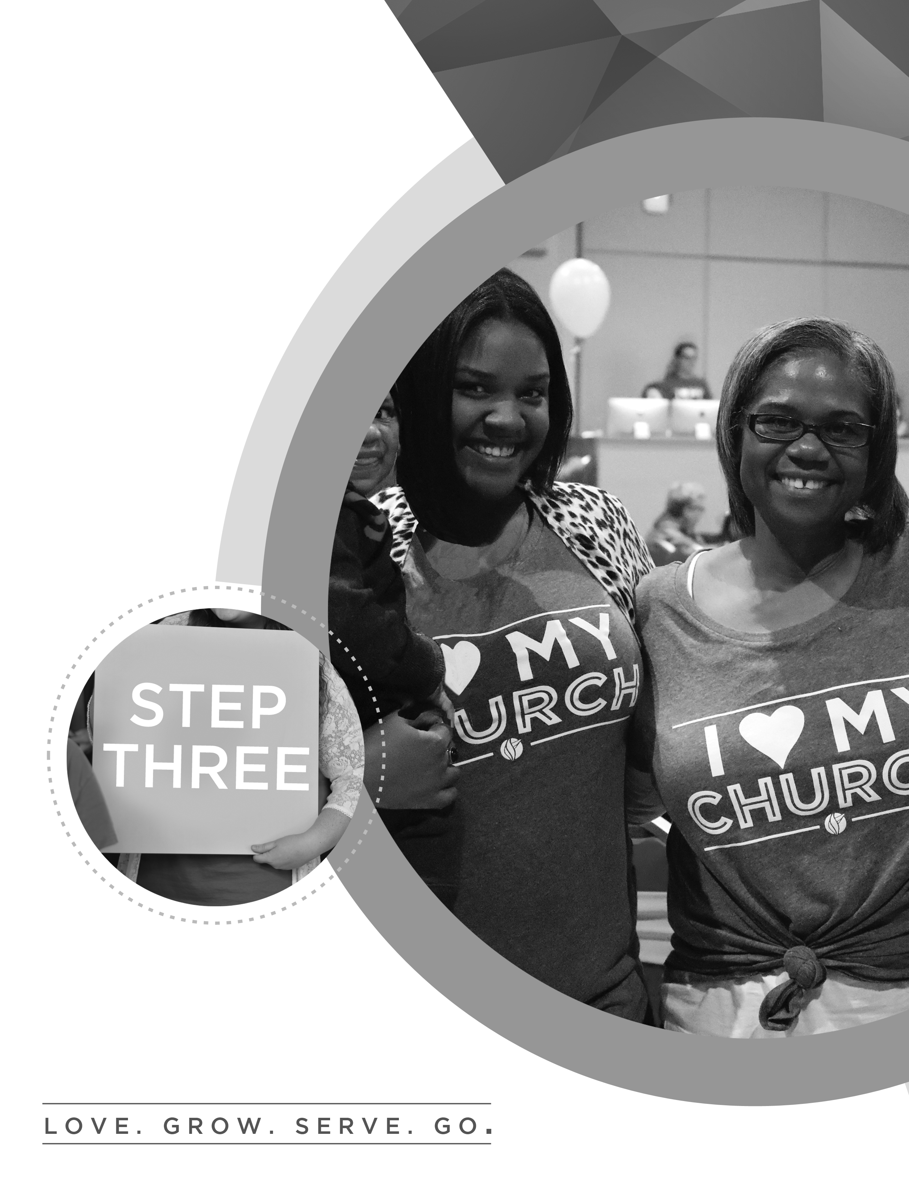

W H Y Y O U ‘ L L L O V E I T H E R E

stepTHREE

WHERE TWO OR THREE GATHER IN MY NAME,
I AM THERE WITH THEM.

MATTHEW 18:20

OUR HOPE FOR YOU

The purpose of today is to get down into the details of what makes us different from other churches. God has given this church a unique vision, and we want to show you how you can be a part of that. We want to share with you our focus as a church, what we value, and a few principles that will help us step fearlessly into the purpose that God has for our lives.

“Let there be real harmony among you so there
won’t be any splits in the church. I plead with you
to be of one mind, united in thought and purpose.”
1 Corinthians 1:10 (LB)

THE SEVEN DIFFERENCES:

1. ________________________________________ CHURCH.

And if the Spirit of him who raised Jesus from the dead is living in you, he who raised Christ from the dead will also give life to your mortal bodies because of his Spirit who lives in you. Romans 8:11

“The grace of the Lord Jesus Christ, and the love of God, and the fellowship of the Holy Spirit be with you all.” 2 Corinthians 13:14

WHAT IS THE HOLY SPIRIT?

Ruwach – a wind, breath, a violent exhalation, blast of breath.

“The earth was without form, and void; and darkness was on the face of the deep. And the Spirit of God was hovering over the face of the waters.” Genesis 1:2

Pneuma – a current of air, blast of breath, a strong breeze.

“It is the Spirit who gives life; the flesh counts for nothing. The words that I speak to you are spirit, and they are life.” John 6:63

- The Holy Spirit is our .

“And I will pray the Father, and He will give you another Helper, that He may abide with you forever.” John 14:16

- The Holy Spirit is our .

“But the Helper, the Holy Spirit, whom the Father will send in My name, He will teach you all things, and bring to your remembrance all things that I said to you.” John 14:26

-We embrace the supernatural.
-We believe supernatural things are possible.

2. ________________________________________ CHURCH

“The whole Bible was given to us by inspiration from God and is useful to teach us what is true and to make us realize what is wrong in our lives; it straightens us out and helps us do what is right. It is God’s way of making us well prepared at every point, fully equipped to do good to everyone.” 2 Timothy 3:16-17 (LB)

We believe that the Holy Bible, and only the Bible, is the authoritative Word of God. It alone is the final authority in determining all doctrinal truths. In its original writing, it is inspired, infallible, and inerrant. A vibrant relationship with God is sustained through Bible study and prayer.

- ____________________ that God’s Word is my highest authority.

- God’s Word with an open heart.

“The earth is filled with your love, Lord; teach me your decrees.” Psalm 119:64

- to God’s Word with obedience.

“Do not merely listen to the word, and so deceive yourselves. Do what it says.”
James 1:22

3. __________________________________________ CHURCH

“For the Son of Man came to see and save the lost.” Luke 19:10

It’s been said that the only institution that exists for the benefit of its non-members is the church. We embrace that completely! Everything we do is geared toward getting as many lost people saved as possible. You’ll hear us say it often: “As many as we can; as fast as we can!”

4. ______________________________________ CHURCH.

- LOVE God. Attend weekend services.
- GROW in faith. Join or smart a small group.
- SERVE others. Complete First Steps.
- GO change the world. Join the Dream Team.

5. ______________________________________ CHURCH

“For God so loved the world that He gave His only begotten Son, that whoever believes in Him should not perish but have everlasting life.” John 3:16

The Gospel is the ultimate demonstration of God’s generous nature towards mankind. The Bible consistently teaches that God blesses us so that we may bless others.

THREE AREAS OF GIVING:

- Give of our .

“See then that you walk circumspectly, not as fools but as wise, redeeming the time, because the days are evil.” Ephesians 5:15-16

- Give of our .

“A spiritual gift is given to each of us so we can help each other.”
1 Corinthians 12:7 (NLT)

- Give of our .

“If your gift is… giving, give generously.” Romans 12:8 (NLT)

Jesus gave His Church a mandate to reach the world around them in three areas:

“You shall be witnesses to me in Jerusalem, and in all Judea and Samaria, and to the ends of the earth.” Acts 1:8

- “In Jerusalem” – OUR CITY

“Pure and undefiled religion before God and the Father is this: to visit orphans and widows in their trouble.” James 1:27

The primary way we reach our city is through our Community Outreach efforts.

- “In Judea and Samaria” – OUR NATION

“To the weak I became as weak, that I might win the weak. I have become all things to all men, that I might by all means save some.” 1 Corinthians 9:22

The primary way we reach our Nation is by starting new churches and strengthening
existing churches.

3. “To the ends of the Earth” – OUR WORLD

“And He said to them, “Go into all the world and preach the gospel to every creature.” Mark 16:15

First Church strategically invests a portion of its resources in missions works
all around the world with a focus on missionaries, unreached people groups, children, and church planting.

6. ____________________________ CHURCH

Serve the Lord with gladness. Psalm 100:2

The secret:
Every member is a minister.
Every task is important.
Every member is a 10 in some area.

7. A CHURCH OF _________________________________.

Be devoted to one another in love. Honor one another above yourselves. Romans 12:10

A. We celebrate one another.
B. We value one another.
C. We are accountable to one another.

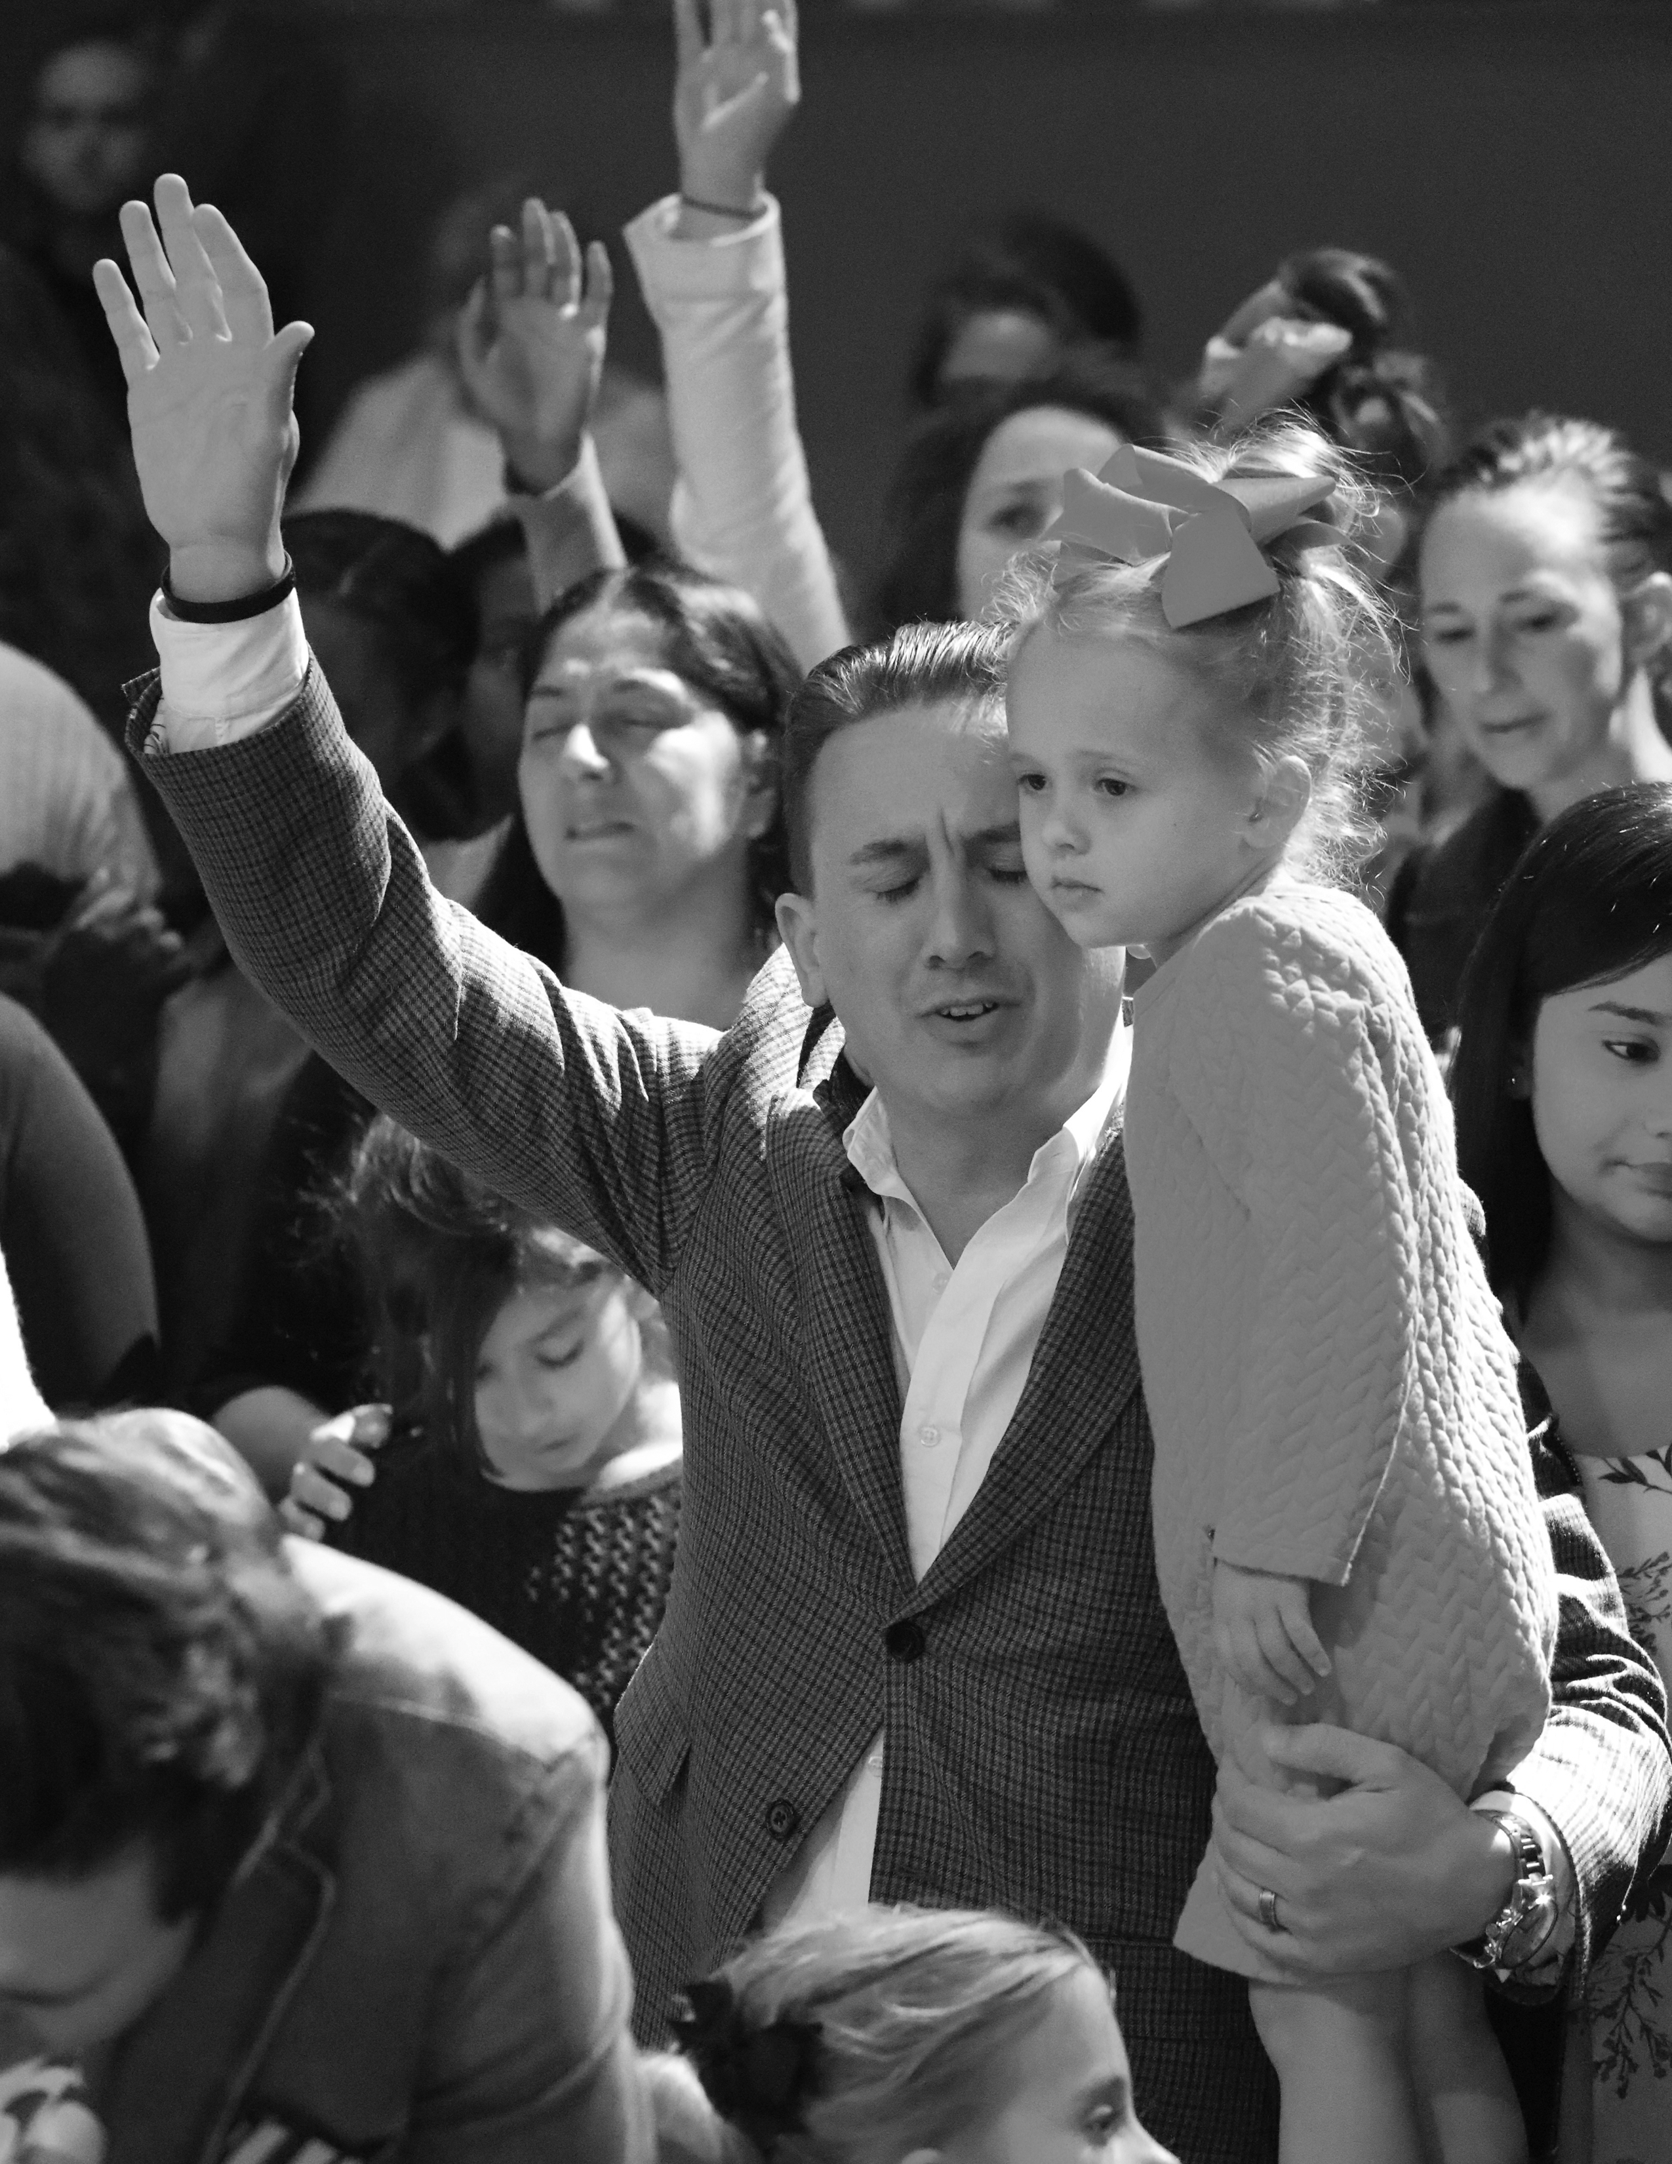
DREAM TEAM HONOR COVENANT

As an essential part of the First Church Leadership family, you have a responsibility to develop and exhibit mature Christian behavior. This should be the basic premise of your desire to participate in a servant-leader position here at First Church.

While serving the Body of Christ as a servant-leader at First Church, you pledge to present a good appearance at all times. In both attire and behavior, you should strive to demonstrate Biblical standards in all situations.

As Christians, the way we present ourselves to others is of vital importance to the way others perceive Christ. Our conduct should never be an embarrassment to Christ, but should exemplify the best qualities of a mature believer and servant-leader.

Exemplifying the highest moral commitment, First Church’s leaders are to maintain a disciplined life of Bible reading, prayer, and fasting. We seek to walk humbly before God and refrain from such things as:

- profanity
- smoking or chewing tobacco
- gambling
- indulging in alcoholic beverages
- dishonest gain
- illegal drugs
- pornography
- sexual immorality
- immodest dress
- all behaviors which might cause Christ to grieve and others to stumble

By providing an example in speech and action, we encourage others to grow in Christ and become servant-leaders themselves. This is a way of life measured by the heart and commitment of each leader in the First Church family. We should regard it as an essential part of our development, not as an imposition or restriction.

Printed Name:

Signature: ____________________________ Date: ____/____/____


G E T C O N N E C T E D

stepFOUR

FOR WE ARE GOD’S WORKMANSHIP,
CREATED IN CHRIST JESUS FOR GOOD WORKS.

EPHESIANS 2:10

OUR HOPE FOR YOU
Today at STEP FOUR our hope is to provide you with clear “next steps” to get involved in a team and step into your purpose.

FIRST CHURCH DREAM TEAM

We were created with a purpose, and that purpose is to make a difference in someone else’s life. The best way for you to do that is by stepping into a fulfilling place where you can make a difference. God has a place for you where your unique abilities and passions can touch the lives of others. At First Church, the Dream Team is the community where that happens.

VISION OF THE DREAM TEAM

- MY TEAM IS MY ____________________.

“I thank my God every time I remember you. In all my prayers for all of you, I always pray with joy because of your partnership in the gospel from the first day until now, being confident of this, that he who began a good work in you will carry it on to completion until the day of Christ Jesus.” Philippians 1:3-6 (NIV)

- MY TEAM IS MY ___________________.

“If you have any encouragement from being united with Christ, if any comfort from his love, if any fellowship with the Spirit, if any tenderness and compassion, then make my joy complete by being like-minded, having the same love, being one in spirit and purpose. Do nothing out of selfish ambition or vain conceit, but in humility consider others better than yourselves. Each of you should look not only to your own interests, but also to the interests of others.” Philippians 2:1-4 (NIV)

3. MY TEAM IS MY ______________________.

“Not that I have already obtained all this, or have already been made perfect, but I press on to take hold of that for which Christ Jesus took hold of me. Brothers, I do not consider myself yet to have taken hold of it. But one thing I do: Forgetting what is behind and straining toward what is ahead, I press on toward the goal to win the prize for which God has called me heavenward in Christ Jesus.” Philippians 3:12-14 (NIV)

4. MY TEAM IS MY _____________________.

“Finally, brethren, whatever things are true, whatever things are noble, whatever things are just, whatever things are pure, whatever things are lovely, whatever things are of good report, if there is any virtue and if there is anything praiseworthy—meditate on these things. The things which you learned and received and heard and saw in me, do these, and the God of peace will be with you. I can do all things through Christ who strengthens me.” Philippians 4:8-9, 13

As a member of the Dream Team, we embrace the following values in order to serve in a way that brings honor to God and one another!

- WE VALUE ______________________.

We prioritize connecting with new people. We are ALL greeters! People matter to God, so they matter to us.

“Do nothing out of selfish ambition or vain conceit. Rather, in humility value others above yourselves, not looking to your own interests but each of you to the interests of the others.” Philippians 2:3-4

- WE VALUE _________________________.

We do life together. We build relationships with our team! Real Life change happens… real leaders are developed… when we take a step towards intentional relationships.

“I thank my God every time I remember you. In all my prayers for all of you, I always pray with joy because of your partnership in the gospel from the first day until now.” Philippians 1:3-5

3. WE VALUE ____________________________.

We are a people of purpose, working together on purpose. Because of this, we make deliberate decisions to empower one another and honor one another. We don’t elevate ourselves above any other member of our team.

“He is the one we proclaim, admonishing and teaching everyone with all wisdom, so that we may present everyone fully mature in Christ.” Colossians 1;28

4 WE VALUE ___________________________.

At First Church, we believe in celebrating the wins! There is nothing more powerful than a life changed by Christ. We get to be a part of that every week!

“In the same way, I tell you, there is rejoicing in the presence of the angels of God over one sinner who repents.” Philippians 4:8-9, 13

TO BEGIN SERVING ON THE DREAM TEAM

- Attend an orientation to the ministry area of your choice.
- Complete and sign the Dream Team Leadership Application and Honor Covenant.
- Complete a one-on-one interview with a team leader for your next steps.
- Attend STEP ONE on the first Sunday of the month and become a church member if you have not already done so.



APPENDICES

APPENDIX 1:

ANSWER KEY

Pg. 52: Spirit-Filled
Pg. 53: Helper, Teacher, Bible-Based
Pg. 54: Accept, Receive, Respond, Others-Focused, Vision-Driven, Giving
Pg. 55: Time, Talent, Treasure
Pg. 56: Joyful, Honor

Pg. 66: Family
Pg. 67: Lifeline, Foundation, Place, Connection,
Pg. 68: Relationships, Honor, Celebration

APPENDIX 2:

A-Team (Administration): This team utilizes their gifts of administration and organization to assist with the administrative needs of First Church. They also work alongside Dream Team leaders to seamlessly transition new Dream Team members into serving.

Café Team: This fun-loving team operates the coffee shop on Sundays and Wednesdays, serving specialty coffee drinks, ice cream, snacks, and connecting with guests.

Communion Team: This team serves behind the scenes to prepare both the elements and the environment for Communion during our Sunday or Wednesday Communion services.

Community Outreach: This team is involved in countless ministries with a focus on bringing God’s love to our communities and world.

Dream Team Serve: This team faithfully serves to host our very own Dream Team members by providing refreshments, prayer, and encouragement during services and special events.

Events Team: National conferences, First Church conferences, and Church-wide events are creatively planned and energetically hosted by this team who places priority on valuing people and serving with excellence.

First Kids: This team leads children into a real relationship with Jesus through Bible stories, worship, prayer, hands-on activities and personal interactions for the preschool and nursery age children.

First Responders: This unit of health care providers serves to provide triage and basic medical attention to our guests in the event of an accident or emergency at First Church.

First Steps Team: As the official hosts of our Growth Track, this team greets guests as well as provides materials and assistance throughout our four classes.

Greeters: This friendly team loves people and makes them feel at home here at First Church. They welcome guests with a smile, encouragement and personal touch so that hearts are open to the Gospel message.

Haven (Special Needs): This team serves guests with special needs, providing intentional one-on-one care, ministry and development.

Hospitality: This energetic team connects with guests by offering a hot cup of coffee and a warm welcome.

Host: This friendly team ensures guest have a great experience from the moment they enter the Sanctuary. Hosts welcome guests and members, distribute announcement cards and assist people in finding their seats.

Information Center: This team connects guests to the Church community, providing resources and information on all of our current events, ministry opportunities and services at First Church.

Kids Check-in: This team welcomes families as they arrive at our First Church Kids areas and facilitates the check-in process that ensures children are cared for effectively and efficiently.

ONE Student Ministry: Join the team that is building the next generation, one dynamic worship experience, relevant Small Group, impactful retreat, and life-changing mission trip at a time!

Parking Team: This fun and enjoyable team is truly the first impression of First Church! If you relish the great outdoors, look good in a uniform, and enjoy telling people where to go, this is the team for you!

Pastor’s Meal Team: This team facilitates a quarterly meet-and-greet meal for guests to interact one-on-one with the pastoral staff. If you enjoy serving newcomers and connecting with guests, join this team.

Prayer Team: This team of trained intercessors covers the weekend and midweek services in prayer, preparing the way for the Lord. Join this team that is blazing the trail for God in our city!

Small Group Leadership: We believe that real life change takes place in the context of relationships. As a Small Group Leader, you have the greatest opportunity to connect with others, fulfill your passions, develop your gifts and live out the Great Commission.

Spanish Translation: This team greets, answers questions, and assists with translation for Spanish-speaking guests. If you’re fluent in Spanish and English, consider serving here!

Technical Production: Bring your creativity and tech savvy to this team that reaches thousands by delivering the Word and worship through audio engineering, camera, lighting, web streaming, and other visual elements.

THE WAVE Kids: This team creates an environment where children are consistently exposed to the real love of Jesus. They intentionally invest in the lives of our children through worship, videos, skits, small groups, greeting, games and more.

Ushers: These mighty men prepare people for a positive worship experience by welcoming and assisting them to a seat, facilitating the offering and maintaining a distraction-free environment.

Worship Arts: Through vocals, instruments, or audio engineering, this dynamic team prepares the way for our guests to encounter the presence of the living God.

APPENDIX 3:

PRAYER GUIDE

…Your kingdom come, your will be done, on Earth as it is in heaven…
Matthew 6:10

But you shall receive power when the Holy Spirit has come upon you; and you shall be my witnesses in Jerusalem, and in all Judea and Samaria, and to the end of the earth. Acts 1:8

Leaders of Our Country

- President Donald Trump & Vice President Mike Pence
- Supreme Court Justices – John Roberts, Clarence Thomas, Anthony Kennedy, Ruth Bader Ginsburg, Sonia Sotomayor, Stephen Breyer, Samuel Alito Jr., Elena Kagan, Neil Gorsuch
- U.S. Senators (Texas) – Ted Cruz, John Cornyn
- U.S. Representatives (Texas) – Jodey Arrington, Brian Babin, Joe Barton, Kevin Brady, Michael Burgess, John Carter, Joaquin Castro, Mike Conaway, Henry Cuellar, John Culbertson, Lloyd Doggett, Blake Farenthold, Bill Flores, Louis Gohmert, Vicente Gonzalez, Kay Granger, Al Green, Gene Green, Jeb Hensarling, Will Hurd, Sheila Jackson Lee, Eddie Bernice Johnson, Sam Johnson, Kenny Marchant, Michael McCaul, Beto O’Rourke, Pete Olson, Ted Poe, John Ratcliffe, Pete Sessions, Lamar Smith, Mac Thornberry, Marc Veasey, Filemon Vela Jr., Randy Weber, Roger Williams

Leaders of Our State

- Governor Greg Abbott
- Mayors – Sylvester Turner (Houston), Tom Reid (Pearland), Jeff Wagner (Pasadena), Paul Horn (Alvin), James A. Thompson (Sugarland), James D. Yarbrough (Galveston), Kevin Holland (Friendswood), Donna Rogers (Webster), Thom Kolupski (Seabrook), Pat Hallisey (League City), Debra Davison (Manvel)

Leaders of Our Church
- Organizational Leadership – David K. Bernard, Jerry Jones
- Church Board – Tee Hodges, Mike Veuleman, Verna Yancy, Stephen MacLauchlan, Lasonya Jewell-Antoine, David King, Jan Saunders
- Staff Families – Ken & Tessie Gurley, Tyler & T’Neil Walea, Johnathan & Carla Dean, Lavelle & Brittain Jeane, John & Jill Mahoney, Cameron & Abi Dodd, Elijah & Autumn Mayo, Daniel & Ruth Tristan, Josh Garcia
- First Steps, Dream Team, Next Steps Directors – Elijah & Autumn Mayo, Dave & Brandi Brown, Jeff & Charity Ellis
- Dream Team Leaders

Our Vision
- LOVE. Pray that all of us could come to love God with all our hearts. Pray for the lost to be saved and feel the love of Jesus Christ in our Weekend Services.
- GROW. Pray for leaders, groups, and the eight hubs of small groups (men, women, marriage/family, students, discipleship, recovery, prayer, outreach.)
- SERVE. Pray that through our Growth Track process, people would take their next steps into service.
- GO. Pray for all those who serve on the Dream Team in taking the Gospel into the world around us.

First Church Ministries
- Children
- Students
- First Impressions Learning Center
- Prison Ministry
- ACTS
- Small Groups
- Motion Conference
- Dream Team Ministries

APPENDIX 4:

QUESTIONS ABOUT TITHING

What is tithing?
“Tithe” means “a tenth part.”

What is the difference between a tithe and an offering?
A “tithe” is giving the first tenth of my income.
An “offering” is anything I give in addition to my tithe.

Why should I tithe?
Because God commands it.
“A tenth of all you produce is the Lord’s.”
Leviticus 27:30

Because Jesus commanded it.
“Yes, you should tithe, and you shouldn’t leave the more important things undone either.”
Matthew 23:23

Tithing demonstrates that God has first place in my life.
“The purpose of tithing is to teach you to always put God in first place in your lives.”
Deuteronomy 14:23 (LB)

Tithing reminds me that everything I have was given to me by God.
“Always remember that it is the Lord your God who gives you the ability to produce wealth.”
Deuteronomy 8:18

Tithing expresses my love to the Lord.
“Each of you should bring a gift in proportion to the way the Lord your God has blessed you.”
Deuteronomy 16:17

God says that refusing to tithe is stealing from Him.
“God says ‘Will a man rob God? Yet you are robbing me!’ But you ask, ‘How do we rob you?’ God says ‘In tithes and offerings ... Bring your whole tithe to My house.’ ”
Malachi 3:8-10

Tithing gives God a chance to prove He exists and wants to bless you.
“Bring your whole tithe to My storehouse. Test me in this” says the Lord, “and see if I will not throw open the floodgates of heaven and pour out so much blessing that you won’t have room enough for it!” Malachi 3:10
What should I tithe?
The tithe should come from the first part of what I earn.
“Honor the Lord by giving him the first part of all your income.”
Proverbs 3:9-10

Where should I give my Tithe?
The tithe should be given where I worship.
“Bring your whole tithe to My Storehouse (Temple).”
Malachi 3:10

When should I Tithe?
The tithe should be given weekly.
“On the first day of every week, set aside some of what you have earned and give it as an offering. The amount depends on how much the Lord has helped you earn.”
1 Corinthians 16:2 (LB)

APPENDIX 5:

How to Start and Maintain Good Habits

Step One: Desire
You must start with a strong desire. You must be internally motivated. External motivations don’t last. If you start only half-heartedly, you will never make it to the success point.

Step Two: Decide
Begin right now! Don’t wait. Don’t procrastinate. You don’t slide into a new habit. “One of these days” never arrives. You must have a starting point. It’s easier to break a bad habit today than it will be tomorrow!

Step Three: Declaration
Announce your intentions publicly. Make a covenant or resolution. The power of a vow is awesome. It is particularly powerful if you put your commitment in writing.

Step Four: Determination
Never allow an exception until the new habit is securely rooted in your life. Each lapse will be fatal. A single slip unwinds many turns at first. Continuity and success at the start is essential. Never be swayed by “just this once.” The act of yielding weakens the will and reinforces your lack of self-control. It takes 3 weeks to become comfortable with a new habit and it takes another 3 to 4 weeks (doing it daily) for it to become a part of your life.

Step Five: Just Do It!
Whenever you feel the slightest urge or prompting to practice this new habit - DO IT THEN! Don’t wait. Seize every opportunity to reinforce your habit. Those feelings will not last, so whenever you feel inclined to perform your new habit, do so!

Step Six: Double Up
Get a partner who will support you and encourage you. Find someone who is willing to hold you accountable and check up on you, especially in the early days before the habit is firmly rooted in your life.

Step Seven: Depend on God
Rely on God’s power to help you establish the habit. Remember, Satan does not want you to develop habits that help you grow spiritually and make you like Christ, so he will do all he can to tempt you, cause you to slip, or discourage you. Pray!
APPENDIX 6:

How to Apply Biblical Truth

1. Explore the passage.

What did it mean to the original hearers?

What is the underlying timeless principle?

How could I practice that principle?

2. Proclaim His promises.
Battles – 1 John 4:4; Luke 10:19; Romans 8:37
Money – Philippians 4:19; Psalm 1:1-3
Fear – Psalm 27:1
Sickness – Psalm 103:3
Confidence – 2 Corinthians 3:6
Safety – Psalm 121:8

3. Share it with others.
“How, then, can they call on the one they have not believed in? And how can they believe in the one of whom they have not heard? And how can they hear without someone preaching to them?”
Romans 10:14

QUALIFICATIONS & LEADERSHIP COMMITMENT OF A DREAM TEAM MEMBER

“The same goes for those who want to be servants in the church: serious, not deceitful, not free with the bottle, not in it for what they can get out of it. They must be reverent before the mystery of the faith, not using their position to try to run things. Let them prove themselves first. If they show they can do it, take them on. No exceptions are to be made for women—same qualifications: serious, dependable, not sharp-tongued, not fond of wine. Servants in the church are to be committed to their spouses, attentive to their own children, and diligent in looking after their own affairs. Those who do this servant work will come to be highly respected, a real credit to this Jesus-faith.”
1 Timothy 3:8-13 (The Message)

A DREAM TEAM MEMBER:
- Is sincere, worthy of respect, and of a good reputation.
- Tithes regularly to First Church.
- Has a genuine desire to serve and minister to other people.
- Leads, motivates, and teaches other people.
- Creates positive group dynamics and resolves conflict within the group.
I believe that I meet the qualifications for serving, and I agree to the following
(Initial each statement)

_______ to become a member of First Church.
_______ to fulfill the mission, vision and purpose of First Church.
_______ to fulfill the responsibilities outlined in this Dream Team 401 training.
_______ to abide by the Leadership Honor Covenant as outlined above in 1 Timothy 3.
_______ to complete First Steps in the next 4-6 weeks.

By signing below, I certify that the information contained in this application is complete, accurate, and not misleading in any way. Should my application be accepted, I agree to submit to the policies and procedures of First Church membership, and to refrain from unscriptural conduct in the performance of my services on behalf of First Church.

Signature of Applicant: _______________________________Date: ____/____/____

APPENDIX 11:

Steps for PERSONALITY ASSESSMENT

How to take the simpleDISCovery Personality Assessment:

Step 1: Answer each question in boxes 1-4 honestly by circling the number that best describes you. Allow yourself 2-1/2 minutes to complete this step.

Step 2: Add the total of circled numbers in box 1 and write the number on the total line. Do the same in box 2, 3, and 4.

Step 3: Identify the box with the highest totaled number and the second highest totaled number which will specify your dominant personality traits. Box 1= the “D” personality.
Box 2= the “I” personality. Box 3= the “S” personality. Box 4= the “C” personality. Write your dominant personality traits sequence in the top right hand corner (DI, ID, SC, CD and so on).

Step 4: Read the description of your dominant personality trait (D, I, S, C) and the description of your two highest personality traits together (DI, ID, SC, CD and so on).

How to take the simpleGIFTS assessment:

Step 1: Answer the Spiritual gifts questions honestly with the corresponding number
1 almost never – 2 seldom – 3 sometimes – 4 frequently – 5 almost always. Allow yourself six minutes to answer all questions.

Step 2: Add each line left to right and place the totaled number in the total column.

Step 3: Identify your highest totaled number with the corresponding letter and the spiritual gift it represents.

Step 4: Read about your gifts.

