
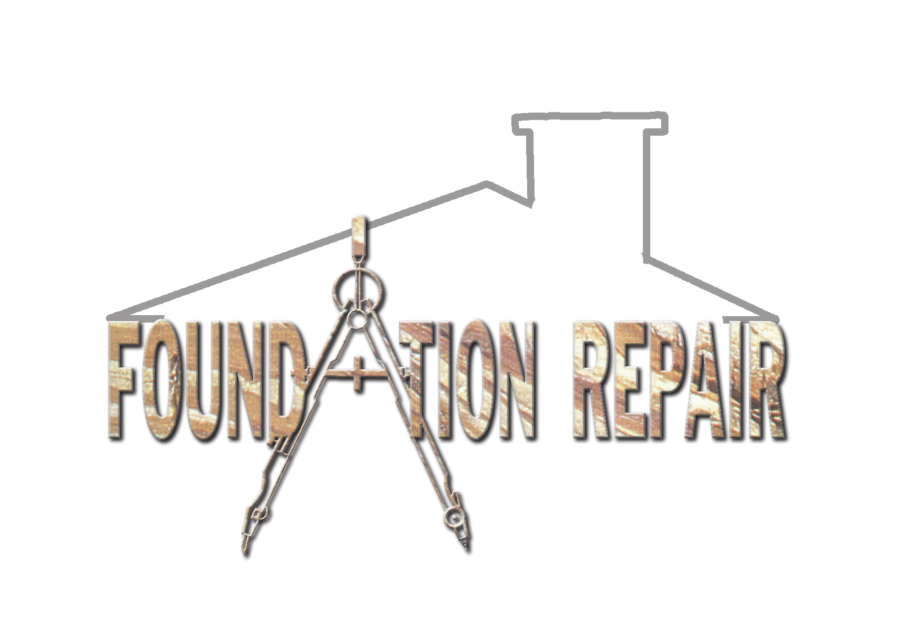

2021 E. Park Blvd. Plano, TX 75074
2021 E. Park Blvd. Plano, TX 75074

