Bumper Video Ideas

Double Rainbow

I like turtles

The Ultimate Cry

Montgomery flea market

1. Is God real?

Does God love me/everyone/Does God hate

Does God change his mind… (There are some things God doesn’t change His mind about)

Does God have a name (SONG) Is Jesus God

Does God punish people (not all punishment comes from God) (Chastises who He loves)

Is Jesus Black?

Is Jesus coming soon

Is Jesus the only way

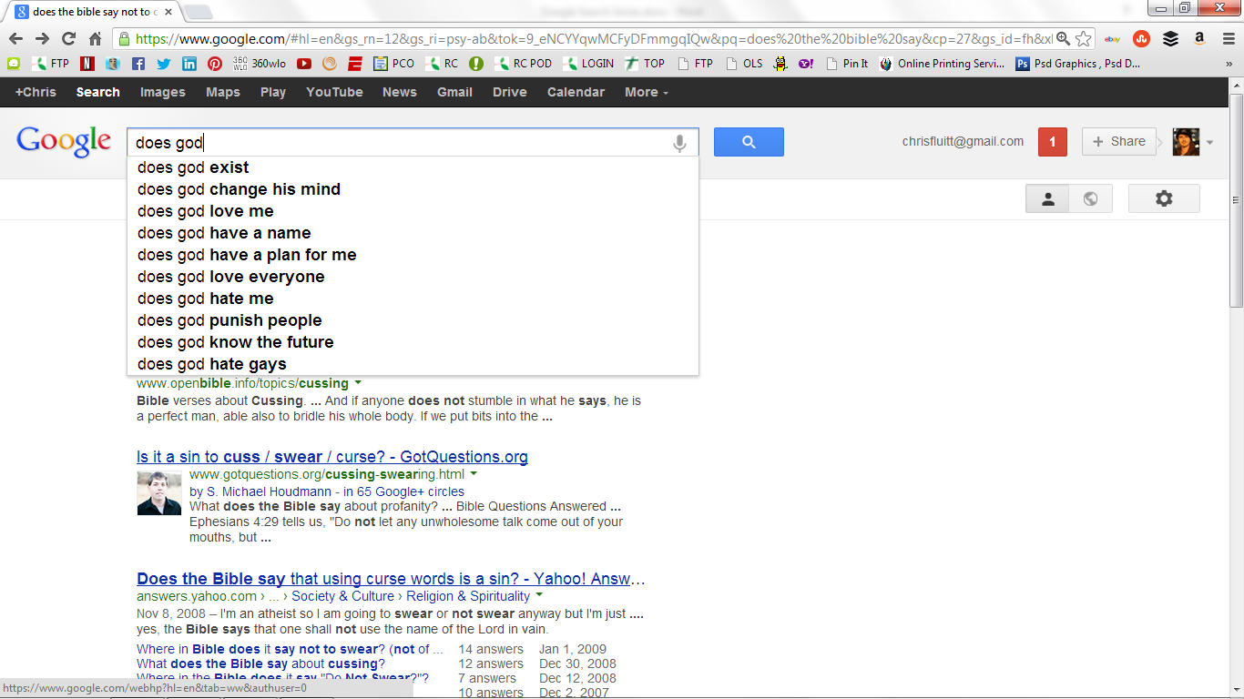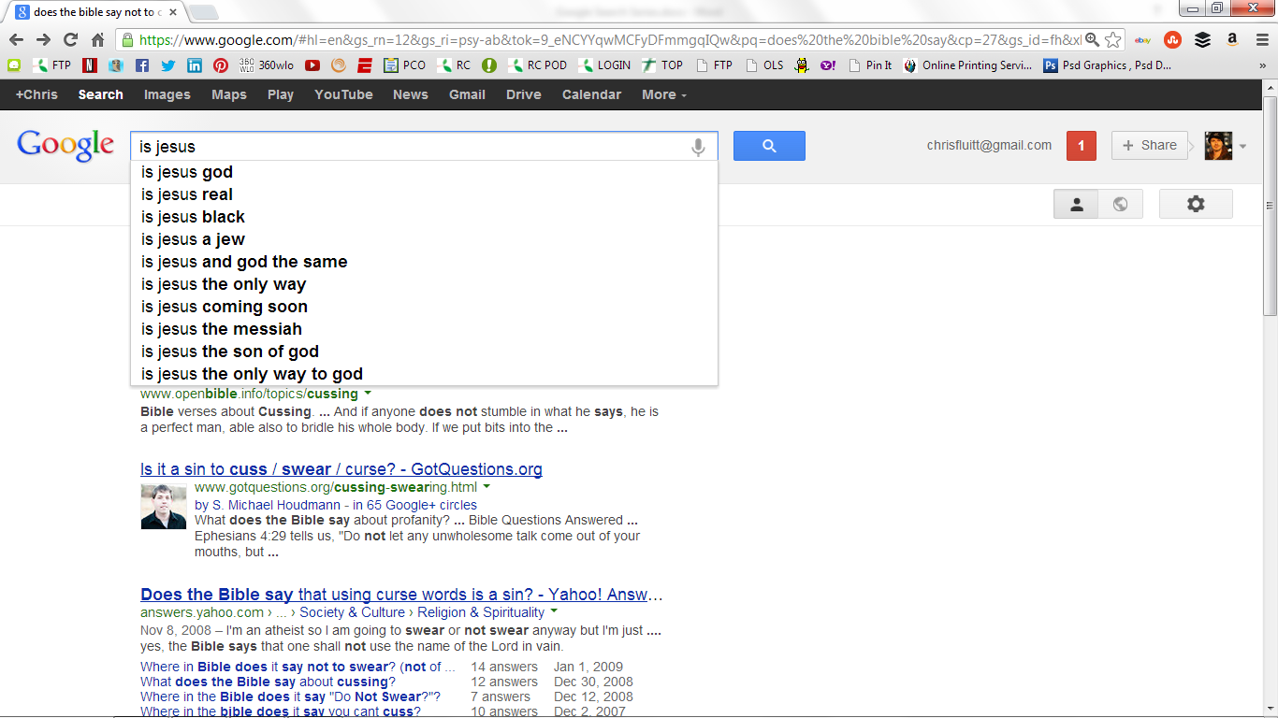

1. Sin/forgiveness
2. Lead in with to be gay & divorce
3. Smoke weed/drink alcohol (Hamartia) (All things are permissible…)(Respect the authority)
4. To eat meat (Acts 15:22) (causing others to stumble 1 cor 8:13)
5. To cuss

Colossians 3:8 But now you yourselves are to put off all these: anger, wrath, malice,blasphemy, filthy language out of your mouth.  
  
James 3:6 And the tongue is a fire, a world of iniquity. The tongue is so set among our members that it defiles the whole body, and sets on fire the course of nature; and it is set on fire by hell.

1. Tattoo
2. To be cremated
3. Will God forgive adultery
4. Will God forgive me for having an abortion
5. Will God forgive everything
6. Unforgivable sin

**\*What about Mortal & Venial sins?**

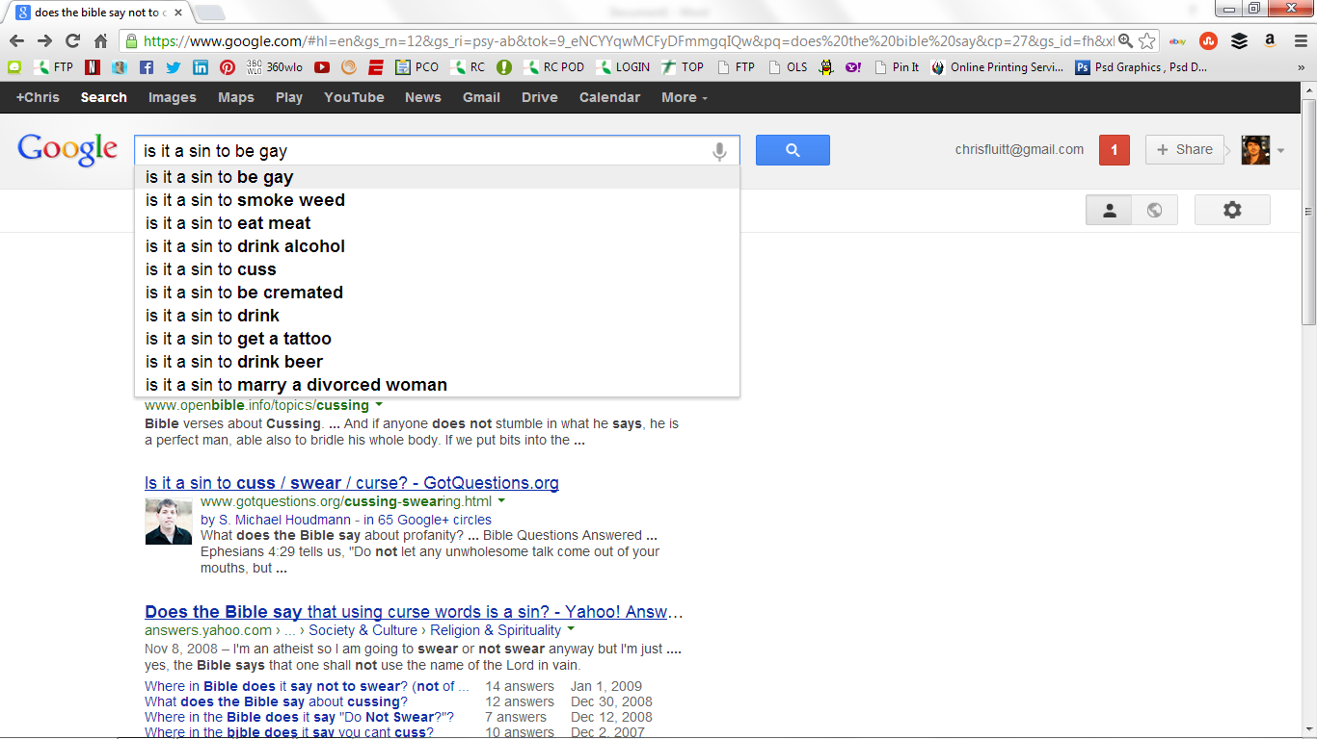

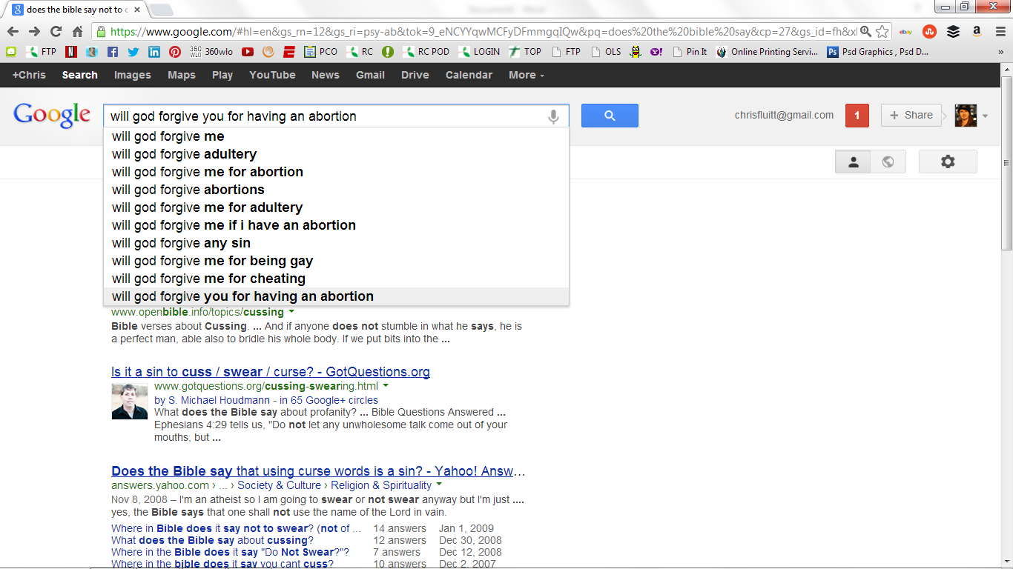

3.

Is the Bible..?

1. Is the Bible the Word of God? (Rhema Word)
2. Who wrote the bible? (Canonized year?)
3. Is the Bible Infallible?/Does the Bible contradict itself?
4. Does the Bible talk about Gambling?
5. Why does the Bible mention Unicorns?
6. Say the earth is flat. Pillars
7. Why is the Bible called the Bible? Why isn’t the word Bible in the Bible?

Biblia – Latin for the Books



4 CHURCHES & CHRISTIANS

1. Why is Church so boring?
2. Why is church on Sunday?
3. Why are there so many kinds of Churches?
4. Why is Church important?
5. Why do churches have steeples & red doors?
6. Why do churches ask for money?
7. Why are Christians mean//hypocrites/Judgemental?
8. Why are Christians Happy?

