Bumper Video Ideas

Double Rainbow

I like turtles

The Ultimate Cry

Montgomery flea market

1. Is God real?

Does God love me/everyone/Does God hate

Does God change his mind… (There are some things God doesn’t change His mind about)

Does God have a name (SONG) Is Jesus God

Does God punish people (not all punishment comes from God) (Chastises who He loves)

Is Jesus Black?

Is Jesus coming soon

Is Jesus the only way

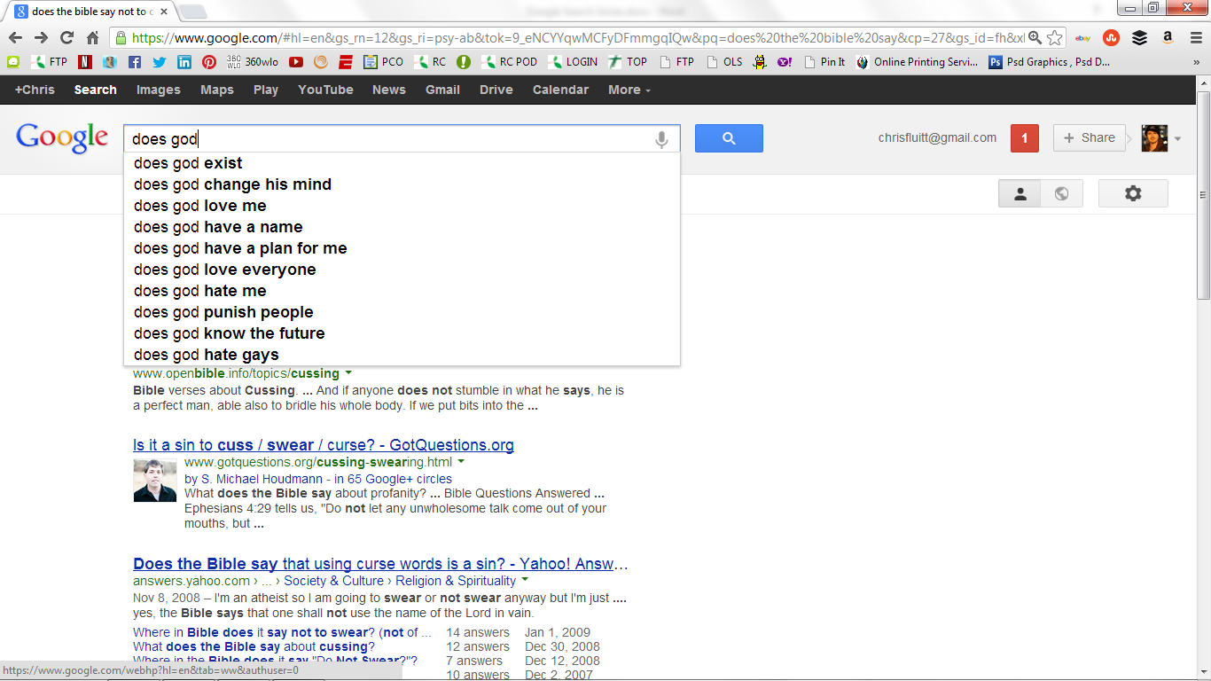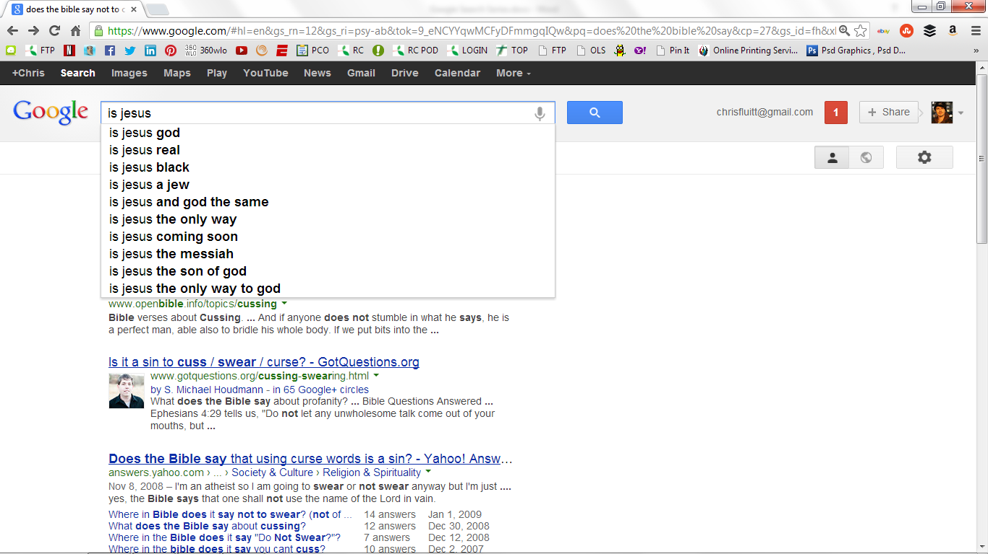

1. Sin/forgiveness

Lead in with to be gay & divorce

Smoke weed/drink alcohol (Hamartia) (All things are permissible…)(Respect the authority)

To eat meat 15:22

To cuss

Colossians 3:8 But now you yourselves are to put off all these: anger, wrath, malice,blasphemy, filthy language out of your mouth.  
  
James 3:6 And the tongue is a fire, a world of iniquity. The tongue is so set among our members that it defiles the whole body, and sets on fire the course of nature; and it is set on fire by hell.

Tattoo

To be cremated

Will God forgive me for having an abortion

Will God forgive adultery

Will God forgive everything

Unforgivable sin

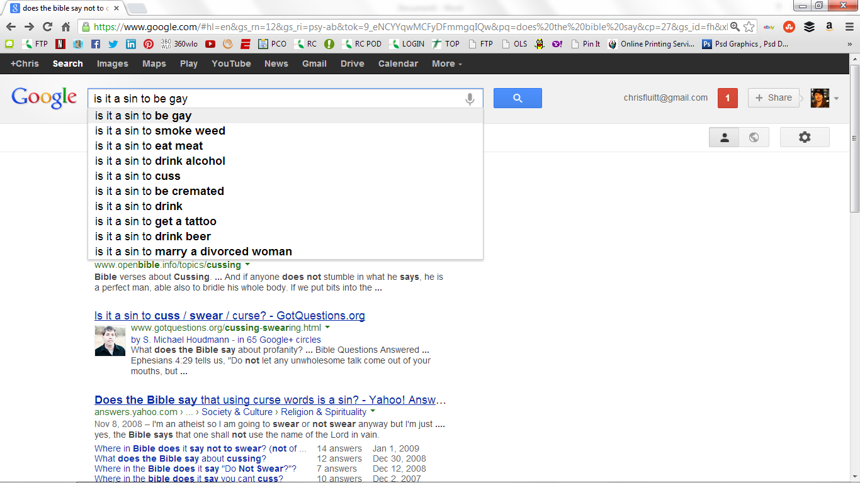

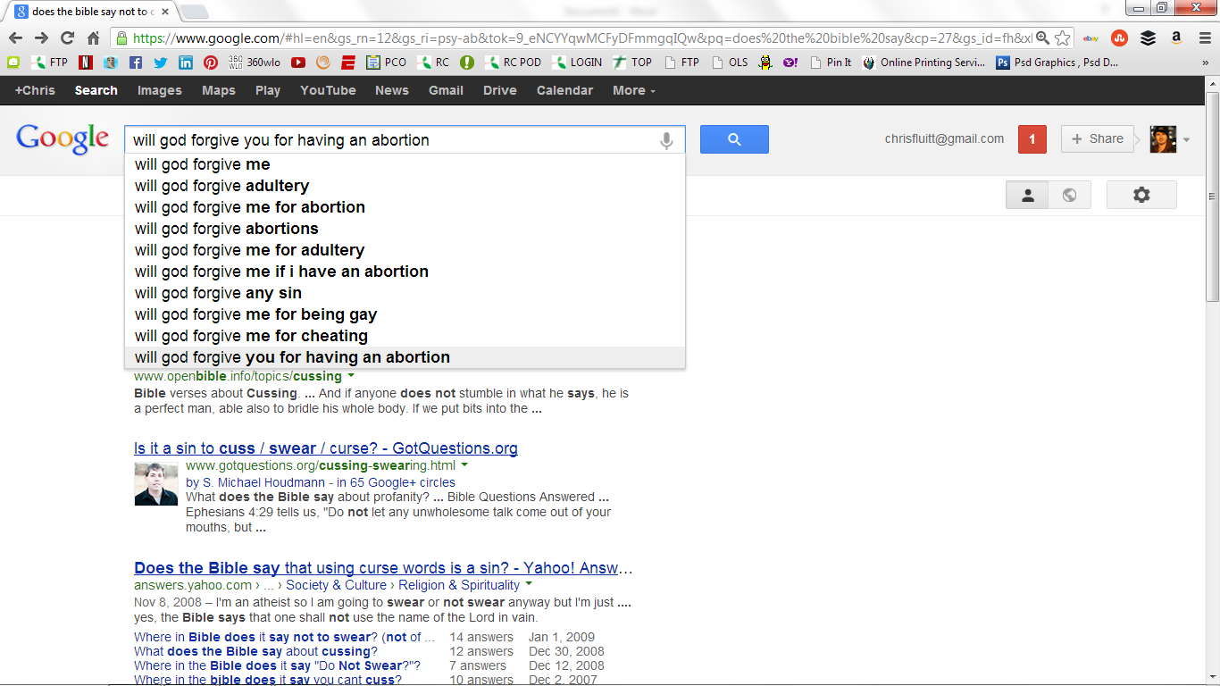

Will God really forgive me… Does he forgive everything

3.

Is the Bible True?

Is the Bible the Word of God?

Who wrote the bible?

Does the Bible contradict itself?

Does the Bible say not to cuss?

Does the Bible say anything about weed?

Gambling a sin

Why does the Bible mention Unicorns?

Say the earth is flat.

Why is the Bible called the Bible? Why isn’t the word Bible in the Bible?



4

